Year 5 – Home Learning Week Beg 11.01.21

Please find a timetable below for our weekly lessons on Microsoft Teams. The input for the sessions will be about 30 minutes and then you will be set independent tasks to do.

 | 9.30am | 11am | 1pm
Monday | Maths (Miss Conlong) | English (Miss Conlong) | Global Learning (Miss Conlong)
Tuesday | Maths (Miss Conlong) | English (Miss Conlong) | Global Learning (Miss Conlong)
Wednesday | Maths (Mrs Jaynes) | English (Mrs Jaynes) | Science (Mrs Jaynes)
Thursday | Maths (Mrs Jaynes) | English (Mrs Jaynes) | PE (Miss Lizell)
Friday | Maths (Mrs Jaynes) | English (Mrs Jaynes) | RE (Mrs Jaynes)

Please visit Miss Lizell’s you tube channel for access to the morning wake up PE session which is at 9am everyday.
https://www.youtube.com/channel/UCo1Ce6-TzdWlBNvvJEF1K5w

Mathematics (9.30am)
This week we are learning about equivalent fractions and converting mixed numbers and improper fractions from one form to another.
Monday – Log onto teams live lesson (number sequences)
Tuesday – Log onto teams live lesson (comparing and ordering fractions 1)
Wednesday – Log onto teams live lesson (comparing and ordering fractions 2)
Thursday – log onto teams live lesson (fractions as division 1)
Friday – Log onto teams live lesson (fractions as division 2)

The independent work which is set following the lesson input is accessible through the Abacus Website – The children have their own log in details and the school code is kmm7 in the bottom box.
https://www.activelearnprimary.co.uk
Make sure you are practising your times tables as much as you can.
Times Tables Rock Star
https://play.ttrockstars.com/auth/school/student/76329
https://www.topmarks.co.uk/maths-games/7-11-years/times-tables
https://www.timestables.co.uk/
English (11am)
This week we are doing character studys. Looking at the character’s feelings, personalities and how external events can affect behaviour and feelings.
Independent work will be set following the lesson.
Monday – log onto live lesson
Tuesday – log onto live lesson
Wednesday – log onto live lesson
Thursday – log onto the live lesson
Friday – log onto the live lesson (comprehension)

Afternoon Lessons (1pm)
Monday – Global Learning – log onto the live lesson
Tuesday – Global Learning – log onto the live lesson
Wednesday – Science – log onto the live lesson
Thursday – PE – log onto the live lesson
Friday – RE – log onto the live lesson

Spelling
We are learning to use endings which are send spelt –cious or –tious
Not many common words end like this. If the root word ends in –ce, the sound is usually spelt as c – e.g. vice – vicious, grace – gracious, space – spacious, malice – malicious. Exception: anxious.
Practise and learn the words listed below.
vicious, precious, conscious, delicious, malicious, suspicious ambitious, cautious, fictitious, infectious, nutritious
In your handwriting books try the following spelling activities:
- Choo Choo Words – write your whole list of spelling words end-to-end as one whole word. Write each new word in a different colour.
- UPPER and lower – write your words once with all uppercase letters and one time with all lowercase letters.
- Rainbow Write – first, write the words in pencil. Then trace over them in two different colours.
- Other Handed – first, write your words in the way you usually do. Then, write the list using your other hand.
- Magazine Words – Use an old magazine or newspaper and find your words or letters that make up words. Glue them down.
- Hidden Words – draw and colour a picture. Hide your spelling words inside the picture. See if someone can find your hidden words.

Reading
Keep reading! Remember to read EVERYDAY.

The Accelerated Reader (AR) programme is also accessible from home during this time too, so once you’ve finished your books make sure you log on and take a quiz.
https://ukhosted43.renlearn.co.uk/2152328/default.aspx

DT Project

DT project for this week is to create an underwater information page for younger children. This must include levers, sliders and pivots.
You may want to focus upon underwater animals, a global water issue or anything else that you may want to choose. To complete this project you will need some A4 / A3 plain paper or some card.

Carry out some research on the information you would like to include on your information page. This could be the size of animals, what they eat, how they protect themselves etc.

You would have found some split pins cellotaped to the inside of your topic book. You may wish to use these for the pivot within your information text.

Carry out some research on levers, pivots and sliders within books. Look at some underwater texts.
You may have even seen some books with levers, sliders and pivots in them!

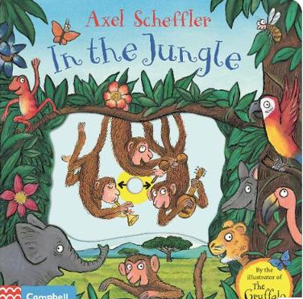

Video 1(Sliders / pull tab) https://www.youtube.com/watch?v=4NiU6l1u8dc
Video 2 (Sliders / pull tab) https://www.youtube.com/watch?v=qyKUw2FJJr4

Now create your information page. See below for a partially completed example. You can see here where the split pin has been used to create a pivot. More information is needed in this example about the animals being shown and the use of a tab pull is needed.

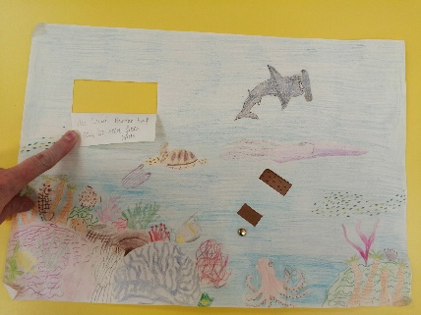

You can put all of your information onto 1 side of paper.

Enjoy the project, make it as colourful as you like. Try to find information which would be suitable for a younger audience. As you are working, think about any problems which arise and how you solved them. Were there any parts of the assignment which you found tricky? Why?
At the end of the week you may take a picture of your work and submit it via teams (into the DT channel on the left hand side of the screen).

Mind Up
https://mindup.org.uk/families/

Skills builder
https://www.skillsbuilder.org/homelearning

French
(Log in – Username - Buckden Password – octopus)
https://www.linguascope.com/

