This week’s learning 11.10.21

Monday
Maths – Oak Academy - follow the links and complete the activities. https://classroom.thenational.academy/lessons/combining-sets-count-all-cru68d

English – Talk about what is happening in the picture, consider how is Beegu feeling, why is she there, where is she going?
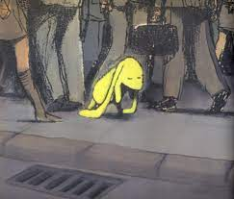
RE – Look at the attached picture. What do you notice? What story could this tell?

Tuesday
Maths – Oak Academy - follow the links and complete the activities. https://classroom.thenational.academy/lessons/combining-sets-count-on-74u32r

English – Imagine you are talking to Beegu. Write down the questions you would ask her.

Global Learning – Notice patterns in the environment and take rubbings of bricks and trees around you.

Wednesday
Maths – Oak Academy - follow the links and complete the activities. https://classroom.thenational.academy/lessons/linking-addition-equations-to-problem-solving-contexts-6rv66t

English – Write a poem about what you think Beegu is feeling in the story so far.
For example –
Lost,
ignored in a world of strangers.
Hoping to finally go home,
Lonely.

French – Draw a picture of France and the United Kingdom and label the capital cities (London and Paris).

Thursday
Maths – Oak Academy - follow the links and complete the activities. https://classroom.thenational.academy/lessons/understanding-commutativity-c5gk8c

English – (Comprehension) https://www.literacyshed.com/silentbluebook.html
Watch the clip and answer the questions attached. Complete an attached sheet.

PSHE – Make a list of all your trusted adults in your life.

Friday
Maths – Oak Academy - follow the links and complete the activities. https://classroom.thenational.academy/lessons/subtracting-by-partitioning-crr3jr

English – (SPAG) Practice your handwriting using the year 1 common exception words.
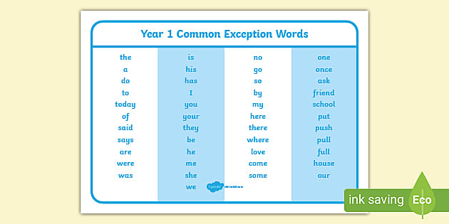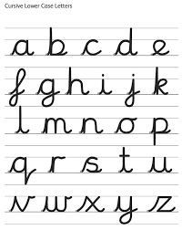
Science – Go on a sound hunt. Using your hearing sense, walk around your house and identify all the sounds you hear.

Daily
Abacus - https://www.activelearnprimary.co.uk/login?c=0 (Log ins are in the children’s reading diaries and the school code is kmm7).
Keep reading!
Read a magazine/newspaper article.
Arithmetic (20 minutes a day) – Count to 100 aloud whist doing body percussion, challenge yourself and now count in tens.
Phonics – Play a phonics phase 2 and 3 game on phonics play.
https://www.phonicsplay.co.uk/resources/phase/2/picnic-on-pluto

PE

Visit youtube and do a session 5 times a week of Joe Wicks/Go Noddle/Cosmic Kids Yoga.

