Week beg: 21.03.22
Talk homework – Tell an adult about your skills builder project.
We have had a lovely week. It has been very productive. We have worked hard on our skills builder project. We focused on creativity, aiming high and staying positive skills in the main but were able to use a wider range of skills.
We began by collaborating and sharing initial ideas. We discussed which space we would like to redesign. We then created a mood board to develop our ideas.
We then worked on our own design and created a 3d image in our shoe boxes. We used our topic of sustainable cities and communities to inspire our ideas. Please find some pictures attached.
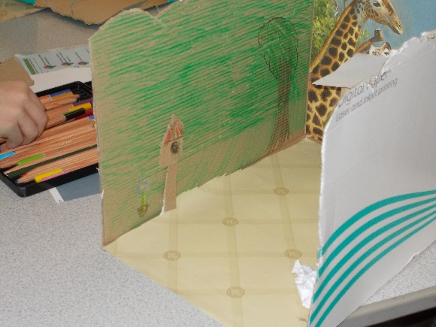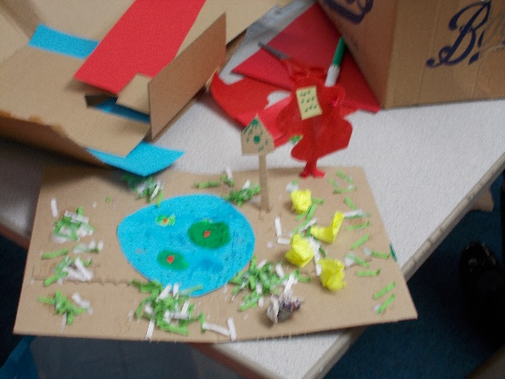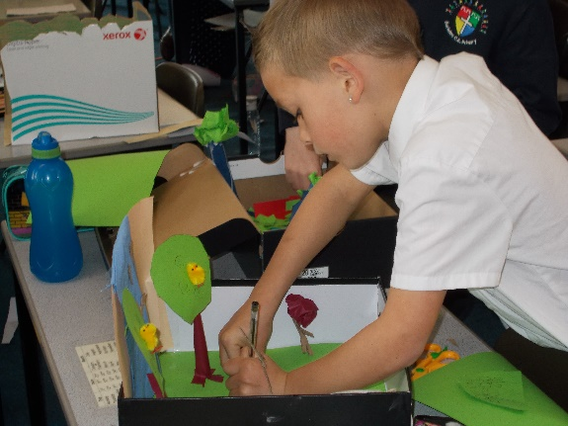
We also learned a lot in Science this week and ended the week with a practical observation on tulips. We dissected and identified the various parts of a flower and drew detailed images of what we saw.

We hope you had a lovely week too and have a relaxing weekend.
Hawthorn class

