How to turn off chat notifications

Click on your circle with your initials.

Go to settings.

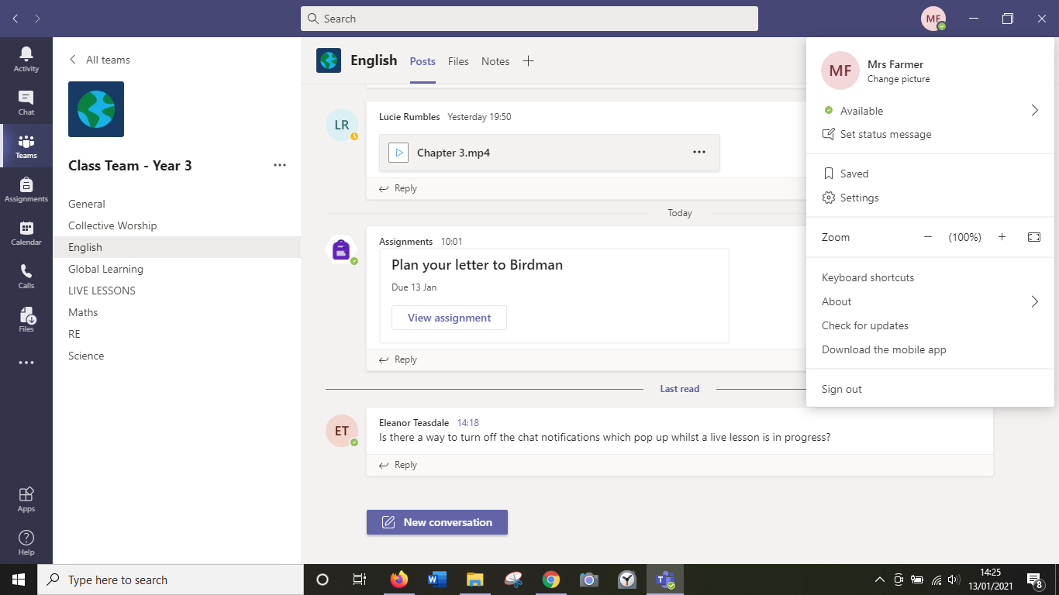

Go to notifications

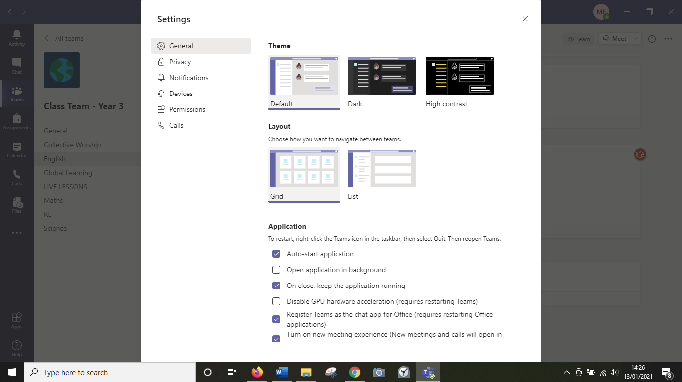

Change your preferences here.

