This week’s learning 24.01.22
Monday
Maths – Add by counting on - See attached Powerpoint and complete the attached sheet.
English – Look at the front cover of our text. Make a plan of how you would find gold. You might need a compass, spades, metal detector and a map remember.
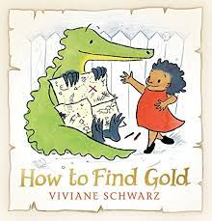
Science – See attached PowerPoint and complete the sheet.
Tuesday
Maths – Adding ones - Complete the attached numberline sheet, remember you can use items around your house to help you count on.
English – Design your own treasure hunt by hiding something in your house and drawing a map for someone to find it.

Global Learning – Label the seas and rivers around the United Kingdom.
https://www.twinkl.co.uk/resource/tg2-g-07-go-teach-rivers-label-uk-seas-and-rivers-interactive-activity
Wednesday
Maths – Complete the attached counting on sheet.
English – Write a set of instruction of how to find gold. Don’t forget to use first, then, after, finally in your instructions.

Music – Make an instrument at home that represents the sound of rain.
Thursday
Maths – Look at the Powerpoint and use objects to work out the calculations.
English – Comprehension – See attached text and answer the questions.

RE – Look at the website with Hindu artefacts on. Now draw your own picture of one of the Hindu God. http://resources.hwb.wales.gov.uk/VTC/ngfl/re/m_parry_carmarthenshire/arteffactau/cysegrfa.htm

Friday
Maths – Practise your maths skills by playing some games on your Abacus account. There are lots to choose from! https://www.activelearnprimary.co.uk/login?c=0 (Log ins are in the children’s reading diaries and the school code is kmm7).
English – (SPAG) Practice your handwriting using the year 1 common exception words.
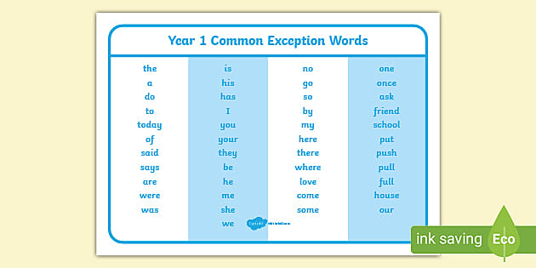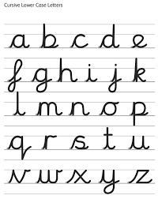
Daily
Abacus - https://www.activelearnprimary.co.uk/login?c=0 (Log ins are in the children’s reading diaries and the school code is kmm7).
Keep reading!
Read a magazine/newspaper article.
Arithmetic (20 minutes a day) – Count to 100 aloud whist doing body percussion, challenge yourself and now count in tens.
Phonics – Play a phonics phase 2 and 3 game on phonics play.
https://www.phonicsplay.co.uk/resources/phase/2/picnic-on-pluto

Practice your typing skills
https://www.bbc.co.uk/bitesize/topics/zf2f9j6/articles/z3c6tfr

PE
Visit Youtube and do a session 5 times a week of Joe Wicks/Go Noodle/Cosmic Kids Yoga.

