Home Learning- Year 2
If you are feeling well enough, please pick an activity from maths and English. Then choose one other lesson to enjoy each day. Please send some photos or bring any work you are able to complete back to school with you.

Maths
Monday-Friday
Log in to PowerMaths Active Learn (Log in details are in your Reading journal) https://www.activelearnprimary.com.au/login?e=-1&c=0
Click on Resources>PowerMaths on the green banner, click on year 2 and under TYPE choose Textbook 2B for explanations and Workbook 2B for questions.
Work through the following lessons covering properties of shape.
PowerMaths
Textbook 2B Unit 10 lessons 1-5 pp. 154-175
Workbook 2B Unit 10 lessons 1-5 pp. 113-127
English
Monday
Today we are going to be writing our character descriptions and setting descriptions for our own fairytale. Think back to your plan you did in school. Begin describing your characters using adjectives. Can you write an expanded noun phrase? This should be around 6 sentences- 3 for your hero and 3 for your villain. Next, you will write a short description of your setting. This should be able 4 sentences. Where is it set? Use your five senses to help you describe your setting: see, hear, smell, taste and feel.
Tuesday
This lesson we will be drawing our story mountain for our fairytale. Remember to include your characters, setting, dilemma and solution.
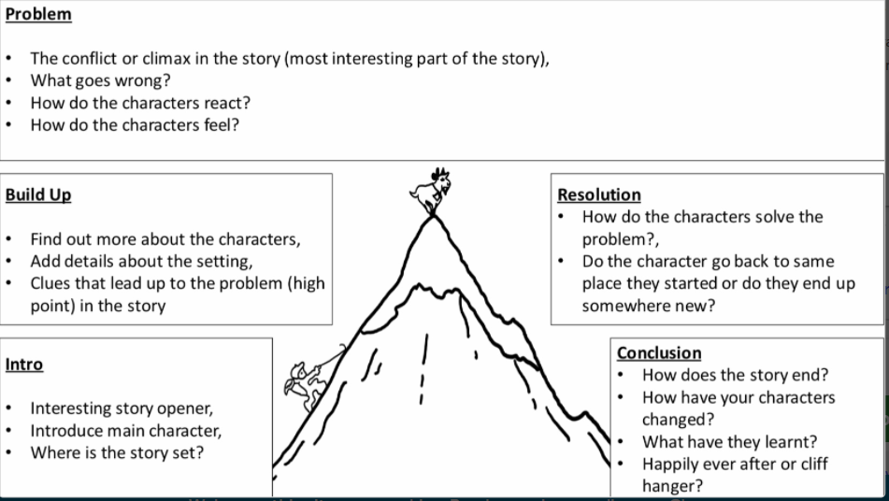

Wednesday-Friday
Over the next few days, you will be writing your very own fairytale. Remember to use your plans to help you. Think about your setting, characters, dilemma and solution. Think back to our lesson on what makes a successful fairytale. Check your punctuation throughout.

Other activities that you can choose from:
Grammar, Punctuation and Spelling:
https://www.bbc.co.uk/bitesize/topics/zkxxsbk
https://www.topmarks.co.uk/english-games/5-7-years/letters-and-sounds
https://spellingframe.co.uk/
https://sentenceplay.co.uk/games/dropping-in
Text Types/Genres:
https://classroom.thenational.academy/subjects-by-key-stage/key-stage-1/subjects/english

Wednesday- Challenge Day
Think about our SDGs of Reduced Inequalities and Gender Equality. Today you will be designing a bedroom suitable for both girls and boys. You can design this as a floor plan or make a model if you can.

Tuesday P.E
We will be learning more gym movements which is hard to do at home.
Do some warm ups (with an adult) to stretch your muscles and get your heart pumping.
Then, to ensure you get some exercise visit YouTube and do a session 5 times a week of Joe Wicks/Go Noddle/Cosmic Kids Yoga.

Thursday- Science
We have been learning about life cycles. Research the life cycle of a butterfly. Can you draw it? Maybe you could find objects to model the different stages of the life cycle.

Friday - RE
Today we are making Easter cards. Remind yourself or talk to an adult about the Easter story. Our Easter card is going to represent the resurrection of Jesus.
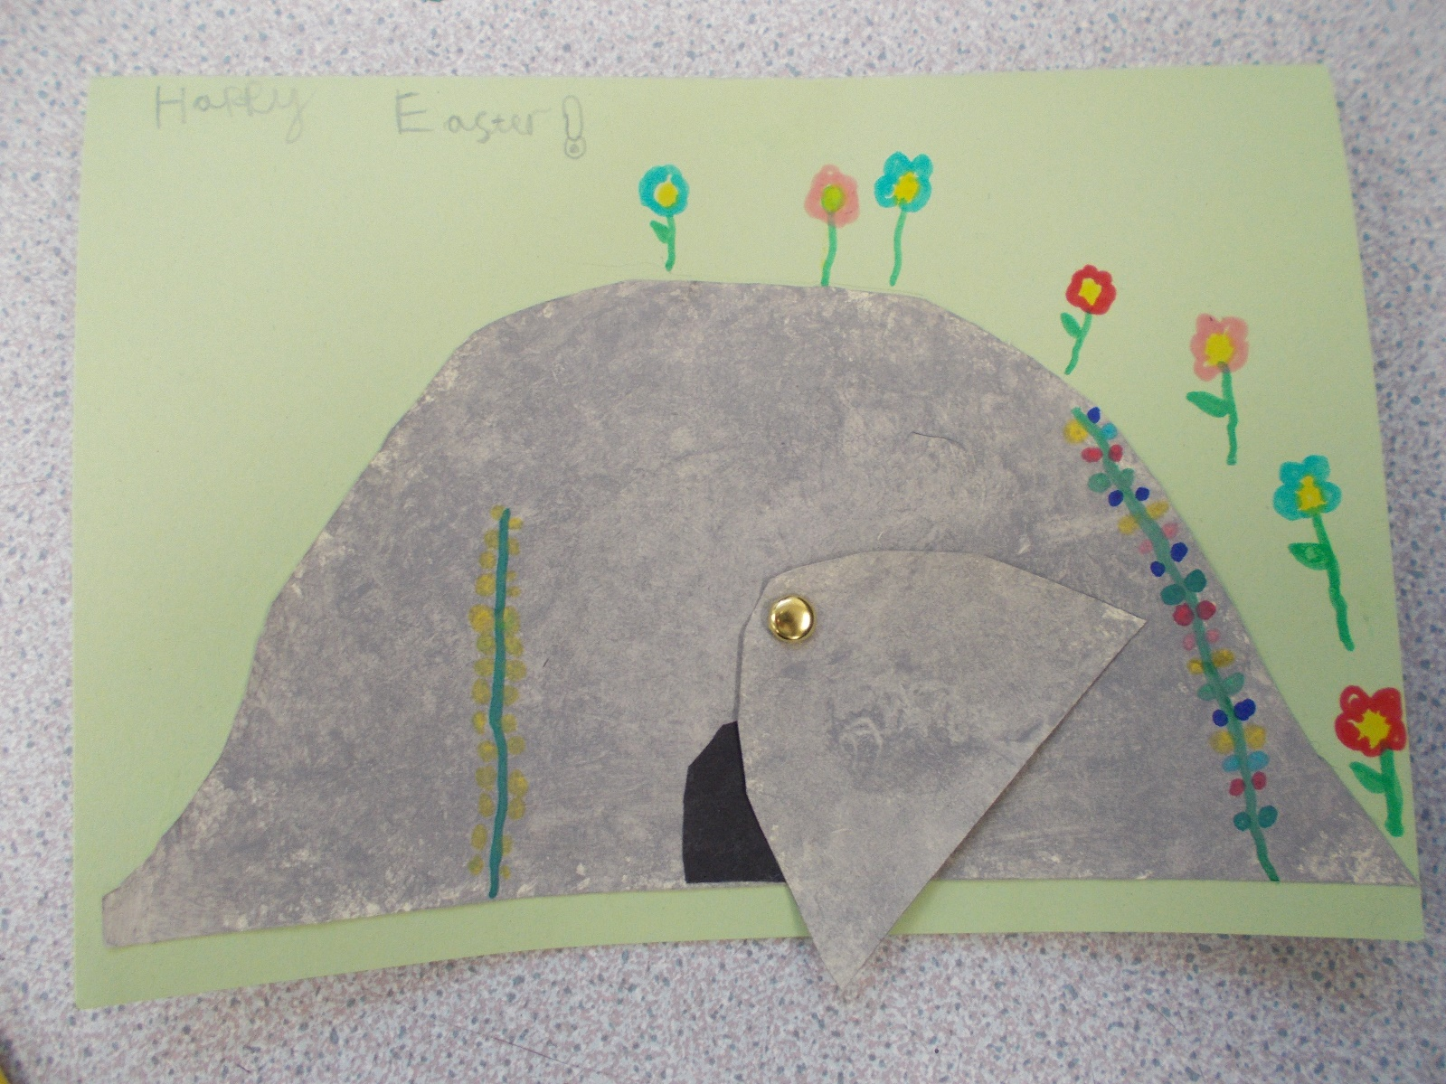

Daily
Keep reading!
Read a magazine/newspaper article.
Arithmetic (20 minutes a day) – Count in 2s 5s and 10s
Watch Newsround
Phonics – Play a phonics phase 3 and 5 game on phonics play.
https://www.phonicsplay.co.uk/resources/phase/3

Times Tables – practise your times tables as much as you can!
Useful websites for times tables:
https://www.topmarks.co.uk/maths-games/7-11-years/times-tables
https://www.timestables.co.uk/

French
Use the powerpoint attached to learn the school subjects in French
- Practise numbers 1-31 in French. Have a go playing these games and familiarising yourself with the spelling/reading of the words. You can play interactive games, watch videos or create posters/flashcards to help you.
https://wordwall.net/resource/3027772/french/french-numbers-1-30
https://www.bbc.co.uk/bitesize/topics/zpy8q6f/resources/1
- Revise months of the year in French
- Revise colours in French
https://www.youtube.com/watch?v=acvUtipaC5Y

