Week beg 24.04.23
This week has been a really productive week. We have had lots of practical learning in the classroom. We have created clay pots/vessels with Mrs Schmidt and they are ready to go into the kiln to be fired.
We have also had a visit from Cambridge Launchpad and Illumina as part of our STEM learning. We had a great morning learning about DNA and how to extract it from a strawberry.

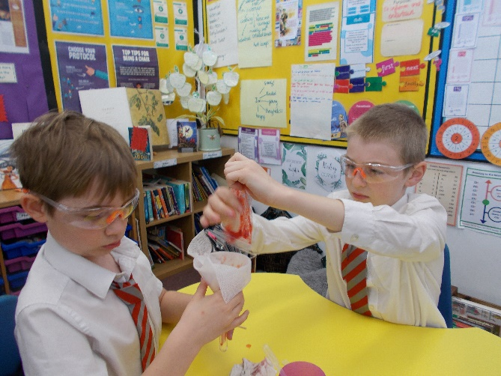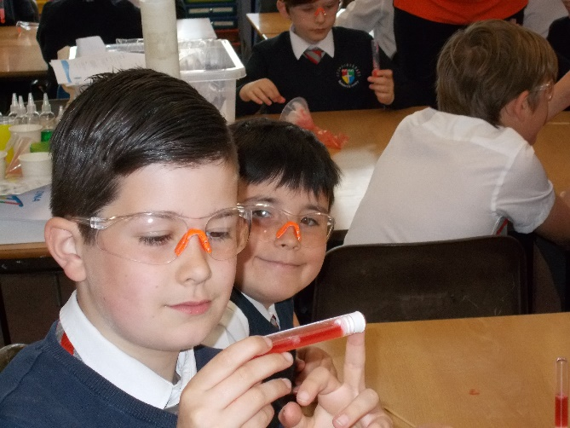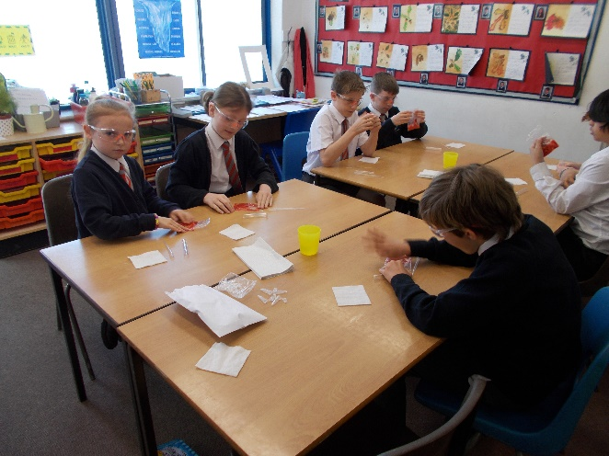

We also learned how to make bread. We used a basic bread recipe before choosing two ingredients to add to it. We used olives, cheese, mango, chocolate, jam, raisins, apricots to name but a few ingredients. The pupils were very pleased with their results.
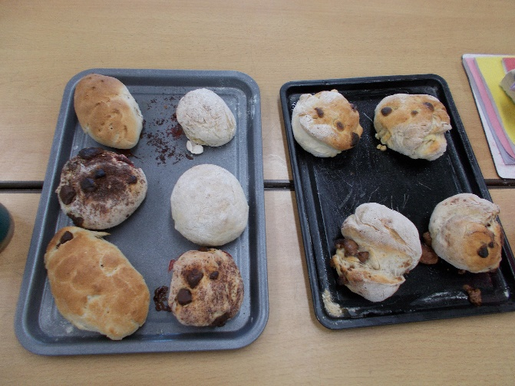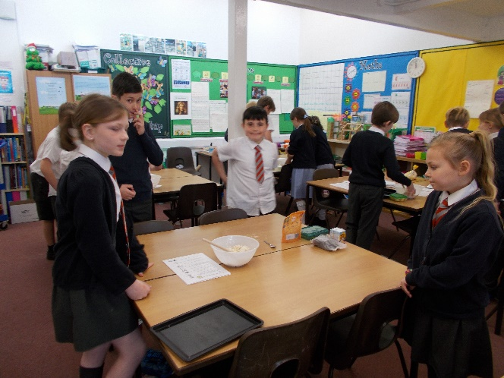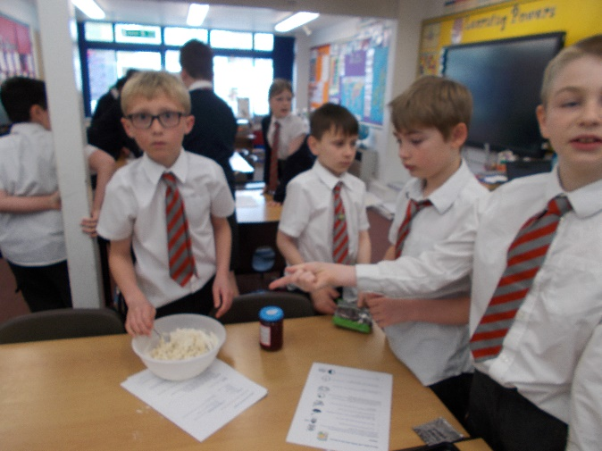
It has also been very exciting finding out the various parts we will be playing and we are looking forward to starting rehearsals for our play.
Finally, we have been learning about Biomes. Annabelle really liked researching all the different biomes around the globe and we will continue to learn about these as the weeks progress.

We are looking forward to a long bank holiday weekend with our families. We hope you have a lovely weekend.

Bluebell class.

