This week’s learning if you are having to self-isolate.

Please complete all work neatly in your books under the date and a short title.

Monday 15th March 2021

Maths
Think about everyday objects that are 3D shapes e.g. a traffic cone is a 3D cone and a tissue box is a cuboid. Hunt for some 3D shapes and draw them, name them and describe their properties…How many vertices, edges and faces do they have?
English
Today we will be thinking about writing in the past and present tenses. Write about what you did yesterday in the past tense. Underline verbs that are in the past tense.
Global
Can you draw a self-portrait? This is one of a series of attempts to draw a self-portrait. Today, we would like you to have a go at drawing your head and shoulders as you think you look. Don’t use a mirror! Next week, we will be learning about proportions to improve our understanding of drawing a self-portrait.
Suggestion for a further activity: Can you remember the names of shops in French?
Use the PowerPoint attached to learn the shop names in French.

Tuesday 16th March 2021

Maths
Today in maths we will be learning about height and length. Use Power Maths Textbook 2B p80-83 to learn about measuring in centimetres. Then answer the questions in the Power Maths practice book 2B p58-60. These documents are added to the blog and available on Abacus. OR you could carefully measure and cut strips of paper that are 7cm, 12cm, 15cm and 16.5cm long.
English
Look back at your picture of your setting for your story. Can you describe the setting using interesting adjectives? Write at least 6 sentences to describe the scenery. Remember to use your senses to help e.g. What can you hear? What can you see?
Global
Use the PowerPoint attached to learn more about the different classes on the Titanic. Make some notes about 1st, 2nd and 3rd class on the Titanic.

Suggestion for a further activity: Practice your handwriting. Write a sentence then check it to make sure: The ascenders are all below the line, the ascenders are tall and straight and higher than the other letters, the lower case letters are all the same size, the capital letter is bigger than all of the lower case letters.

Wednesday 17th March 2021
Maths
Today in maths we will continue to learn about lengths and height. We will be learning to measure in metres. Use Power Maths Textbook 2B p84-87. Then answer the questions in the Power Maths practice book 2B p61-63. These documents are added to the blog and available on Abacus. OR measure your kitchen. If a bus is 12m long and 3m high, how many buses can you fit in your kitchen?
English
Today think of a second setting that could feature in your story. Make a quick sketch and describe in detail what you can see.
Global
Complete the titanic template by colouring all first, second and third class sections in the correct colours using the reference picture. Think why the first class may have been in the top of the ship and third class was at the bottom of the ship?
Suggestion for a further activity: Research the life cycle of a butterfly and draw a diagram to show your understanding or make a model
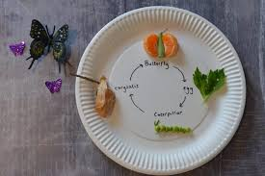

Thursday 18th March 2021
Maths
Today in maths, we will continue to learning how to compare lengths. Use Power Maths Textbook 2B p88-91. Then answer the questions in the Power Maths practice book 2B p64-66. These documents are added to the blog and available on Abacus. OR find three objects e.g. a pencil, a box and a chocolate bar and measure their lengths. Compare their lengths to identify which is the longest, shortest, which is longer and shorter.
English
Today it’s time to start planning our story. Draw a story mountain and plan your story. How does the story start? How does the story tension build? What big problem occurs? Remember to include trapping a witch! How will the problem be resolved? How does your story end?
Global
Today you will need the two crosses that you made in a previous R.E. lesson. You made the crosses using a happy colour scheme and a sad colour scheme. Watch this video of The Easter Story https://www.youtube.com/watch?v=Wnbo2AmS3OI
As you watch, when you get to a happy part of the story e.g. people waved palms to welcome Jesus, draw a little picture or write a short note in your happy cross. Similarly, when you reach a sad part of the story record it on your sad cross.
Suggestion for a further activity: Can you draw all the members of your family in age order. Youngest first and eldest last?

Friday 19th March 2021
Maths
Today in maths we will learn about ordering lengths. Use Power Maths Textbook 2B p92-95. Then answer the questions in the Power Maths practice book 2B p67-69. These documents are added to the blog and available on Abacus.
English
Complete the comprehension attached.
Global
Make an information page explaining everything you know about the Titanic.

Suggestion for a further activity: Continue to learn how to spell the year 2 common exception words which are written in your reading log.

Additional maths activities

You can use Abacus (Power Maths) and the Whiterose website with this week’s learning objective as a focus for learning all free of charge.
Whiterose - https://whiterosemaths.com/homelearning/year-2/
Abacus - https://www.activelearnprimary.co.uk
The children have their own log in details and the school code is kmm7 in the bottom box.
On Abacus your child has been assigned the Power Maths Textbook and Workbook that we use in school

Times Table Rock Star – practise your times tables as much as you can!
https://play.ttrockstars.com/auth/school/student/76329
Other useful websites for times tables:
https://www.topmarks.co.uk/maths-games/7-11-years/times-tables
https://www.timestables.co.uk/

Revision
Number and Place Value
- To read and write numbers to 100 in words and numerals.
- To find the next multiple of 10 from a given number.
- To find 10 more and 10 less than a given number.
- To find multiples of 10 more and less than a given number e.g. 17…….10 and 20
- To practise recall of number bonds to 10 and 20 mentally i.e. 6 + 4, 5 + 5, 16 + 4, 15 + 5
- To practise recall of number facts to 10 mentally i.e. 6 = 4 + 2, 3 + 3, 5 + 1.
Additional English activities
SPAG - https://www.topmarks.co.uk/english-games/7-11-years/spelling-and-grammar

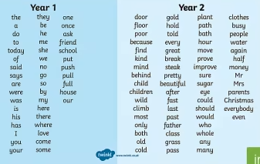
- Read and spell the Year 1 Common Exception Words
- Read the Year 2 Common Exception Words
- Spell the Year 2 Common Exception Words
Practise a few at a time, little and often. Remember – Look, Cover, Write, Check! Make your learning as active as you can, use chalks outside, lots of colour pencils, make the words in playdough or write letters on beans and use those to spell the words.

Some children (not all) have a Nessy login for – Reading and Spelling practise https://www.nessy.com/uk/

Phonics/Reading
Revise all phase 3 and phase 5 sounds
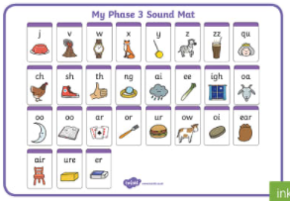 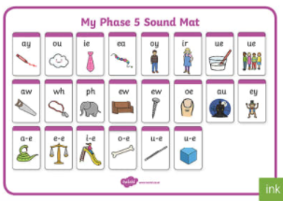
We have been looking at sound buttoning lots of ‘real’ and ‘alien’ words using these sounds, such as queek, splain, screet, scratch, train, etc. We have been spotting the digraphs and trigraphs in lots of words to help with blending and reading new and unfamiliar words correctly.
There are some apps which you may find useful to recap and practise the above sounds.
- Cambugs app (first one is free)
- Reading Eggs https://readingeggs.co.uk/ has many phonics games
Remember to read EVERYDAY.
When you read with your adult(s) at night, get them to ask you questions about the characters, the setting and the plot of the stories!
i.e. Can you describe the main character? What has just happened in the story? Where is the story set? What’s it like there? How does the character feel about what has happened? What do you think might happen next?
Here is a really useful website which offers lots of our banded books to read online, and is free to sign up! www.oxfordowl.co.uk
P.E. Stay active (2 hours a week)

Or you could try sessions of P.E. with Joe Wicks.
(I think he is running sessions on Mon, Wed and Fri starting 11th January)
https://www.youtube.com/c/TheBodyCoachTV/search?query=kids

Also try super movers to make sure you are keeping fit and active
https://www.bbc.co.uk/teach/supermovers/ks1-collection/zbr4scw

Mind Up https://mindup.org.uk/families/

Skills builder https://www.skillsbuilder.org/homelearning

Please take photos of any work you would like us to see and send to them to us at the year 2 email address Year2@buckdenacademy.org
or submit to your Microsoft class teams account by responding to an assignment.

