This week’s learning 11.10.21

Monday
Maths – Oak Academy lesson 6 –
Adding two, 2-digit numbers
https://classroom.thenational.academy/lessons/adding-two-2-digit-numbers-crvk6d
English – We will continue to read The Last Wolf this week until we get to this page.
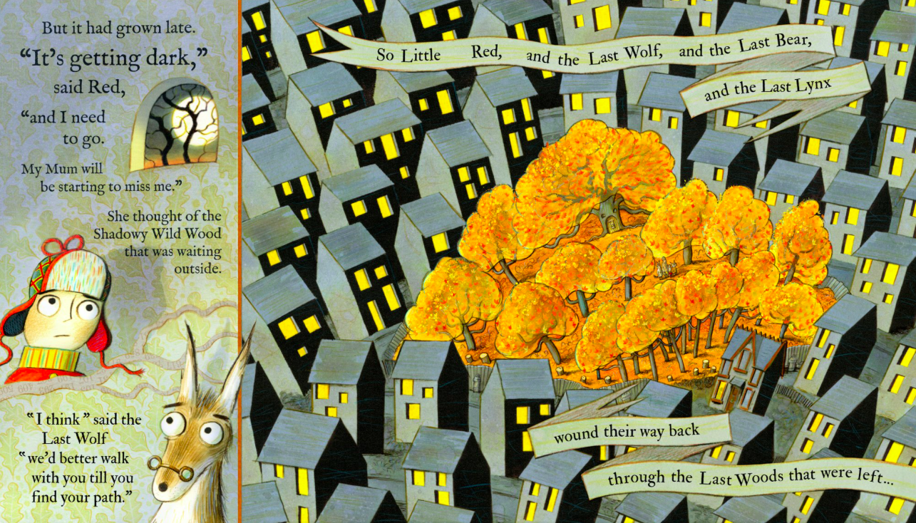
I think we will all find it shocking to see how small the forest really is and how many houses have been built around what remains of the forest. Can you make a list of all of the reasons why it is bad for our forest woodland animals, that the forest is now so small because so many houses have been built.
Global learning/DT/Science – We will be designing our bug houses today. Have a close look at the picture below and think why it is a good habitat for a bug house. What makes a good bug house? What materials are needed to make the inside of a bug house? In the box below can you design your own bug house? What material will you put where? Why? Draw in the interior of your bug house and label each material e.g. twigs, cones, hay, shredded cardboard.
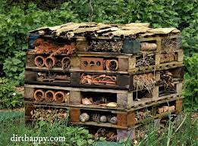

Tuesday
Maths – Adding two digit numbers
Practise what you learnt yesterday. If you need a challenge use bigger numbers.
English – Discuss with an adult what we can do to look after the animals that are protected in our country. Last week we learnt about Badgers and how their setts are protected by rules to prevent them being destroyed. We have also learnt how important it is to look after our hedgehog population. Look at the picture above where we discover in The last Wolf that the forest is tiny because it has been cut down to build housing. Look back over the lsit you made yesterday of why this is damaging for woodland animals. Is it also damaging for humans and our planet? We will be thinking about who we could write a letter to to help everybody understand how important trees are for the future of our planet. Have a think about all of the things you would want to include in your letter.
Global/DT/Science
Using wood or a shoe box make a bug house based on your design yesterday.

Wednesday
Maths – https://www.sheppardsoftware.com/math/addition/fruit-splat-game/
Try levels 6 and 7
English – Write your letter that you have been planning yesterday and the day before.

Science-Did you know a conker is a seed? Watch this video about horse chestnut trees.
https://www.youtube.com/watch?v=73bCzw5SqA4

Thursday
Maths – Oak National Academy Subtracting two, 2-digit numbers
https://classroom.thenational.academy/lessons/subtracting-two-2-digit-numbers-6gup2t
English –
See the grammar sheet attached and do as much as you can in 45 min
French- Practise numbers 1-31 in French use this video to help you https://www.youtube.com/watch?v=DnrTrbJ6mYs
Can you create a poster to help you remember them?

Friday
Maths – Oak National Academy
https://classroom.thenational.academy/lessons/adding-and-subtracting-two-2-digit-numbers-ctk3gr
English – Continue with another 45 min of the grammar sheet that you started yesterday
R.E. – In R.E. we have learnt how Christians believe God made our planet in 7 days. In PSHE we have learnt the importance of rules. Can you make a poster to show some rules of how to look after our planet?

Daily
Keep reading!
Read a magazine/newspaper article.
Arithmetic (20 minutes a day) – Count in 2s 5s and 10s
Phonics – Play a phonics phase 3 and 5 game on phonics play.
https://www.phonicsplay.co.uk/resources/phase/3

Times Tables – practise your times tables as much as you can!
Useful websites for times tables:
https://www.topmarks.co.uk/maths-games/7-11-years/times-tables
https://www.timestables.co.uk/

PE

Visit youtube and do a session 5 times a week of Joe Wicks/Go Noddle/Cosmic Kids Yoga.

