This week’s learning 22.11.21
Monday
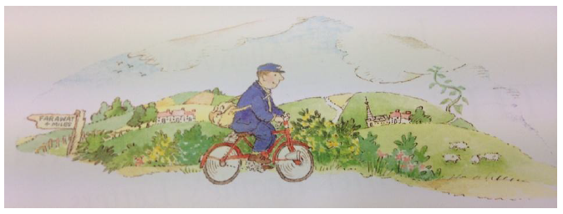
English –

Who is he?

What is he like?

What does he do at work?

How do you know?

Who might he have post for?

What might it be?
RE – Welcoming people is a Mitzvah or ‘Good Deed’
How would you welcome someone into your home?
How would you welcome someone into our classroom/school?
How could we welcome someone new to our country?
Draw a picture to show what you would do to welcome someone new and write a sentence to describe what you have drawn.
Tuesday
Maths – Complete the number line subtraction sheet to 10 attached. You can also draw pictures and cross out the subtracted number to help you.
English –
Look around the house for some letters. Can you spot any with a stamp on?
Design your own Christmas stamp that could be used to put on a letter.

Global Learning –
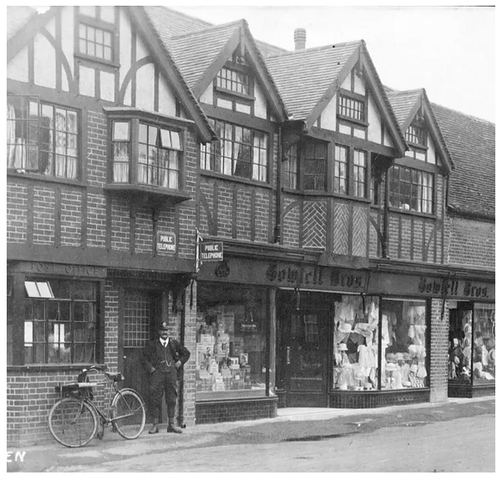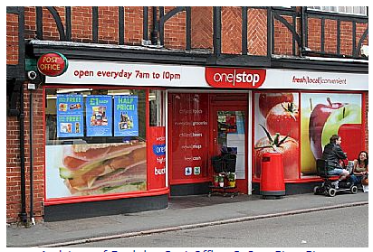

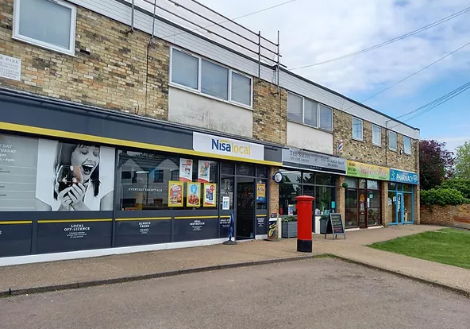
Compare the pictures – what is the same? What is different? How have the community buildings changed over time? What do you notice about the pictures? Write some words/sentences to describe what you can see.
Wednesday
Maths – Complete the number line subtraction sheet to 20 attached. You can also draw pictures and cross out the subtracted number to help you.
English – Write a letter to your teacher telling them what you have been doing at home today! Don’t forget to tell them your favourite part and include any interesting details!

Science – Testing the Properties of Materials.
Find some different objects from around the house made of different materials (straws, spoons, table, tape measure, elastic band) – investigate whether they are bendy or not bendy and complete the sheet attached.
Thursday
Maths – Top Marks – Subtraction Game https://www.topmarks.co.uk/subtraction/subtraction-to-10
English – SPAG – Last week we looked at joining two clauses together using the conjunction ‘and’. We looked at two pictures and wrote a sentence to describe what we could see.
Look at the pictures below. Write a sentence to describe what you can see using the sentence starter ‘I can see...’ and use the conjunction ‘and’ to join the two words together.

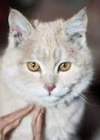
Can you write some sentences of your own using the word ‘and’ to join two clauses together?
French – Watch the video https://www.youtube.com/watch?v=fZR66TjjrDc. Sing the song and practise saying the different colours in French.

Friday
Maths – Practise your maths skills by playing some games on your Abacus account. There are lots to choose from! https://www.activelearnprimary.co.uk/login?c=0 (Log ins are in the children’s reading diaries and the school code is kmm7).
English – (SPAG) Practice your handwriting using the year 1 common exception words.
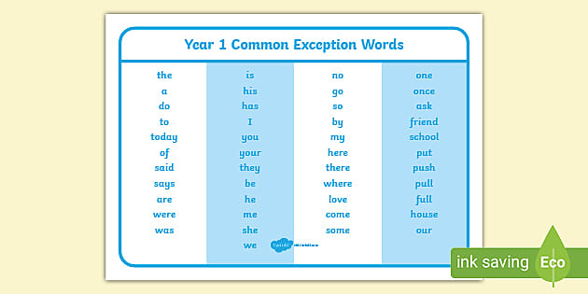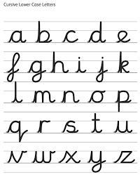
Daily
Abacus - https://www.activelearnprimary.co.uk/login?c=0 (Log ins are in the children’s reading diaries and the school code is kmm7).
Keep reading!
Read a magazine/newspaper article.
Arithmetic (20 minutes a day) – Count to 100 aloud whist doing body percussion, challenge yourself and now count in tens.
Phonics – Play a phonics phase 2 and 3 game on phonics play.
https://www.phonicsplay.co.uk/resources/phase/2/picnic-on-pluto

PE
Visit Youtube and do a session 5 times a week of Joe Wicks/Go Noodle/Cosmic Kids Yoga.

