Click on assignments on the left hand side.
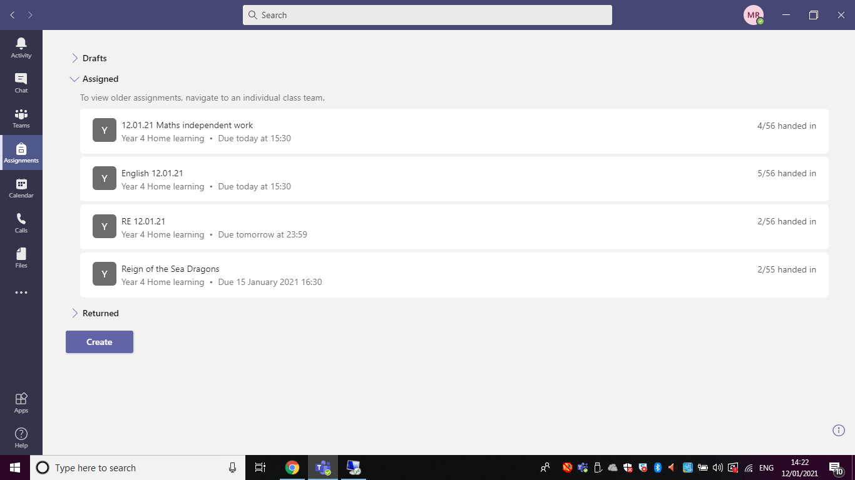

Click on the correct assignment
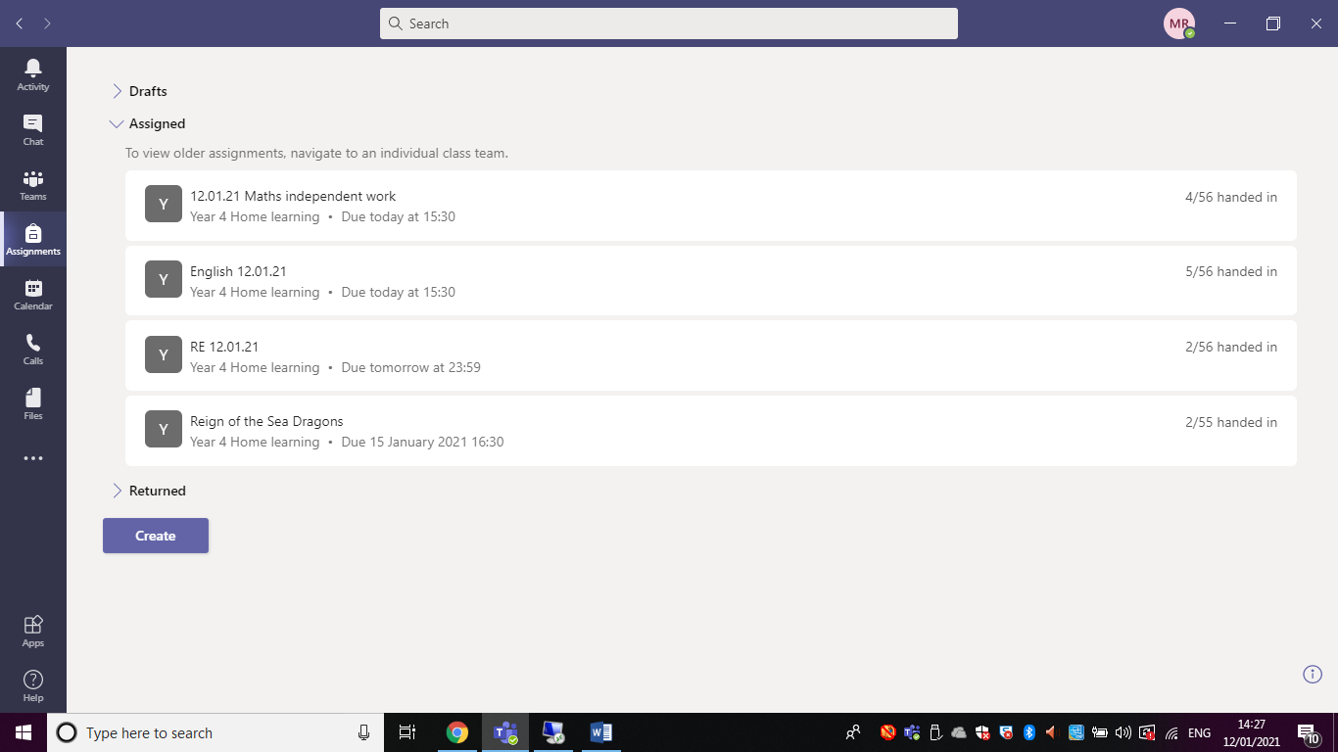

OR…..
Click on the channel.
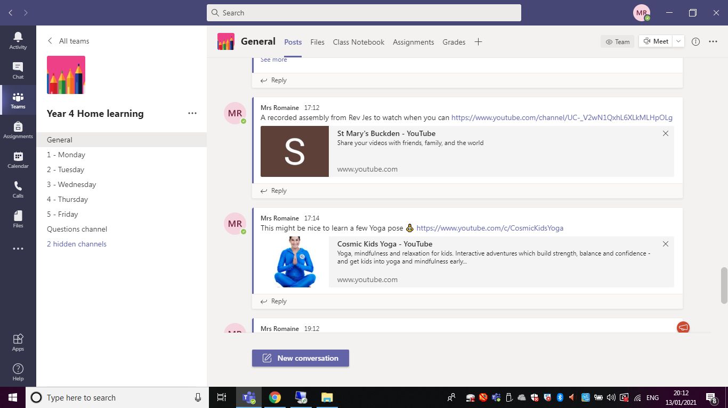

Open the assignment and
Add work

Add work or photo document from your files. Upload from device is at the bottom of the menu, this allows you to search your photos or documents.

Click the blue hand in button in the top right hand corner.
If you need to amend what you have submitted click on the three dots.

