Good Morning,

Today, Thursday 4th January is as follows:

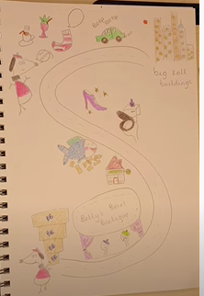
English-. Story map Claudes adventure
(https://www.youtube.com/watch?v=H_OhI7W7zhg a video of a storymap for Claude’s adventure in the city)
Now make your own storymap for Claude’s adventure to the hospital. Can you see a pattern to the stories? (Claude and Sir Bobblysock sneak off without Mr and Mrs Shin shoes knowing, something bad happens, Claude saved the day, they get back before Mr and Mrs Shiny Shoes)
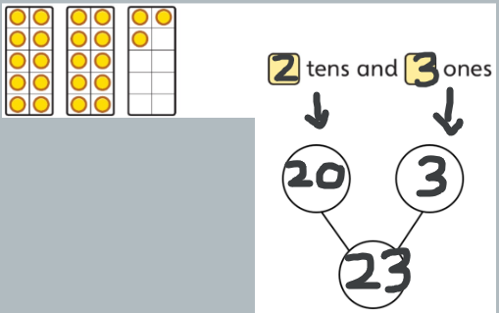
Maths- Representing numbers to 50
Children continue to represent numbers to 50 using a variety
of concrete materials. Children should continue to see the groups of tens and ones in each number to support their understanding of place value.
Fill in the part whole models on the sheet or complete Practice book pages 61-63

Phonics- Todays phonics is sound is igh/ie i i-ey.
Follow the link below and click on today’s date.
Thursday 4th February: Lesson 24 Review igh/ie i i-ey
https://lettersandsounds.org.uk/for-home/year-1
Please then complete one activity from the challenge sheet in the file section.
https://www.phonicsplay.co.uk/
username: jan21
password: home

Science- Seasonal changes
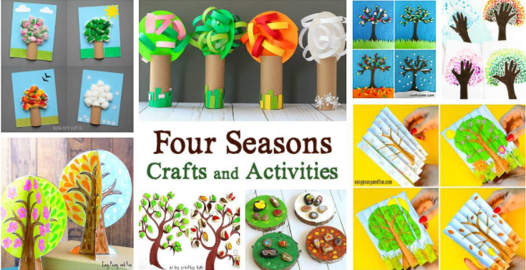
I am setting you a crafty science challenge this week. Can you make something that shows me the 4 seasons and what we are likely to see in each season. That could be animals, clothing we wear or the weather.

