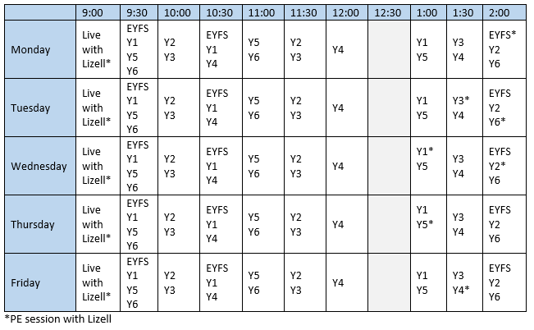

Day | 9.00 | 9.45 | 10.30 | 11.00 | 11.30 | 12.00 | 12.30 | 1.30
Monday | LIVE  PE with Lizell | Collective worship | LIVE  Maths lesson | Independent Maths work | Independent TT RockStars | LIVE  Maths marking and  English Lesson | Independent English work | Science
Tuesday | LIVE  PE with Lizell |  | LIVE  Maths lesson | Independent Maths work | Independent TT RockStars | LIVE  Maths marking and  English Lesson | Independent English work | RE
Wednesday | LIVE  PE with Lizell |  | LIVE  Maths lesson | Independent Maths work | Independent TT RockStars | LIVE  Maths marking and  English Lesson | Independent English work | Skills Builder
Thursday | LIVE  PE with Lizell |  | LIVE  Maths lesson | Independent Maths work | Independent TT RockStars | LIVE  Maths marking and  English Lesson | Independent English work | Global learning
Friday | LIVE  PE with Lizell | Collective worship | LIVE  Maths lesson | Independent Maths work | Independent TT RockStars | LIVE  Maths marking and  English Lesson | Independent English work | PE with Lizell

