This week’s learning 01.11.21
Monday
Maths – Oak Academy - follow the links and complete the activities. https://classroom.thenational.academy/lessons/counting-back-in-ones-to-subtract-6gu64r

English – Watch the clip of Little Red Riding Hood and act out the story using props from around your house. https://www.youtube.com/watch?v=LDMWJCrDVMI

RE – Think about what makes a good deed. Do a good deed for someone in your house and draw a picture and label it to show what good deed you did.
Tuesday
Maths – Oak Academy - follow the links and complete the activities.
https://classroom.thenational.academy/lessons/linking-subtraction-equations-to-problem-solving-contexts-cdjkgc

English – Write a letter to Grandma and warn her about the wolf.

Global Learning – Draw a picture of the road, some water and a railway track. Now draw and label the vehicles you would find in each area.

Wednesday
Maths – Oak Academy - follow the links and complete the activities.
https://classroom.thenational.academy/lessons/recognising-the-relationship-between-addition-and-subtraction-60tp4t

English – Write a description of the wolf. Remember to use and in your sentence.
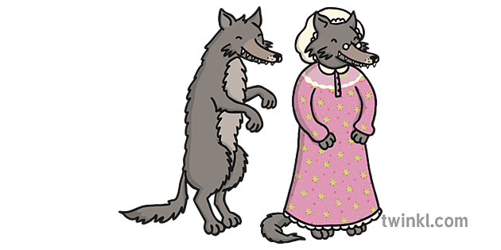
Science – Watch the clip about Materials.
https://www.bbc.co.uk/bitesize/topics/zrssgk7/articles/z9pgcdm
Complete the activities on the ‘Labelling Materials’ sheet attached.

Thursday
Maths – Oak Academy - follow the links and complete the activities.
https://classroom.thenational.academy/lessons/exploring-problems-involving-addition-and-subtraction-6dh68c

English – (Comprehension) Watch the Little Red Riding Hood clip again. Answer these questions - What was your favourite part and why? Would you like to meet a wolf like this? Where else could the wolf have hidden? How was Grandma feeling? How was the wolf feeling?

Draw a picture of your favourite part or another animal that might be in the story.

French – Have a conversation with someone in your house and say hello and goodbye in French. Bonjour and Au Revoir.

Friday
Maths – Oak Academy - follow the links and complete the activities.
https://classroom.thenational.academy/lessons/exploring-further-problems-involving-addition-and-subtraction-6cv64d

English – (SPAG) Practice your handwriting using the year 1 common exception words.
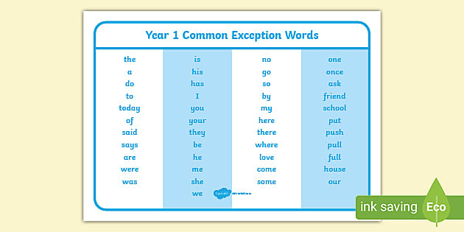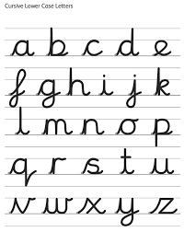

Daily
Abacus - https://www.activelearnprimary.co.uk/login?c=0 (Log ins are in the children’s reading diaries and the school code is kmm7).
Keep reading!
Read a magazine/newspaper article.
Arithmetic (20 minutes a day) – Count to 100 aloud whist doing body percussion, challenge yourself and now count in tens.
Phonics – Play a phonics phase 2 and 3 game on phonics play.
https://www.phonicsplay.co.uk/resources/phase/2/picnic-on-pluto

PE

Visit youtube and do a session 5 times a week of Joe Wicks/Go Noddle/Cosmic Kids Yoga.

