This week’s learning 24.01.22
Please return any work that you complete back to school.
Monday
English – https://classroom.thenational.academy/lessons/to-engage-with-a-text-6tj3jd
Maths – https://classroom.thenational.academy/lessons/understanding-percentage-6gvpad
PSHE – Find out how alcohol passes into your blood stream and how it affects your main organs.
Tuesday
Maths – https://classroom.thenational.academy/lessons/percentage-as-a-fraction-and-decimal-6mrk0r
English – https://classroom.thenational.academy/lessons/to-explore-the-function-of-apostrophes-6xj66d
RE – Today we are thinking about forgiveness. Think about this statement - All crimes should be forgiven? Write an argument for or against this statement.
Wednesday
Maths – https://classroom.thenational.academy/lessons/understanding-percent-in-the-world-70uk0e
English – https://classroom.thenational.academy/lessons/to-explore-the-functions-of-a-colon-c5hkjd
Art – Here are some images of rivers that people have created. Can you create your own image of a river using the images below as inspiration.
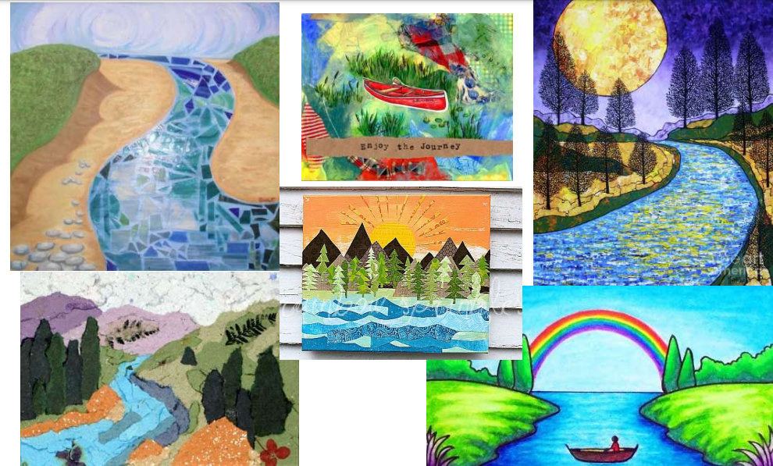

Thursday
Maths – https://classroom.thenational.academy/lessons/finding-percent-of-a-quantity-6xh36d
English – https://classroom.thenational.academy/lessons/to-explore-prepositions-6wwkcd
Global Learning- Geography – There is a lot of discussion in the news about pollution in our rivers, both at home and across the world. Find some articles of interest to you and summarise what you learn from them. Can you come up with a suggestion to help prevent river pollution?

Friday
Maths – https://classroom.thenational.academy/lessons/finding-percent-of-a-quantity-problem-solving-c9h38d
English – https://classroom.thenational.academy/lessons/to-analyse-the-authors-use-of-colour-c4rkgc
Science – Go in to your garden and collect some mud, stones, grass, and put them into a bottle from your recycling, make sure these items come to about half way up your bottle. Then fill to the top with water. Give it a good shake and you have created some rather dirty water……. Now, filter that water to make it as clean as possible, use items in your home to help.

Daily
Log into SATs Companion and do any practise session.
TT Rockstars: https://ttrockstars.com/
Keep reading – at least 20 minutes every day. As well as your reading books try to look at a newspaper/magazine article, recipe or non-fiction book.

PE
Visit YouTube and do a session of Joe Wicks.

French
Use Linguascope to learn the names for different family members in French.

