Week beg: 13.03.23
This week we have had a great week in Science. We have written posters to demonstrate our knowledge on friction.
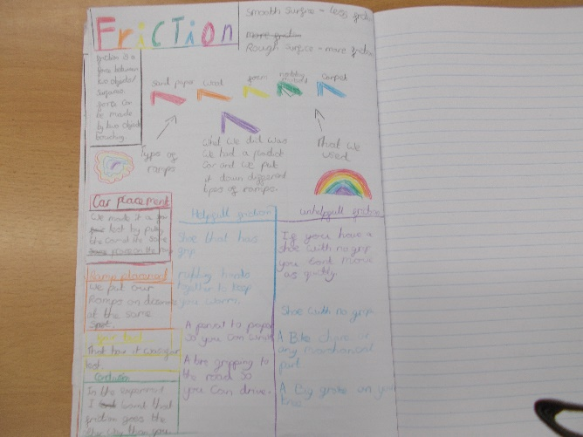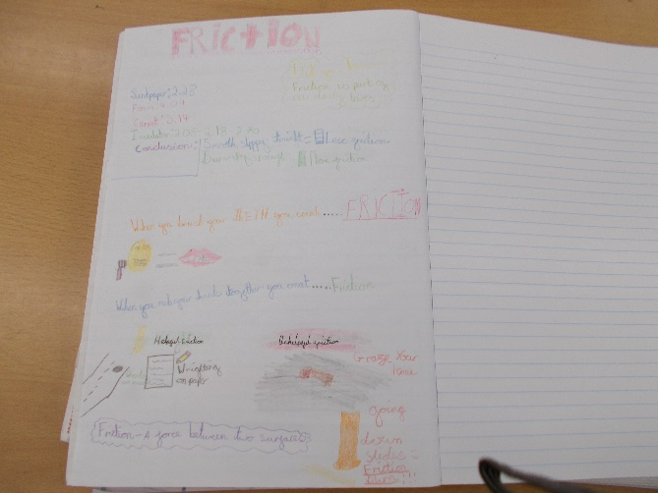

We also conducted an experiment to see whether the surface area of a parachute impacted the rate of descent. We are yet to pull the data together and draw conclusions.
In English, we performed an extract from the text we are reading. We thought about tone, volume, repetition and action and how this can influence the way we perceive the action. The children did a great job and were very kind and thoughtful to one another in their feedback.
Isla has enjoyed Maths, she likes to challenge herself and learn new strategies and concepts.
In Computing, Jonathan enjoyed creating a persuasive advert online to try to convince the public that his city is sustainable and worth visiting. All pupils looked like they were really enjoying the process.
In Art, the pupils have been designing their sustainable buildings both in 2D and 3D. This week, they will also choose a winning design to move forward with and build.
We hope you have a restful weekend.

Bluebell Class

