Week beg: 30.01.23
This week we have been very hands on. We have had lots of practical projects, including setting up our science projects. We have been testing to see whether a salt solution is a reversible or irreversible change. We are starting to see results and, as such, are able to draw conclusions from this.
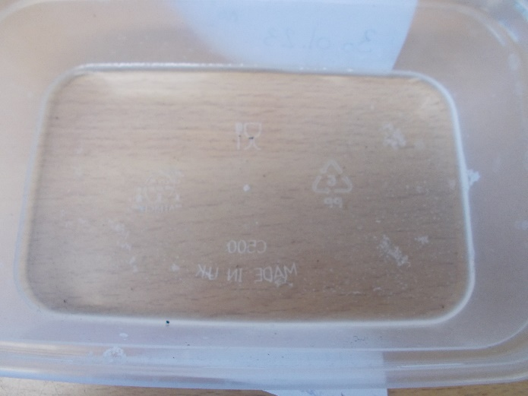

Already, we have observed that salt crystals are starting to form in our solution and are starting to see that water evaporation is occurring.
In DT, we have been practising creating levers and sliders in order to complete our final design. We are very proud of our work and are looking forward to sharing them with Year 3.
In Computing. We continued with spreadsheets and the pupils have learnt about cell addresses. They had great fun creating codes for pupils to follow and see if they created the right image.
We hope you have a lovely weekend.

Bluebell class

