This week’s learning 4.1.22
Tuesday
Maths – Recognising 3D shapes.
Watch the video link https://vimeo.com/476287832
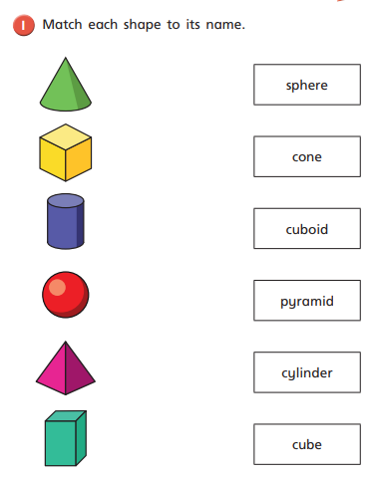
Draw/copy each shapes onto a piece of paper and write the correct name next to each of them.
English – Sorting Nouns and Adjectives
Watch the video https://www.youtube.com/watch?v=IT-G4c2-CHU all about adjectives and the video https://www.youtube.com/watch?v=PsMfMFJsSe0 all about nouns.
Can you tell us what a noun and an adjective are?
Look at the list of words below. Can you sort them into nouns and adjectives? Write them on the worksheet attached ‘Tuesday Noun and Adjective Sort’ or write them on your own piece of paper.
teacher school pretty lovely school
bumpy round pencil clock weird
wacky cool rubber green ring
dry sad beard hair brown

RE
Who created the world?
Watch the video of the Story of Creation https://www.youtube.com/watch?v=teu7BCZTgDs
Think about why it is important that we look after Gods Creation, our world.
Write a list of 10 rules to tell us how to look after our world.
Wednesday
Maths – Sorting 3D shapes.
Watch the video link https://vimeo.com/477200613
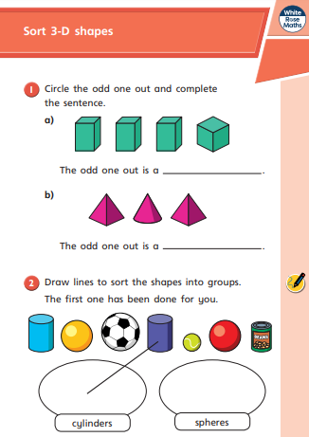
Complete the sheet attached ‘Wednesday Sorting 3D shapes’.
Challenge: Find a range of objects around the house that are different 3D shapes, i.e. a toilet roll tube, a dice, a ball, a cardboard box. Can you sort them in different ways? Think about colours, sides, shapes, faces. Don’t forget to take photographs of your sorting!
English – Writing adjectives to describe a noun
Look at the pictures below. What are they? These are the nouns.
Cut out the pictures and write what the noun (name) underneath.
Use some amazing adjectives to describe each of the nouns you have stuck down. You can write them as words or you can write some super sentences to describe the nouns.
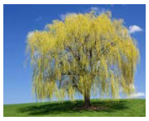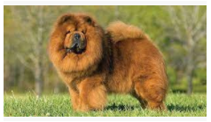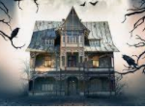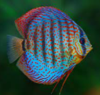
Global Learning – The UK.
Use Google Maps to look closely at the United Kingdom. Can you identify the four countries that make up the UK? Complete the ‘Wednesday Global Build the UK’ activity sheet to cut out the four countries of the UK and stick them down on the blank map. If you don’t have access to the sheets or a printer, have a go at drawing your own map of the UK and label the four countries that make up the United Kingdom. Don’t forget to use Capital Letters for the names of the Countries.
Thursday
Maths – Recognising and naming 2D shapes.
Watch the video link https://vimeo.com/476288716
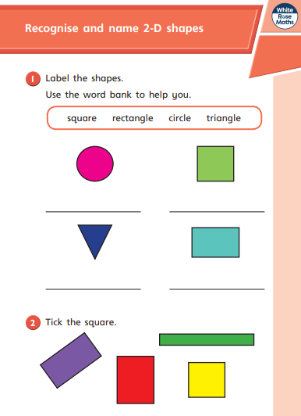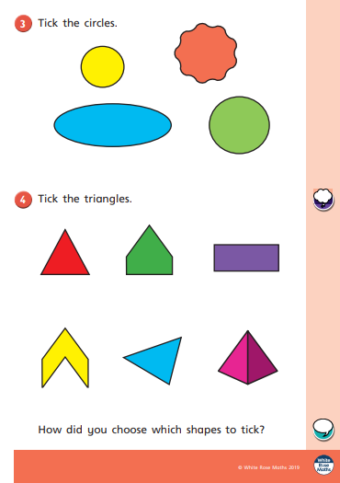
Complete the sheet as well as the sheet attached ‘Thursday Recognising 2D shapes’.
English – Draw an animal of your choice.
Label all of the nouns you can see – the animals different body parts. Use the ‘Thursday Animal word mat’ attached to help you think of the different parts and to support your spelling.
Now you need to think of some adjectives to describe the animals body parts! Think about what the parts look like, their colour, their size, what they might feel like, etc.
For example:
Long stripy tail
Big round eyes
Fluffy Brown Mane
Thick black hooves
French – Watch the video https://www.youtube.com/watch?v=lsc3qLMaCu8 about counting from 1-10 in French.
Practise counting in French out loud. Can you tell your adults how to count from 1-10 in French? Can you say your age in French?
Friday
Maths – Practise your maths skills by playing some games on your Abacus account. There are lots to choose from! https://www.activelearnprimary.co.uk/login?c=0 (Log ins are in the children’s reading diaries and the school code is kmm7).
English – (SPAG) Practice your handwriting using the year 1 common exception words. Don’t forget to use your cursive letter formation!
PE – Perform the transport dance that we have been learning about in our Dance lesson. Follow the link to see the dance: https://www.youtube.com/watch?v=fGEyttZb5Qk
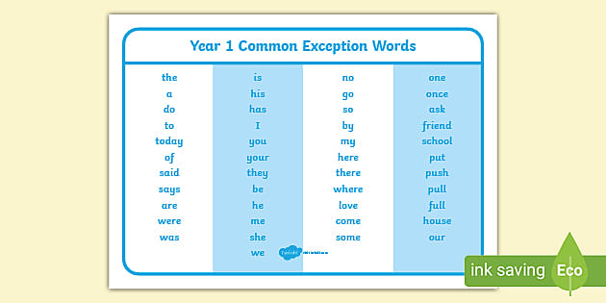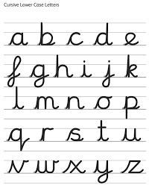
Daily
Abacus - https://www.activelearnprimary.co.uk/login?c=0 (Log ins are in the children’s reading diaries and the school code is kmm7).
Daily reading! Please record this in your child’s reading record.
Arithmetic (20 minutes a day) – Count in 1s to 20 forwards and backwards. Count in 10s to 100 forwards and backwards. Count in 2s to 20 – practise counting in these jumps lots as they can be tricky!
Phonics – Revise all phase 2, 3 and 5 sounds so far.
Can they read each sound? Can they write each sound when you say them out loud?
s a t p i n m d g o c k ck f
h b l r u e ff ll ss

j v w x y z zz ch sh th qu ng ai ee
igh oa oo ow oi ar or ur air ear ure er

ou ay ea i-e ir ew ue

Play some phonics games including some of these sounds.
https://www.phonicsplay.co.uk/resources/phase/2/picnic-on-pluto

PE
Visit Youtube and do a session 5 times a week of Joe Wicks/Go Noodle/Cosmic Kids Yoga.

Handing in Home Learning

PLEASE SEND EVIDENCE OF YOUR HOME LEARNING TO THE YEAR 1 EMAIL ADDRESS year1@buckdenacademy.org
You may also choose to send your child into school with their home learning when they come back.
All home learning will be marked/responded to by a member of the Year 1 team.

Thank you for your hard work at this very tricky time!
Year 1 Team

