This week’s learning 17.09.21

Monday
Maths – Oak Academy - lesson 11
https://classroom.thenational.academy/lessons/practising-finding-one-more-and-one-fewer-and-ten-more-and-ten-fewer-6rukje
English – Imagine you are in a forest or think back to a time you were in a forest yourself. Watch this video or find pictures of forests to help you imagine. Think about your five senses. Make a list of all the things you can see, hear, taste, smell and feel.
https://www.youtube.com/watch?v=uEMmpJgaXvo
PSHE – What makes a good neighbour? Draw a picture of how you could be a good neighbour.

Tuesday
Maths – Oak Academy - lesson 12 https://classroom.thenational.academy/lessons/identifying-number-patterns-75jk8r
English – Capital letters and full stops. Identify where capital letters and full stops should be in these sentences, then write them in your neatest handwriting with the correct punctuation.
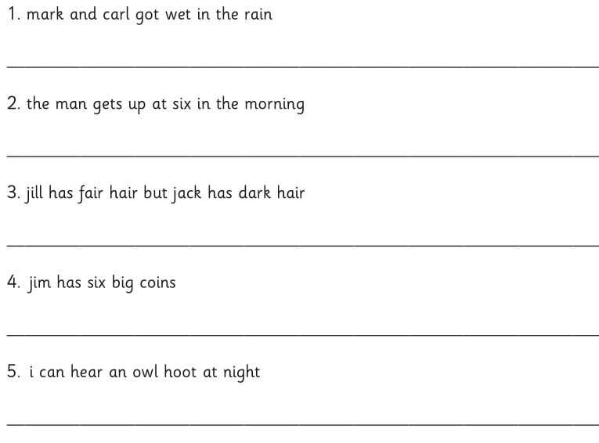

Global Learning – We have been thinking about why trees are important. Look out of your window or sit in your garden and draw what you can see. Label whether the things you see are alive, never alive or dead. Challenge: Do you know what these things provide us? E.g. wood/paper.

Wednesday
Maths – Oak Academy - lesson 15
https://classroom.thenational.academy/lessons/revisiting-numbers-within-100-64v30c
English – Use your word bank you created on Monday to write five expanded noun phrases to describe the forest. Remember, an expanded noun phrase includes adjective, adjective noun. The tall, green trees were endless.
Science – Living and non-living things
Complete this game identifying living and non-living things. How do you know they are living? What do all living things need to survive?
https://www.turacogames.com/games/living-non-living/

Thursday
Maths – Oak Academy - End of unit quiz https://classroom.thenational.academy/units/numbers-within-100-9ce3/quiz
English – Now we have read Little Red Riding Hood, can you order the events in the story? If you need reminding of the story, refer to the second link.
https://teach.files.bbci.co.uk/schoolradio/english/little_red_riding_hood/sequencing_activity.pdf
https://www.bbc.co.uk/teach/class-clips-video/english-ks1-little-red-riding-hood-index/zmnrqp3
French- Practise numbers 1-31 in French use this video to help you. Moving your learning forwards from last week, collect some items (buttons, pasta, pencils, for example) can you count how many items you have only counting in French? https://www.youtube.com/watch?v=DnrTrbJ6mYs

Friday
Maths – Comparing two digit numbers revision. Use this interactive dienes builder to create number sentences using < > =. Listen to the song again to help you remember which symbol to use. For example you could write or use dienes to show 34<56. Challenge: Can you compare three numbers? 56<65=65
https://apps.mathlearningcenter.org/number-pieces/
https://www.youtube.com/watch?v=ka9zbPcqXBI
English – Watch newsround. What are the current headlines? Can you make a poster of what you have learnt about events happening around the world today? Discuss and share these with your family and friends. https://www.bbc.co.uk/newsround

R.E. – Can you recall what happens on days 1-7 in the Creation story? If you can’t remember them all use this link to help you. Can you draw a picture for each day to represent each creation? https://www.youtube.com/watch?v=qsQHClXz6VA

Daily
Keep reading!
Read a magazine/newspaper article.
Arithmetic (20 minutes a day) – Count in 2s 5s and 10s
Phonics – Play a phonics phase 3 and 5 game on phonics play.
https://www.phonicsplay.co.uk/resources/phase/3

Times Tables – practise your times tables as much as you can!
Useful websites for times tables:
https://www.topmarks.co.uk/maths-games/7-11-years/times-tables
https://www.timestables.co.uk/

PE

Visit youtube and do a session 5 times a week of Joe Wicks/Go Noddle/Cosmic Kids Yoga.

THIS WEEK IS GREEN WEEK!
https://greatbiggreenweek.com/
What does green week mean to you? How could you support climate change?

Choose an activity from here, have fun and be green!

https://www.busythings.co.uk/climate-change/activity-ideas

