This week’s learning:

Collective Worship
LOGON TO MICROSOFT TEAMS AT 9:30-9:45am ON TUESDAY AND FRIDAY FOR CLASS ASSEMBLIES

Mathematics
This week we are learning about multiplication starting with making equal groups, multiplication as equal groups and then adding equal groups and using arrays. Then we will use what we have learnt to practise our 2, 5 and 10 times tables.

LOGON TO MICROSOFT TEAMS AT 10:00 DAILY FOR A LIVE MATHS LESSON
You can use Abacus (Power Maths) and the Whiterose website with this week’s learning objective as a focus for learning all free of charge.
Whiterose - https://whiterosemaths.com/homelearning/year-2/
Abacus - https://www.activelearnprimary.co.uk
The children have their own log in details and the school code is kmm7 in the bottom box.
On Abacus your child has been assigned the Power Maths Textbook and Workbook that we use in school
This week in school we will be working on Textbook A Unit 5 Multiplication lessons 1-10. The textbook has explanations and examples and the workbook has questions to practise multiplication skills.
Live lesson 7.1.21 accompanying questions Workbook 2A Unit 5 lesson 2 p137
Live lesson 8.1.21 accompanying questions Workbook 2A Unit 5 lesson 3 p140

Times Table Rock Star – practise your times tables as much as you can!
https://play.ttrockstars.com/auth/school/student/76329
Other useful websites for times tables:
https://www.topmarks.co.uk/maths-games/7-11-years/times-tables
https://www.timestables.co.uk/

Revision
Number and Place Value
- To read and write numbers to 100 in words and numerals.
- To find the next multiple of 10 from a given number.
- To find 10 more and 10 less than a given number.
- To find multiples of 10 more and less than a given number.
- To practise recall of number bonds to 10 and 20 mentally i.e. 6 + 4, 5 + 5, 16 + 4, 15 + 5
- To practise recall of number facts to 10 mentally i.e. 6 = 4 + 2, 3 + 3, 5 + 1.
English
LOGON TO MICROSOFT TEAMS AT 11:30 DAILY FOR A LIVE ENGLISH LESSON
This week we are starting a new book called The Lonely Beast by Chris Judge.
There are versions that you can listen to online here: PLEASE DON’T READ IT ALL YET. WE REVEAL A PAGE AT A TIME.
https://www.youtube.com/watch?v=hibEHyuYYrs
https://www.youtube.com/watch?v=UdYxM7JCFpg

Lesson 1
Look at the picture when the Beast arrives at the city.
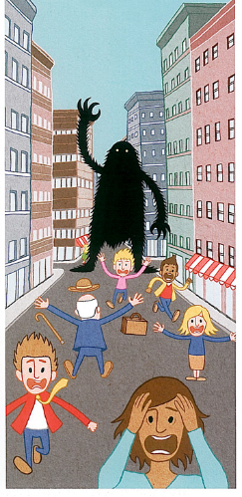
Write about how the people are reacting and what they are thinking when they see the Beast
What is happening in this scene? - Why are the people running away? How are they feeling? What might they be saying? - If the character was speaking what might it be saying? - Where did it come from? What will it do next?

Lesson 2
We are going to be reading a story about this Beast.
What sort of story are you expecting? Why? - What do you think this story might be about? - What sort of creature is this? - Do you know any other monsters like this?
Watch this trailer (https://www.youtube.com/watch?v=WRzshxnjeXI),
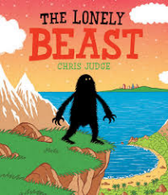
What do you think now? Have your ideas about the story changed? Why? Why not? - What do you think it is doing? Where is it going? Where has it come from? - Does it remind you of anything?
Look at the front cover of the book
What does it mean to be lonely? - Why do you think he is lonely? - Why is he standing at the cliff’s edge? What can he see? - What is he thinking about?

Lesson 3 Grammar
Expanded noun phrases.
First draw a picture of the Beast. Then think of 7 nouns the Beast has e.g. fur, eyes, body etc. Then expand each noun with an adjective e.g. black, rough fur. Label your diagram.
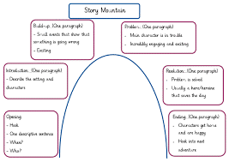
Lessons 4 and 5
Read the whole story. Discuss the main events and map them on a story mountain. Can you retell the story using your story mountain?

Lesson 6
Re-read the underwater section of the Beast’s journey to the city from ‘He jumped in and started to swim…’ until ‘Just when he could swim no more, he hitched a lift from a friendly whale.’ Talk about the sea creatures that the Beast encounters on this leg of his journey and imagine the way in which they move in the water.
• Watch Michael Rosen perform ‘ The Jellyfish’ on Poetryline https://clpe.org.uk/poetryline/poems/jellyfish-0
Can you read the poem?

Lesson 7
Watch footage of jellyfish (http://www.youtube.com/watch?v=aJUuotjE3u8) eliciting descriptive words and phrases that come to mind: - What do they look like? - How do they move? - They remind Michael Rosen of polythene bags or that they could be waving frilly underwear. What do they remind you of? Pretend to be a jellyfish think carefully about how you are moving.
Now find some chalk, felt tip pens or paints and draw a picture to express the way the jelly fish move.

Lesson 8
Think of words and phrases to describe the jellyfish underwater and write them on strips of paper. Put the strips together to form a poem, rearranging re-arranging the order as you read until it ‘sounds’ good.

Lesson 9
Write some sentences using the conjunctions to describe anything that has happened so far in the book.
e.g. The Lonely Beast was lonely because he lived on his own. In the sea the Lonely Beast saw some jellyfish that he loved because they are a lovely colour. The Lonely Beast went on a long journey but he didn’t get tired as I would.

Lesson 10
Write a character description describing the Beast. Remember to describe what he looks like (his appearance) and what he is like (his character).

SPAG - https://www.topmarks.co.uk/english-games/7-11-years/spelling-and-grammar
- Read and spell the Year 1 Common Exception Words
- Read the Year 2 Common Exception Words
- Spell the Year 2 Common Exception Words
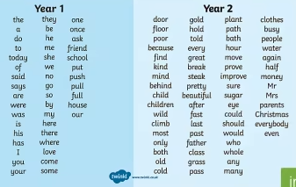
Practise a few at a time, little and often. Remember – Look, Cover, Write, Check! Make your learning as active as you can, use chalks outside, lots of colour pencils, make the words in playdough or write letters on beans and use those to spell the words.
Nessy – Reading and Spelling practise https://www.nessy.com/uk/

Phonics/Reading
Revise all phase 3 and phase 5 sounds
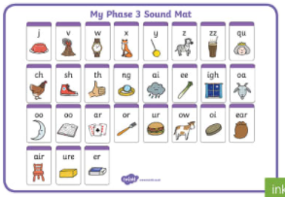 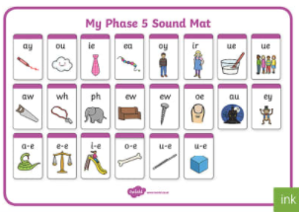
We have been looking at sound buttoning lots of ‘real’ and ‘alien’ words using these sounds, such as queek, splain, screet, scratch, train, etc. We have been spotting the digraphs and trigraphs in lots of words to help with blending and reading new and unfamiliar words correctly.
There are some apps which you may find useful to recap and practise the above sounds.
- Cambugs app (first one is free)
- Reading Eggs https://readingeggs.co.uk/ has many phonics games
Remember to read EVERYDAY.
When you read with your adult(s) at night, get them to ask you questions about the characters, the setting and the plot of the stories!
i.e. Can you describe the main character? What has just happened in the story? Where is the story set? What’s it like there? How does the character feel about what has happened? What do you think might happen next?
Here is a really useful website which offers lots of our banded books to read online, and is free to sign up! www.oxfordowl.co.uk

Global learning (Geography, History, DT, Art, R.E or P.E.)

LOGON TO MICROSOFT TEAMS AT 2:00 DAILY FOR A LIVE GLOBAL LESSON
This week we are starting our new Global Learning topic: Clean Water and Sanitation.
- Where on Earth can you find water?
Lesson 1
- Make a mind map of all of the places that you can find water on our planet – think big!
Lesson 2
- Learn the Oceans of the World
Lesson 3
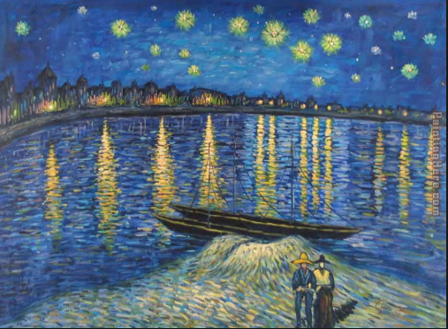
This is a famous painting by Van Gogh-
Do you like the painting. Write down everything that you like about the painting and reasons why you might not like it.

Lesson 4
Watch this clip https://www.youtube.com/watch?v=TWb4KlM2vts
Now can you draw and label a picture of the Water Cycle?
Lesson 5
Using Google Earth or a map if you have one, can you locate Grafham water.
This website https://parallel.co.uk/os-openmap-cyo/#13/52.29548/-0.2474
allows you to print a map, can you find Grafham Water and colour in all water in blue.
Lesson 6
Spend some time looking at our Geography Knowledge Organiser (attached to the Blog)
Do you know the meaning of the Key words and can you spell them.

Science
This week we are learning about the importance of hygeine.
Lesson 1
- Can you make a poster about how to wash your hands properly.
Lesson 2
-Watch this video on the Oak academy about a habitat.
https://classroom.thenational.academy/lessons/what-is-a-habitat-cmupat
Can you think about and describe a water habitat. Draw and label a picture.
Lesson 3
-Research an underwater food chain. To help you do this think about the animals and plants that live in a pond. Draw a diagram of your food chain.
Lesson 4
With an adult try to filter some muddy water using a selection of materials e.g. newspaper, cotton fabric, kitchen roll and some netting. Which material worked well and why?

P.E. (2 hours a week)

LIZELL IS RUNNING A LIVE SESSION AT 9-9:30 EACH MORNING
THE YEAR 2 LIVE LESSON EACH WEDNESDAY WILL BE P.E. WITH LIZELL

Or you try sessions of P.E. with Joe Wicks.
(I think he is running sessions on Mon, Wed and Fri starting 11th January)
https://www.youtube.com/c/TheBodyCoachTV/search?query=kids

Also try super movers to make sure you are keeping fit and active
https://www.bbc.co.uk/teach/supermovers/ks1-collection/zbr4scw

Mind Up https://mindup.org.uk/families/

Skills builder https://www.skillsbuilder.org/homelearning

Please take photos of any work you would like us to see and send to them to us at the year 2 email address Year2@buckdenacademy.org
or submit to your Microsoft class teams account.

