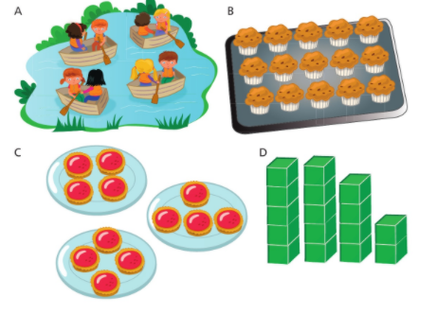
- Work out which groups are equal and which are unequal.

- Write these down as multiplication questions (remember about commutativity).

