he Money Maze

Age 7 to 11
Challenge Level
Go through the maze, collecting and losing your money as you go. You may not go through any cell more than once, and can only go into a cell through a gap, for example, you may not go from 5 to 6, or from 7 to 3.
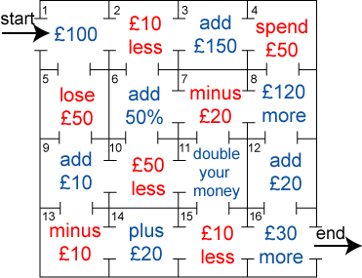
Which route gives you the highest return? How much is it?
Which route gives you the lowest return? How much is it?

Rosie went into the sweet shop with 50p to spend.
There were chews for 10p, mini eggs for 15p, Chocko bars for 25p and lollypops for 35p.
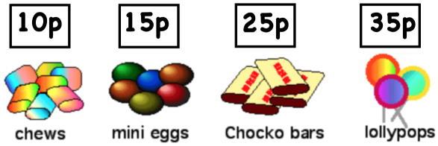
What could she buy if she wanted to spend all her money?
Alice, James, Katie and Henry went into the shop too. They each had 100p to spend and they all spent all of their money.
Alice bought at least one of each kind of sweet. Which one did she have two of?
James spent his money on just one kind of sweet, but he does not like chews. Which sweets did he buy?
Katie bought the same number of sweets as James but she had 3 different kinds. Which sweets did she buy?
Henry chose 8 sweets. What could he have bought?

