Home Learning- Year 2
If you are feeling well enough, please pick an activity from maths and English. Then choose one other lesson to enjoy each day. Please send some photos or bring any work you are able to complete back to school with you.

Maths
Monday-Friday
Log in to PowerMaths Active Learn (Log in details are in your Reading journal) https://www.activelearnprimary.com.au/login?e=-1&c=0
Click on Resources>PowerMaths on the green banner, click on year 2 and under TYPE choose Textbook 2B for explanations and Workbook 2B for questions.
Work through the following lessons covering 2D and 3D shapes.
PowerMaths
Textbook 2B Unit 9 lessons 1-5 pp. 102-123
Workbook 2B Unit 9 lesson5 1-5 pp. 75-89

English
Monday
Reread Rapunzel by Bethan Woollvin or watch it here https://www.youtube.com/watch?v=12OPa2hL914
What are potions? Can you describe what a spell is?
Watch ‘A witches spell’ poem https://www.youtube.com/watch?v=wKNHUMCo-h0 or read it here:
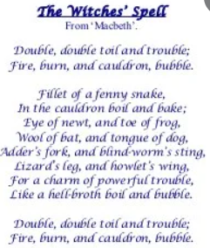
What do you notice?

Tuesday
What is rhyme?
Watch this video. https://www.bbc.co.uk/bitesize/topics/zjhhvcw/articles/zqjgrdm
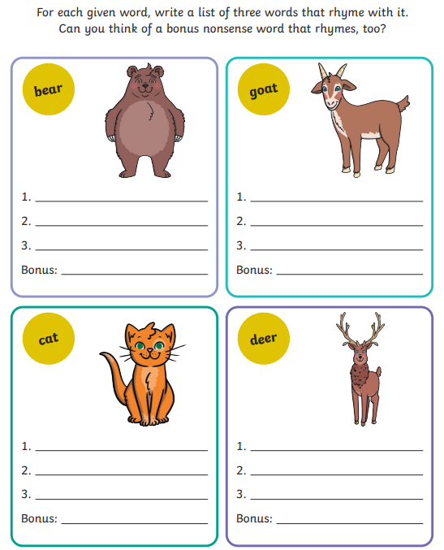

Go into the garden or ask your parents to make a potion together. As you add ingredients, see if you can think of a rhyming word for each. You will need to use your imagination!
Try to use sentence starters like:
A sprinkle of ……
A dash of…..
A spoonful of….
E.g. A sprinkle of fun and a dash of sun.

Thursday
Today you will write your own poem about a potion or spell. Start by thinking about what adjectives and rhyming pairs you may use. You can use your ideas from yesterday or have a go using one of these templates. 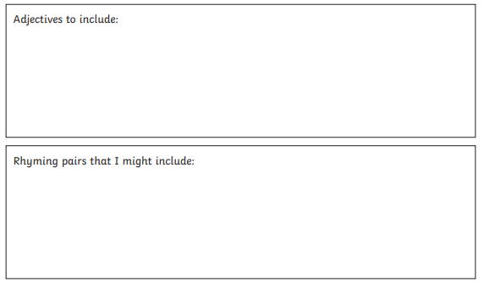
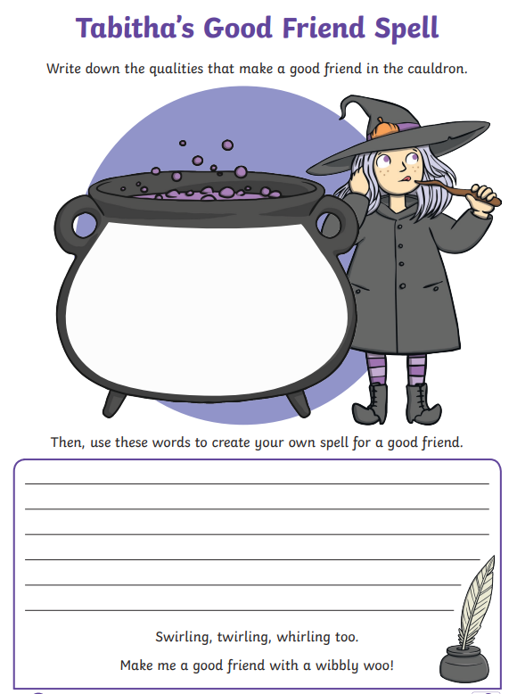

Friday
Exclamation Marks:
https://www.bbc.co.uk/bitesize/topics/z8x6cj6/articles/z3dcmsg
Complete worksheet below.
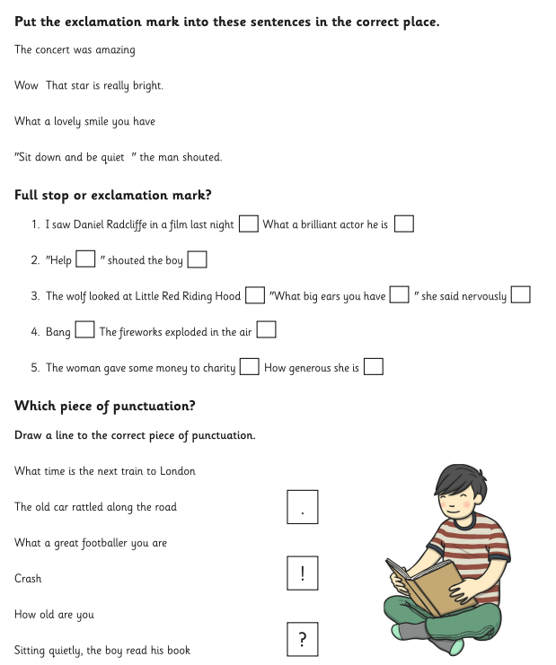

Other activities that you can choose from:
Grammar, Punctuation and Spelling:
https://www.bbc.co.uk/bitesize/topics/zkxxsbk
https://www.topmarks.co.uk/english-games/5-7-years/letters-and-sounds
https://spellingframe.co.uk/
https://sentenceplay.co.uk/games/dropping-in
Text Types/Genres:
https://classroom.thenational.academy/subjects-by-key-stage/key-stage-1/subjects/english
Wednesday Topic day
DT: Today we are going to make a wooden frame for our self-portraits. In school, we will be gluing together wooden lollipop sticks to form a frame. Later in the year, we will be doing this with natural resources, you are welcome to try this at home!
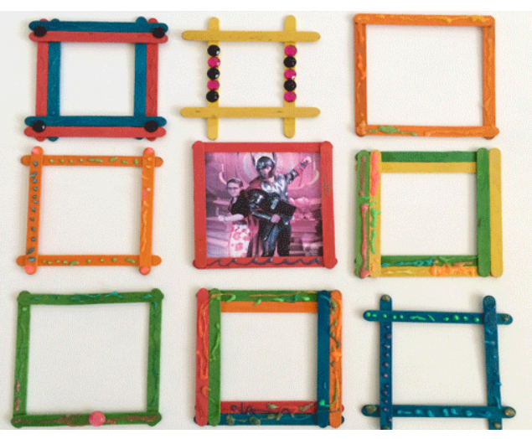
Computing:
Using https://www.j2e.com/j2code/
Lesson 1- Make a rocket land on a planet

Tuesday P.E
We will be learning more gym movements which is hard to do at home.
Do some warm ups (with an adult) to stretch your muscles and get your heart pumping.
Then, to ensure you get some exercise visit YouTube and do a session 5 times a week of Joe Wicks/Go Noddle/Cosmic Kids Yoga.

Thursday- Science
Look through some photos of when you were younger. Ask your parents to tell you all about how you grew up. When did you start walking, talking, writing? Use the sheet attached to learn how babies grow into adults.

Friday - RE
Think about how at Easter Christians remember the importance of forgiveness. Christians believe God will forgive their sins and that they should follow Jesus' example and forgive others.
Write a little poem or prayer about forgiving somebody who did something wrong to you.
Can you answer the question- Why is Easter so important to Christians?

Daily
Keep reading!
Read a magazine/newspaper article.
Arithmetic (20 minutes a day) – Count in 2s 5s and 10s
Watch Newsround
Phonics – Play a phonics phase 3 and 5 game on phonics play.
https://www.phonicsplay.co.uk/resources/phase/3

Times Tables – practise your times tables as much as you can!
Useful websites for times tables:
https://www.topmarks.co.uk/maths-games/7-11-years/times-tables
https://www.timestables.co.uk/

French
Use the powerpoint attached to learn the school subjects in French
- Practise numbers 1-31 in French. Have a go playing these games and familiarising yourself with the spelling/reading of the words. You can play interactive games, watch videos or create posters/flashcards to help you.
https://wordwall.net/resource/3027772/french/french-numbers-1-30
https://www.bbc.co.uk/bitesize/topics/zpy8q6f/resources/1
- Revise months of the year in French
- Revise colours in French
https://www.youtube.com/watch?v=acvUtipaC5Y

