Year 3 – Assignment Crib Sheet
There are two ways to access assignments.

Find the day you need to do work for.

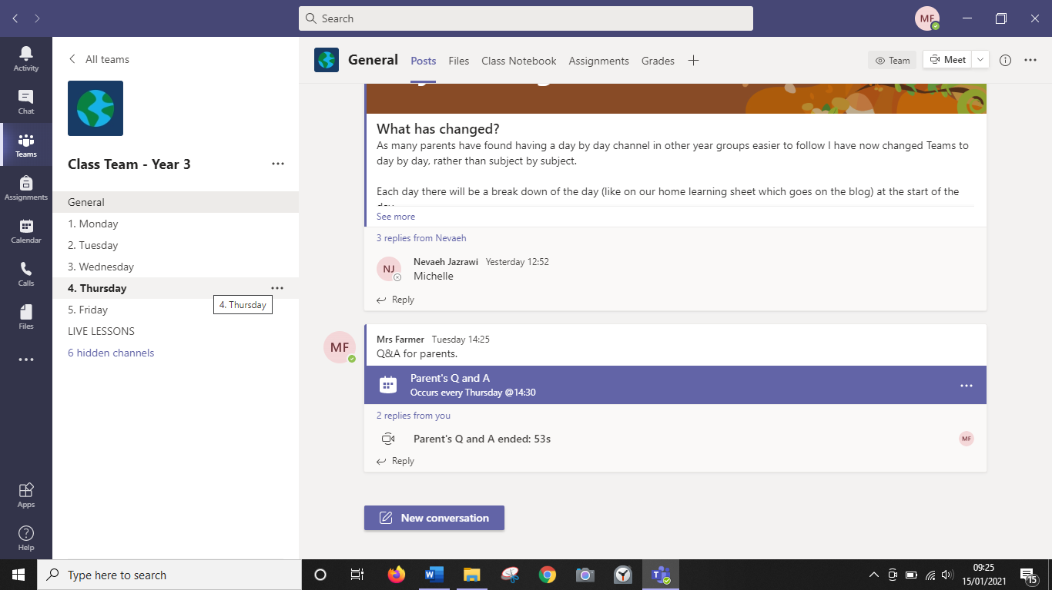
Look in the channel posts for the assignment.
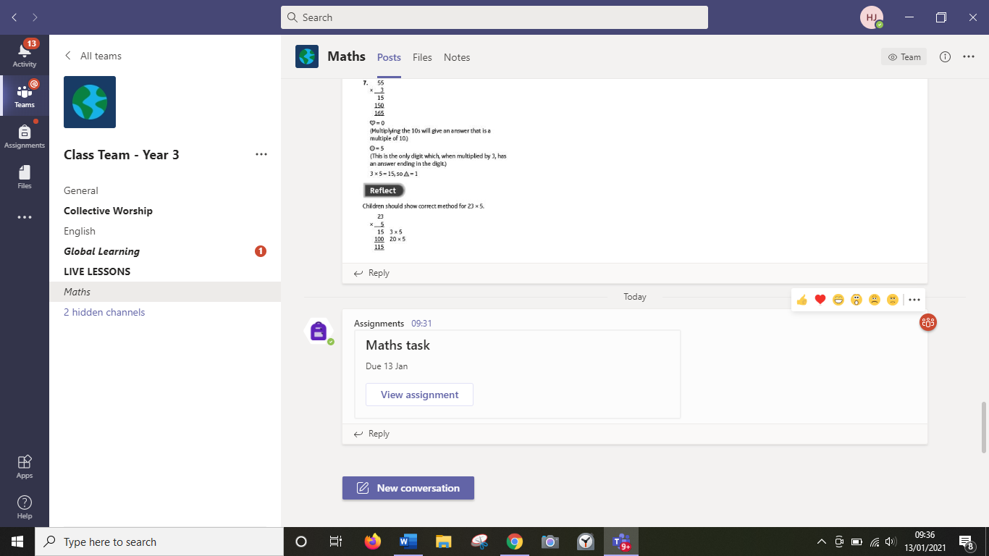
Click on it to open it. Then click on the work attached, if there is any, to view it.
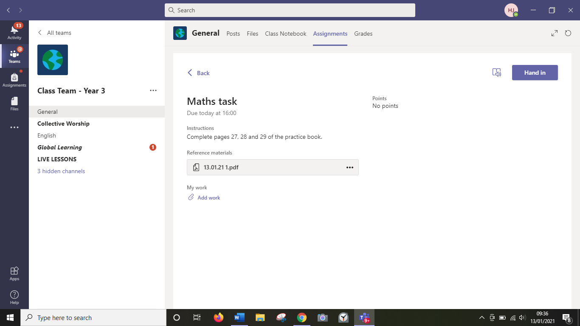

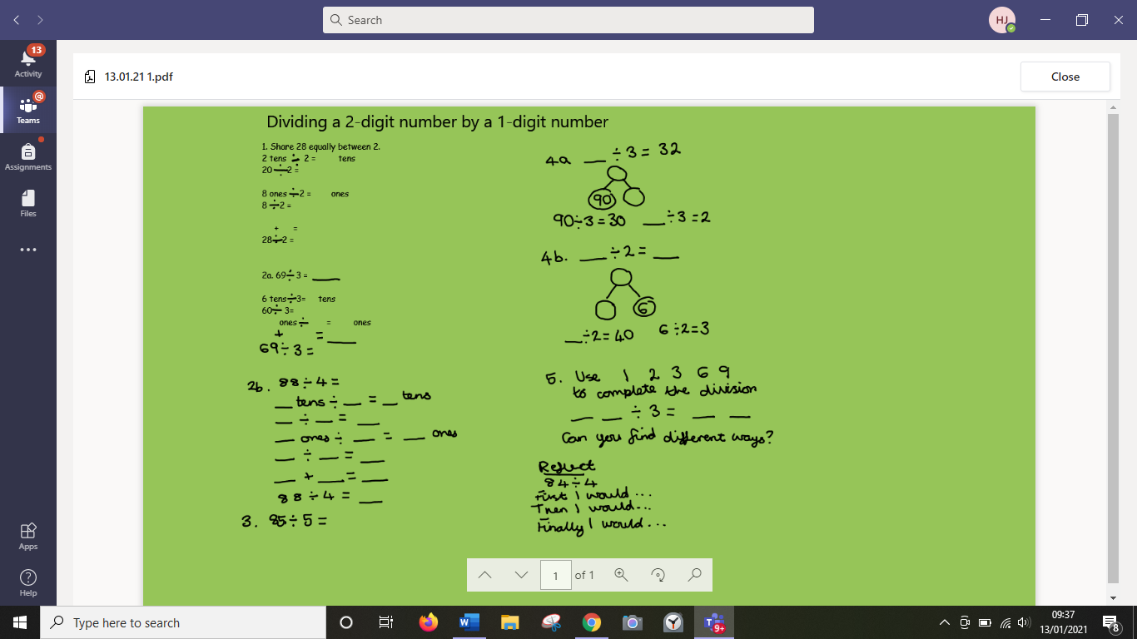

You can add your own work by clicking add work.
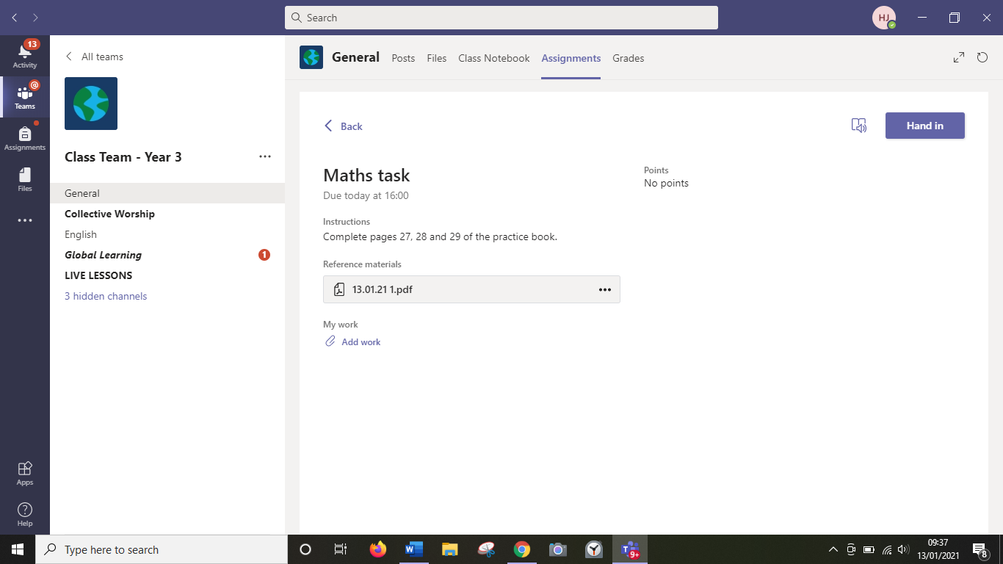
Click new file to make a new document.
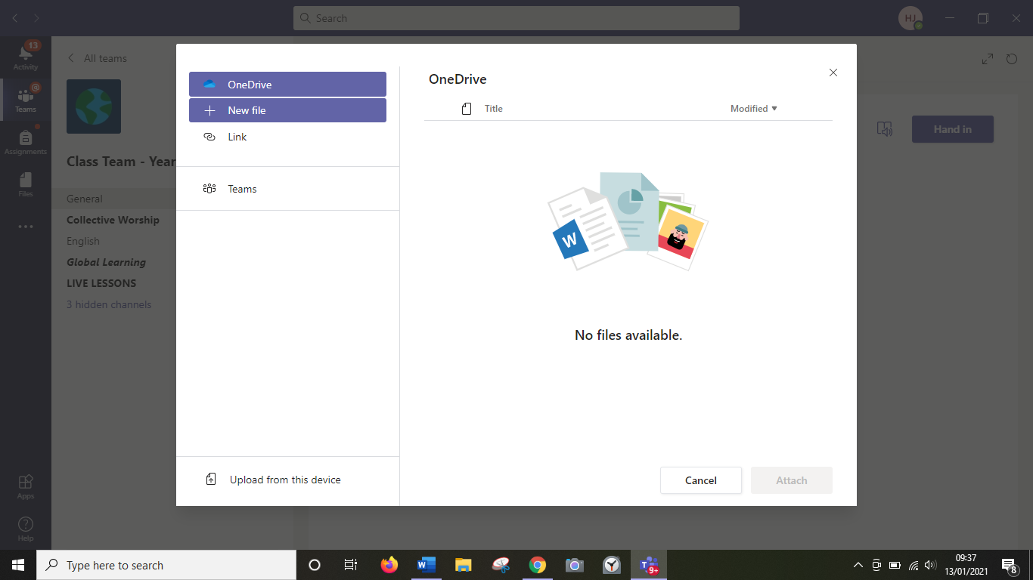

Choose the type of document you want to make.
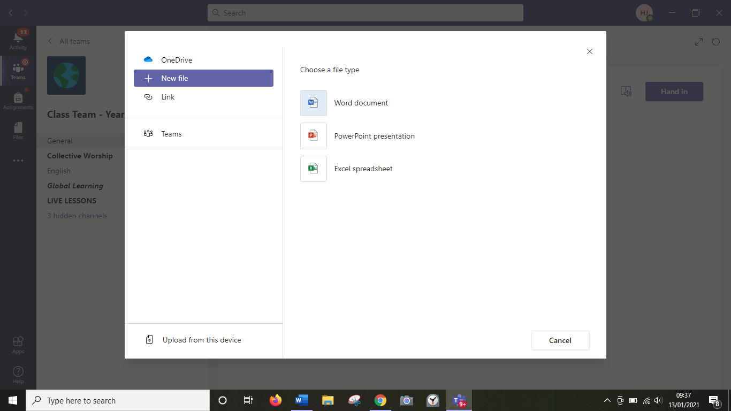
When you have finished, click the hand in button.

At the side bar this a tab called assignments. Click on this. Here you can your assigned work and completed work.
To complete work follow the steps above.
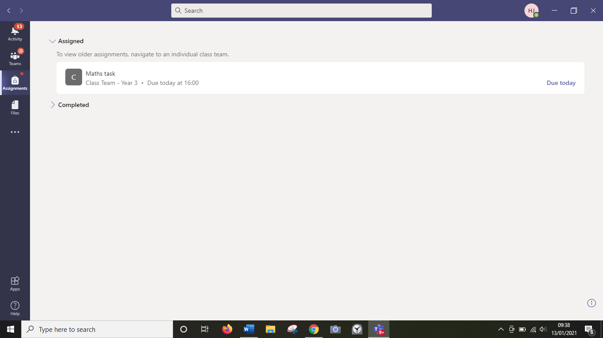
To see feedback on your work
Click on completed.
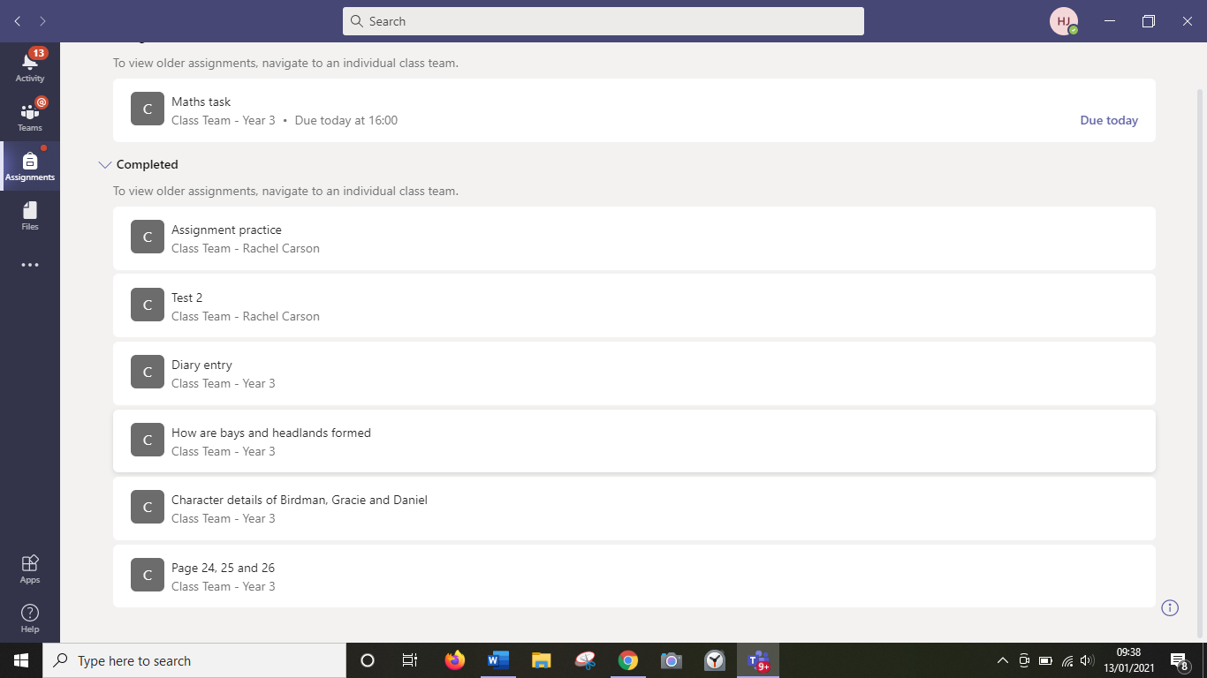

Here you can see feedback.
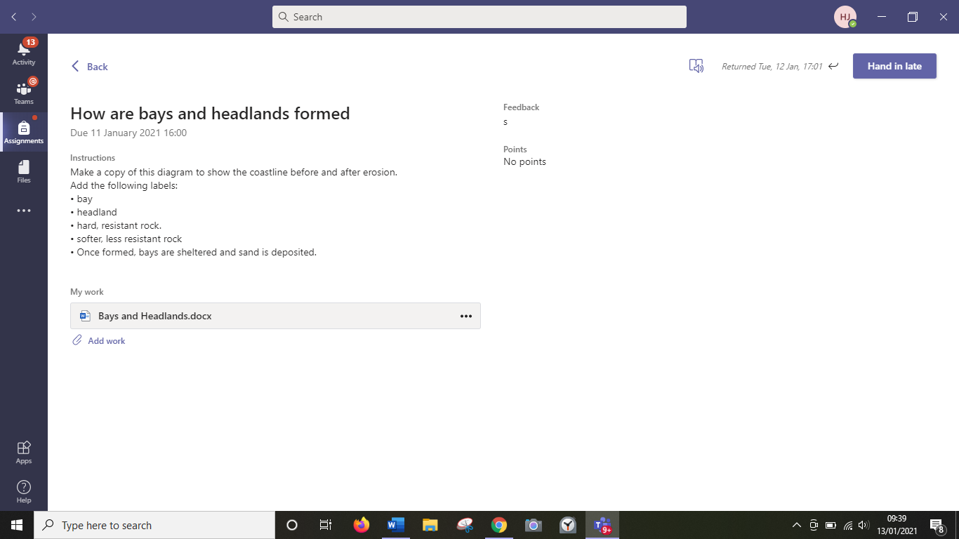

Feedback meanings:
n – no work visible on assignment/ not been done.
s – child is in school for this piece of work.
Anything else – a teacher has written you a comment. Please read it.

