This week’s learning 01.03.21
Daily PE Live with Miss Lizell at 9AM every weekday!
https://www.youtube.com/channel/UCo1Ce6-TzdWlBNvvJEF1K5w

Mathematics – Power Maths – Please log on to Power Maths (Same as Abacus), school code kmm7.
As part of world book day this week please complete the following:
- Create a poem of your favourite book character
- Find an interesting place to read a book and take a photo of you reading in that space.
- Create your favourite book character using interesting objects you can find from on walks or from around your house.
Here is a picture that you might want to attach for the 3rd one as an idea:
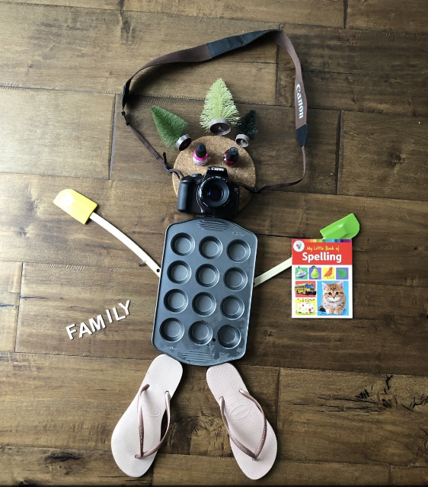

01.03.21
Maths – Live lesson at 10.30 AM Textbook
Independent work - Practice book 4B – Unit 10, lesson 6, Hundredths (1), pages 135-137. Hand in assignment with work attached.
English Live lesson at 12.00 PM
Independent work – write a short paragraph about how the narrator’s curiosity might make Ahmet feel. Try to begin your paragraph with a Fronted Adverbial.
Hand in assignment with work attached.
Science Live lesson at 1.30 pm.
Independent task – create a poster that would be displayed in the classroom to explain how different sounds travel to our ears. Remember to explain the link between the loudness of a sound and the size of the vibrations and explain how these sounds reach our ears. Make your poster eye catching, colourful, include pictures, diagrams and words.
---------------------------------------------------------------------------
02.03.21
Maths– Live lesson at 10.30 AM Textbook
Independent work - Practice book 4B – Unit 10, lesson 7, Hundredths (2), pages 138-140. Hand in assignment with work attached.
English Live lesson at 12.00 PM
Independent work – think about and then answer the following questions as fully as possible.
- In what ways is the bully’s behaviour is enabled by the people and culture of the school?
- What role do the teachers play?
- What role does language play in empowering the bully?
Hand in assignment with work attached.
RE - Live lesson at 1.30 pm.
Independent work – draw on outline of Noah and write a description of him all around. Inside the outline make a list of Noah’s qualities.

----------------------------------------------------------------
03.03.21
Maths Live lesson at 10.30 AM Textbook
Independent work - Practice book 4B – Unit 10, lesson 8, Hundredths (3), pages 141-143. Hand in assignment with work attached.
English Live lesson at 12.00 PM
Independent work – Write a short speech on what makes the foundations of a healthy, positive school culture? Think about what you will say and how best to say it. Your audience will be the children of the school.
Hand in assignment with work attached.
PE Live lesson at 1.30 pm.
------------------------------------------------------------------

04.03.21
Maths Live lesson at 10.30 AM Textbook
Independent work - Practice book 4B – Unit 10, lesson 9, Dividing by 100, pages 144-146. Hand in assignment with work attached.
English– Live lesson at 12.00 PM
Independent work – SPAG – Expanded noun phrases
Pick 5 characters from the pictures and write an expanded noun phrase to describe them. Start your sentence, use at least three adjectives, THEN put ‘with’ after your noun to give you a longer expanded noun phrase. For example, can you find the tall, strong, smiling man with a blue hat and an axe?
Hand in assignment with work attached.
Global learning Live lesson at 1.30 pm.
Independent work – Write a persuasive letter to your local MP (Member of Parliament) persuading them to lower the voting age to 16.
Use these things to help you:
• use an introductory paragraph to explain what you are arguing for;
• think of 3 or 4 reasons why 16 year olds should be able to vote;
• give evidence and facts for each of these reasons;
• use a final paragraph to sum up your argument.
Remember to:
• use rhetorical questions;
• use powerful adjectives;
• use words which imply agreement e.g. obviously, without doubt, of course.

Hand in assignment with work attached.
05.03.21
Maths Live lesson at 10.30 AM Textbook
Independent work - Practice book 4B – Unit 10, lesson 10, Dividing by 10 by 100, pages 147-149. Hand in assignment with work attached.
English Live lesson at 12.00 PM
Independent work – Comprehension
English 05.03.21 Emmeline Pankhurst Comprehension
https://forms.office.com/Pages/ResponsePage.aspx?id=WWP7dCZlx0CYxtFo2XQsHE2yuTaVqEVEogH--g2LAStUOUhNQ0JNUUNGTUJQOTg0RzROSDMyTTFLRy4u
Skills builder afternoon
Find this in the Friday channel, files tab at the top of the page.
--------------------------------------------------------------------------------
Arithmetic (20 minutes a day)
Make sure you are practising your times tables as much as you can.
Times Table Rock Star
https://play.ttrockstars.com/auth/school/student/76329
https://www.topmarks.co.uk/maths-games/7-11-years/times-tables
https://www.timestables.co.uk/
Spellings
Practice your spellings in which every creative way you like. I have uploaded the spelling menu to give you some ideas.
Spellings
This week’s spelling rule - homophones
1) rain
2) rein
3) reign
4) scene
5) seen
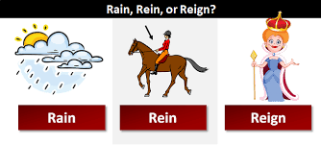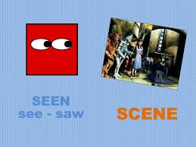
Reading
Keep reading!
Read a magazine/newspaper article.

Remember to read EVERYDAY.
The Accelerated Reader (AR) programme is also accessible from home during this time too, so once you’ve finished your books make sure you log on and take a quiz. https://ukhosted43.renlearn.co.uk/2152328/default.aspx

Nessy (20 minutes a day)
https://www.nessy.com/uk/

Mind Up
https://mindup.org.uk/families/

GenR8
Please use the below link or download the video as required.
https://youtu.be/4Pk6-khf21g
Other GenR8 Reflect videos can be found at https://genr8.org/prayer-spaces Along with other Inspire Prayer Space resources specifically for use at home.
GenR8 Connect videos can be found at https://genr8.org/videos
Rev Jes
Assembly now uploaded on to 'St Mary's Buckden' YouTube channel. St Mary's Buckden - YouTube

Visit youtube and do a Joe Wicks session/Cosmic kids/Go noodle

Young Artists' Summer show – This is something fun and creative to take part in if you wish.
As a school we have registered for the Young Artists' Summer show. This is an opportunity for the children to explore and create a piece/s of artwork overtime and at their own pace. The Young Artists’ Summer Show is a free, open submission exhibition for young artists aged 5 - 19 years studying in the UK and British schools overseas. To take part, students or their parents/guardians can submit artworks. These artworks are then judged by a panel of artists and arts professionals with selected artworks displayed online and on-site at the Royal Academy of Arts. https://youngartists.royalacademy.org.uk/get-involved Artworks can be submitted until 26 April 2021 at 5pm.

Submitting your work
Type your work or take photos of any work you would like us to see and upload them in the assignment for that lesson.

