This week’s learning 17.01.22
Monday
Maths – Comparing numbers of objects. Compete the attached activity sheet, remember you can use items around your house to help you.
English –
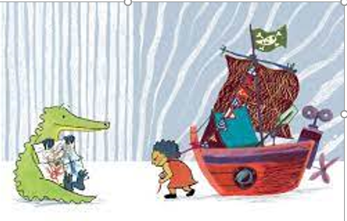
Look at the illustration from our new book and answer the following questions –
What do you notice in this picture?
Is there anything you like about it? Why? Why not?
Is there anything that you dislike? Why?
Does it remind you of anything?
Does anything puzzle you?
What kind of story do you think this will be?
What can you say about the characters?
What would you like to find out?
Science – Look through the attached Powerpoint and sort the attached animals cards into herbivores, carnivores and omnivores.
Tuesday
Maths – Comparing numbers – Look through attached Powerpoint and complete the attached activity sheet.
English – Here is a picture of Anna and Crocodile, they are two characters from our book. Write a description of what they look like.
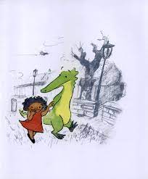

Global Learning – Find out any facts about the United Kingdom. Find out about London, UK rivers, the tallest mountain, the largest lake, what are the national flowers of each part of the UK.

Wednesday
Maths – Ordering objects. Look through attached Powerpoint and complete the attached activity sheet.
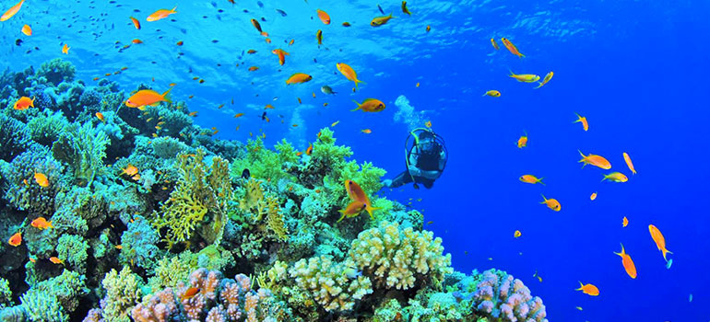
English – Look at the under water picture and write some sentences to describe what you can see. Don’t forget your capital letters, finger spaces, handwriting and fullstops.

Music – Make an instrument at home that represents the sound of rain.
Thursday
Maths – Ordering numbers. Look through attached Powerpoint and complete the attached activity sheet.
English – Comprehension – See attached text and answer the questions.

RE – Choose one of your sense (touch, taste, smell, hear, sight) and draw a picture of something you can do in your house which uses this sense to welcome a guest into your house.

Friday
Maths – Practise your maths skills by playing some games on your Abacus account. There are lots to choose from! https://www.activelearnprimary.co.uk/login?c=0 (Log ins are in the children’s reading diaries and the school code is kmm7).
English – (SPAG) Practice your handwriting using the year 1 common exception words.
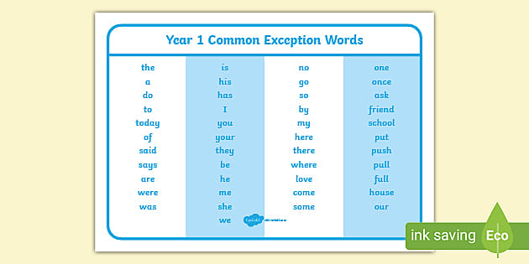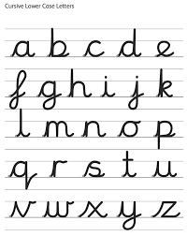
Daily
Abacus - https://www.activelearnprimary.co.uk/login?c=0 (Log ins are in the children’s reading diaries and the school code is kmm7).
Keep reading!
Read a magazine/newspaper article.
Arithmetic (20 minutes a day) – Count to 100 aloud whist doing body percussion, challenge yourself and now count in tens.
Phonics – Play a phonics phase 2 and 3 game on phonics play.
https://www.phonicsplay.co.uk/resources/phase/2/picnic-on-pluto

Practice your typing skills
https://www.bbc.co.uk/bitesize/topics/zf2f9j6/articles/z3c6tfr

PE
Visit Youtube and do a session 5 times a week of Joe Wicks/Go Noodle/Cosmic Kids Yoga.

