Sand

golden grainy soft smooth sandcastles

digging bucket spade beach sunshine
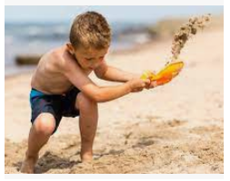
seaside shells crabs summer
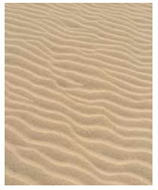
family friends games

