Good Morning,
Today, Friday 5th February is as follows:

English- Make a story map for your own Claude adventure
Look back at the daydream picture on page 11. Where do you think Claude will go next – you could look back at your ideas from a few weeks ago. This time we are going to make a new story map but for his next adventure. Think about where you are sending him, what bad thing will happen? How will Claude save the day?
Next to your pictures on your story map include some words or phrases to describe your setting, names of characters, key event or even speech bubbles.

Maths- Representing numbers to 50
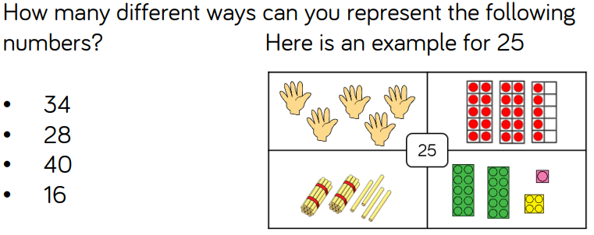
Today is about reinforcing the understanding of 10s and 1s in numbers and how they can be shown. Your challenge today is to show lots of different ways to show 1 number (see the example in the picture).
This can be completed on a sheet by drawing or in a more practical way by using cubes, 10s frames etc and talking a photo.

Phonics- Todays phonics: a review of the week.
Follow the link below and click on today’s date.
Friday 5th February: Lesson 25 Review the week
https://lettersandsounds.org.uk/for-home/year-1
Phonics play is also free throughout January so you could explore some of the games on there. https://www.phonicsplay.co.uk/
username: jan21
password: home

Assembly – Mrs Heathers celebration assembly, look out for the link.

Skills builder- please see the document in files

