This week’s learning 31.01.22
Monday
Maths – Add by making 10.
English –
Look at the illustration - Where do you think Anna and Crocodile intend to go? What makes you think that? Does this remind you of anything you know in real life or stories? Do you have any questions? Does anything puzzle you? Where would you go in your search for gold? What might happen on your adventure? Now, create a map that will help Anna and Crocodile to find gold.
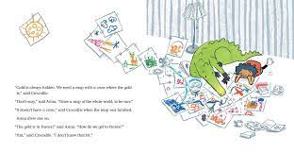
Science – Create your own senses experiment with items around your house.
Tuesday
Maths – Solving word problems - addition.
English – https://www.youtube.com/watch?v=vxWlWJUfMEo Watch the clip of the story of How to find gold up to 1 minute, 26 seconds and make your own story book retelling the story so far.

Global Learning – Look at the Global Learning PowerPoint about animals that live in the Ocean and draw your own under water scene.
Wednesday
Maths – Word problems - addition.
English – Look at the picture and write descriptive sentences about what you can see.
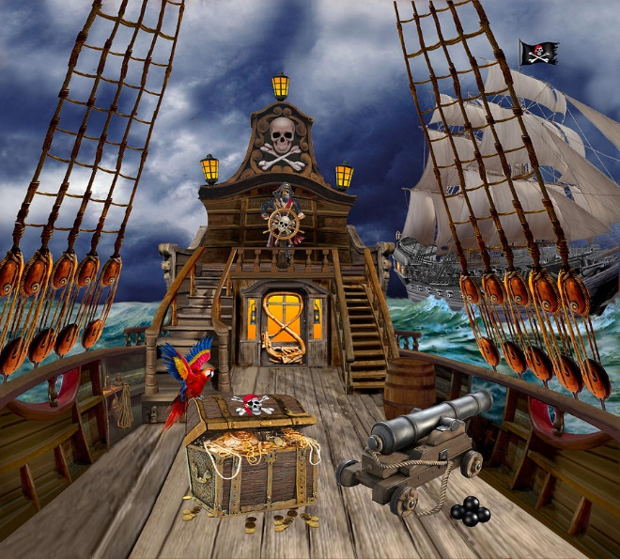

Music – Make an instrument at home that represents the sound of rain.
Thursday
Maths – Subtracting ones.
English – Comprehension – See attached text and answer the questions.

RE – Look at the website with Hindu artefacts on. Now draw your own picture of one of the Hindu God. http://resources.hwb.wales.gov.uk/VTC/ngfl/re/m_parry_carmarthenshire/arteffactau/cysegrfa.htm

Friday
Maths – Practise your maths skills by playing some games on your Abacus account. There are lots to choose from! https://www.activelearnprimary.co.uk/login?c=0 (Log ins are in the children’s reading diaries and the school code is kmm7).
English – (SPAG) Practice your handwriting using the year 1 common exception words.
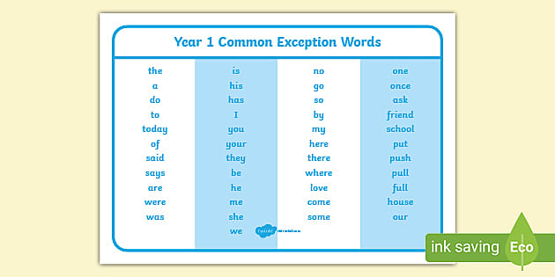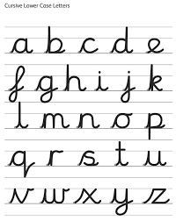
Daily
Abacus - https://www.activelearnprimary.co.uk/login?c=0 (Log ins are in the children’s reading diaries and the school code is kmm7).
Keep reading!
Read a magazine/newspaper article.
Arithmetic (20 minutes a day) – Count to 100 aloud whist doing body percussion, challenge yourself and now count in tens.
Phonics – Play a phonics phase 2 and 3 game on phonics play.
https://www.phonicsplay.co.uk/resources/phase/2/picnic-on-pluto

Practice your typing skills
https://www.bbc.co.uk/bitesize/topics/zf2f9j6/articles/z3c6tfr

PE
Visit Youtube and do a session 5 times a week of Joe Wicks/Go Noodle/Cosmic Kids Yoga.

