^{6th} July
Dear Year 2,
Hello everyone! It was lovely to speak to you all again this week. The theme for the blog this week is ‘Sport.’ I hope you enjoy some of these activities.
I hope you are enjoying writing your daily journals to capture what you are doing at home during this time. Remember to write in your journal:
- How you are feeling
- What you have done. This can be any of the work you have done from the blog and anything that you have done whilst at home.
- What you have enjoyed each day.
I can’t wait to see your journals which will be shared upon our return to school with your classmates!
If you would like to take some photos of your work to show, me you can send them to the school office! I have loved seeing the videos/photos/work that you have been sending in.
Take care and stay safe
Hopefully I will see you all soon
Mrs Jaynes and Mrs Tarpey
x
This is a suggestion of how much learning to do over a day with a year 2 child. These slots add up to 2 hours of learning, split into small chunks with breaks. Of course what is important is that you do what works best with your family. The work listed below is more than enough for 5 days of 2hr learning so please choose the tasks that you would prefer to do with your child. Also don’t forget to do some exercise and read every day!
am 20 min | Maths activity
am 20 min | English activity
10:30 | Snack time
am 2 x 20 min | TT Rockstars/Nessy
12:30 | Lunchtime
pm 20 min | Something unfinished from the morning or maybe some art
pm 20 min | An activity from general activities list

Sport Week

Maths
Task 1
Watch the clip
https://youtu.be/bMcwUHDXX4g
How many jumps can you can do in one minute.
How many times can you can run around your garden in 2 minutes.
How long does it take you to run around your garden?
Measure how far you can jump?
Measure how high you can jump?
Find your pulse and measure how many times you feel your pulse in 60 seconds. Then exercise for 2 minutes. Then measure your pulse again. What do you notice when you compare the two numbers? What has happened?

Task 2
Watch the clip
https://youtu.be/Zfm3gC7RCHk
Draw a football/netball pitch/court. It should be 28cm long, 8cm wide. Half way along each long side put a dot. Join the two dots with a line that cuts the pitch into two halves. Half way along that line put a dot. Find something that has a small circle on the end and draw a circle in the middle of the pitch. You then need to add a semi-circle at both ends. Can you label the lengths of all 4 sides of your football pitch/netball court and add up the total length. Don’t forget to add the units.

Task 3
Some children from the class are thinking about races because they are interested in the Olympics. Afzal, Bengy and Chrissy like the idea of getting medals. They know that there are Gold, Silver and Bronze medals.
Afzal says that if he won he'd get Gold and if Bengy then came second he'd get Silver and Chrissy would then get Bronze.
Chrissy says that's right but if she'd come first she would get the Gold and then when Bengy came second he'd get Silver again and Afzal would get Bronze.
Bengy has other ideas too.
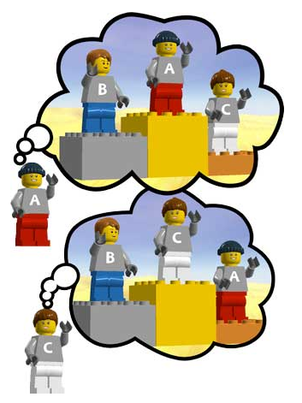
If the children found all the different ways in which they could be first, second and third, how many would they find?

Task 4
Other sites that you could also use for learning your times tables
https://www.topmarks.co.uk/maths-games/hit-the-button
https://www.timestables.co.uk/3-times-table.html

Task (20 min a day)
The following activities are ongoing tasks and should be practised every week at times that would suit you best. You do not need to do them all every day, pick one or two per day.
Number - count in steps of 2, 3, and 5 from 0, and in tens from any number, forwards and backwards
Know number bonds to 20
Times tables - recall and use multiplication and division facts for the 2, 5 and 10 multiplication tables (Try making mini times tables booklets)
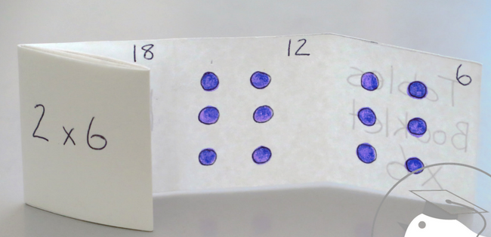
Time - tell and write the time to five minutes, including quarter past/to the hour (on an analogue clock)
Know the number of minutes in an hour and the number of hours in a day.
Money - Recognise different monetary coins, find different combinations of coins that equal the same amounts of money
Measure - measure items in cm/m, kg/g, l/ml

Task (2 x 20 min per week)
TT Rockstars https://ttrockstars.com/

Task (2 x 20 min per week)
Abacus https://www.activelearnprimary.co.uk/login?c=0

English
Remember to read every day

Task 1
Watch the clip
https://youtu.be/JOd-2Nc4Gas
Alternatively all of the information contained in the videos is written below.
Look at the first picture (in the file labelled task 1). Who do you think these people are? What are they doing? What are they looking at? Why are they standing the way that they are? Look for clues on the picture, facial expressions and body language to guide your answers.

Task 2
Watch the clip
https://youtu.be/rtnaxpW3UwM
Alternatively all of the information contained in the videos is written below.
Look at the picture (labelled task 2). Who might these 2 characters be? Where are they? Look closely at the picture for clues. How might these characters be linked to Egg Box Dragon? Write a prediction, making links to the picture.

Task 3
Watch the clip
https://youtu.be/-KQfIPat4v8
Alternatively all of the information contained in the videos is written below.
Write a book review of the whole story (see sheet attached)

Task (if you have a password 2 x 20 min)
Nessy https://www.nessy.com/uk/

Spelling
Look at common exception words (see list attached)
Play lots of different games to ensure that you can spell each of these words.

Science
Task 1 (1 x 20min)
https://www.bbc.co.uk/bitesize/clips/zhhxpv4#:~:text=Muscles%20are%20used%20every%20time,muscle%20relaxes%20and%20becomes%20longer.
Watch this video to discover why we need muscles to move.

Task 2 (1 x 20 min)
Try to make a model arm with muscles to move the bones
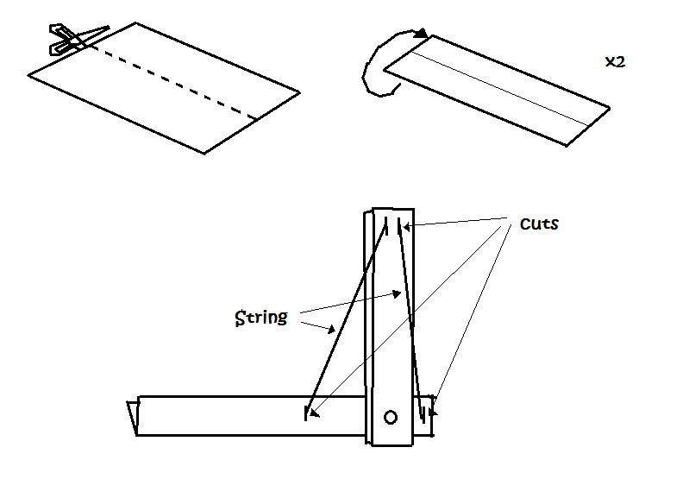

Task 3 (1 x 20 min)
What should sportsmen and sportswomen eat?
Do you know somebody in your family that does a lot of sport? Could you interview that person to ask them what healthy foods they eat to help them stay fit? Make a healthy menu for a sportsperson for a week.

Geography
Task 1 (1x20min)
Research the Olympic rings.
Find out why there are 5 rings.
Why are they those colours?

Art
Task 1 (1x 20 min session)
Draw and colour the Olympic rings
https://www.google.com/search?q=draw+the+olympic+rings&rlz=1C1GCEU_enGB821GB821&oq=Draw+the+olympic+rings&aqs=chrome.0.0l3j69i60l2.6915j0j8&sourceid=chrome&ie=UTF-8&safe=active&surl=1
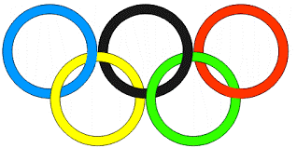
Task 1 (1x 20 min session)
Design a mascot for the next Olympics. Use the examples below for ideas. What would make a good mascot?
This is Vinicius and Tom from the 2016 Summer and Paralympics.
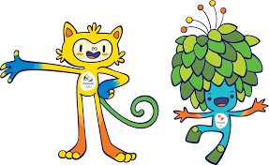
This is Wenlock and Mandeville from the London 2012 Olympics
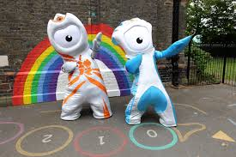
P.E.
Complete a mini-biathlon this week by going on a bike ride and running around your garden.

THE SOCK OLYMPICS!
Have fun taking part in the sock Olympics. Get all of the family involved if you can!

Computing
https://www.rodocodo.com/

