Maths tasks week beginning 6th July 2020
Task 1 - What is double?
Game: children could roll 1 dice each. If the dice land on the same number, the children have rolled a double. The first child to recognise this and shout ‘Double!’ wins a point. Children could be asked to find the total both dice make.

You could also play board games that need 2 dice and talk about doubles when they are rolled.
Dominos is also a good game to play to look at doubles, what they are and try adding them together.

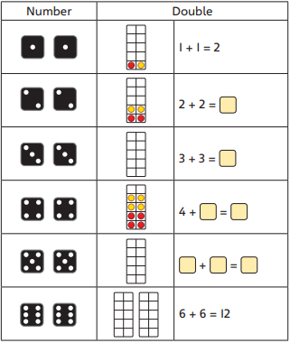
Here’s a worksheet if you would like to do one.

Task 2 different representations of double
See video Week 6 maths 1
Today is a challenge. How many different ways can you show a double?
For example, if you are showing double 3 you could show this on a 10s frame, part whole model, bar model, number line or addition calculation.

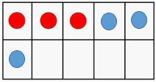

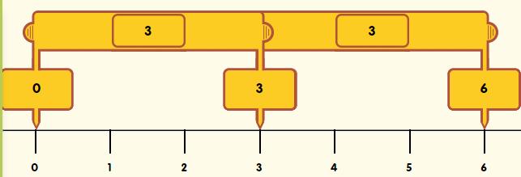
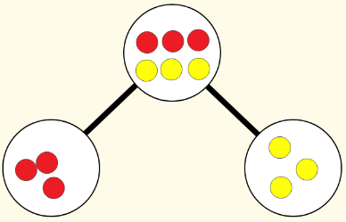

3 + 3 = 6

Task 3 solving word problems - multiplication
See video Week 6 maths 2

• What information do you need to solve the question? How is the information presented?
• How could you represent the problem in a different way?
•You can draw pictures or make arrays to help you.

Solve these in practical ways with objects first. Then you could move on to drawing arrays and using 10s frames and number lines to help.
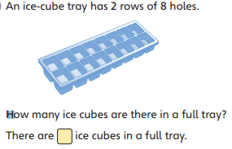
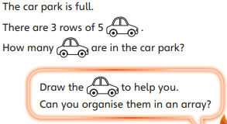

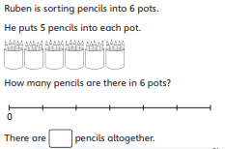
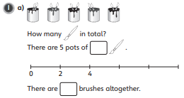

Task 4 time
Find out:
How many seconds there are in a minute.
How many minutes there are in an hour.
How many hours in a day.
How many days are in a week. (can you name the days of the week in the correct order)
How many days in a month.
How many months in a year. (can you name the months of the year and place them in the correct order)

Task 5 time
See video Week 6 maths 3
We can use a clock to measure how long activities take. What do we use to measure time?
Estimate how long you think it will take:
Would it take seconds, minutes or hours?
- To run around your garden
- Colour in a picture
- To do 10 star jumps
Time these activities and see how close you were.
Activity | Estimate | Actual time
To run once around my garden | 30 seconds | 47 seconds

