English tasks 6th July

Task 1
See video Week 6 English 1
After reading the text again and think about these questions.
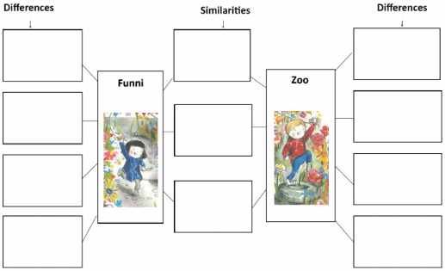
O What do you really think was missing for Funni?
o Do you think she still feels an ‘ache’ or ‘hole’?
o How do you think Zoo has helped take this away?
Look back at the story and the relationship Funni and Zoo have built. Use the double bubble activity to compare and contrast the characters (see end of document). At this point, children may be more tuned into their similarities, but encourage them to also look carefully for the differences that keep them unique despite their strong friendship:

Task 2
Look back at your double bubble activity where you looked at the similarities and difference between Funni and Zoo. You may have noticed that both children have kites, for example, but did you notice how each kite reflected their different personalities?
You might have noticed the colours red and blue. Funni has a blue coat and red watering can. Zoo has a red jumper and blue jeans reflecting the colours in Funnis kite.
You might go on to look at the differences in the shapes of their kites and what clues these might give us about their characters.
Design a kite to reflect your personality Think about the shape of your kite and the colours you will include. How will they reflect your personality?

Task 3
See video Week 6 English 2
These questions give children accessible starting points for discussion, encouraging openness.
o Tell me…was there anything you liked about this story?
o Was there anything that you particularly disliked…?
o Was there anything that puzzled you?
o Were there any patterns…any connections that you noticed…? Did it remind you of anything else you’ve read or seen?

Create your own book review. There is a template available at the end of this document.

Task 4/5
See video Week 6 English 3
Read the blurb aloud to the children, talk about the final sentence: ‘When the two meet, it’s not just the flowers that blossom, but a very special friendship.’
Talk more with the children about the idea of friendship:
o Why were Zoo and Funni such good friends?
o What were they able to give each other through their friendship?
o Have they got a friend, at home, at school or somewhere else, who is really special to them? They might talk about a friend their own age or someone who is younger or older, or even a special pet or toy.
o What does your friendship bring to each other?

Allow time for the children to visualise the person they are talking about and to draw a picture of the person they are thinking about

Independent writing – write about a special person to you. Write about who they are, where you met, things you have in common or differences between you. Why are they so special to you?

The key here is to write independently as much as you can. Think about each sentence and say it out loud before you write it down to make sure your happy with it and it makes sense.

Remember full stops, capital letters and finger spaces. Can you include words to join your ideas and sentences such as:
And because but when until since although so if



