
Week beginning 6th July 2020 Sports
Task 1
Research the Olympic rings.
Find out why there are 5 rings.
Why are they those colours?

Task 2
Draw and colour the Olympic rings
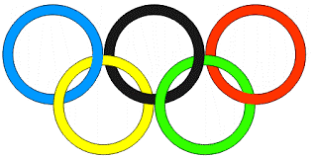
https://www.google.com/search?q=draw+the+olympic+rings&rlz=1C1GCEU_enGB821GB821&oq=Draw+the+olympic+rings&aqs=chrome.0.0l3j69i60l2.6915j0j8&sourceid=chrome&ie=UTF-8&safe=active&surl=1

Task 3
Design a mascot for the next Olympics. Use the examples below for ideas. What would make a good mascot?
This is Vinicius and Tom from the 2016 Summer and Paralympics.
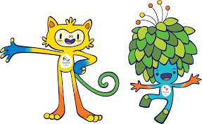
This is Wenlock and Mandeville from the London 2012 Olympics
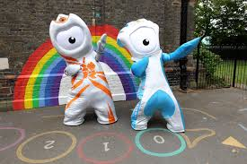

Task 4
Complete a mini-biathlon this week by going on a bike ride and running around your garden.

Task 5
Create your own sports day or mini olympics.
What events will you have? Egg and spoon race, three legged race, dressing up race, throwing, jumping, running.

