06.07.20
Good Morning Year 4,

This week’s theme for our learning is Sports week. Make sure you have fun!

Task 1 | AM 20 min | Maths lesson
Task 2 | AM 20 min | English lesson
10:30 Snack time
Task 3 | AM and PM 2 x 20 min | TT Rockstars/Rodocodo/SPAG
12:30 Lunchtime
Task 4 | PM 20 min | Art activity
Task 5 | PM 20 min | History/Geography
Task 6 | PM 20 min | French/Skills Builder/RE
2:00 Snack time
Task 7 | PM 20 min | Science
Task 8 | PM 20 min | This could be finishing an activity from earlier or an activity from the general list.
Daily journal and reading

Mathematics Task 1 (20 min)
The activities listed below are key Mathematical areas that the children need to practise every week, they do not need to do them all every day, but pick one or two per day. These will be ongoing and you can complete them in any fun ways you can.
Key Mathematical areas;
Number - count in multiples of 6, 7, 9, 25 and 1000
Times tables recall multiplication and division facts for multiplication tables up to 12 × 12
Measures - Convert between different units of measure - kilometre to metre; hour to minute]
Money - estimate costs, compare costs and calculate amounts in £ and p
Time - read, write and convert time between analogue and digital 12- and 24-hour clocks
convert from hours to minutes; minutes to seconds; years to months; weeks to days.

Make sure you are practising your timestables as much as you can.
Abacus - The children can access this resource via the website https://www.activelearnprimary.co.uk
The password is year 4 and the school code kmm7 in the bottom box.

PLEASE NOTE YOU DO NOT NEED TO PRINT THESE SHEETS, YOU CAN ANSWER THEM ON PAPER.
Task 1 – Task 1 Maths lesson video. Part 1 https://youtu.be/mRnwfiDP9bw
Part 2 https://youtu.be/iy2R-mmupl0
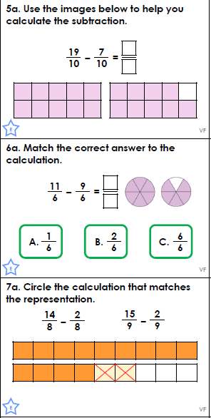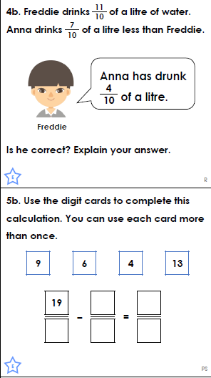
Answers
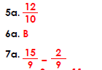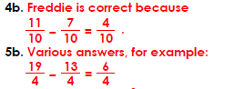

Task 2 – Task 2 Maths lesson video. https://youtu.be/eVk8jQxGCyU
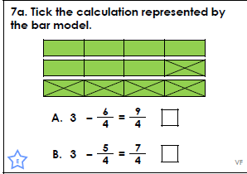
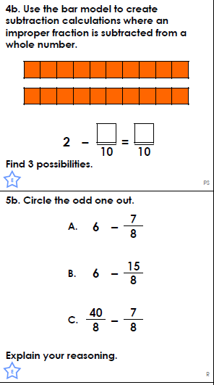
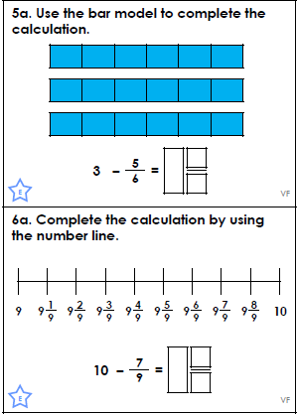

Answers
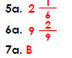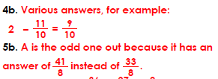

Task 3 – Task 3 Maths lesson video. Part 1 https://youtu.be/zW91LAZzxrk
Part 2 https://youtu.be/mEEhnop2j_A
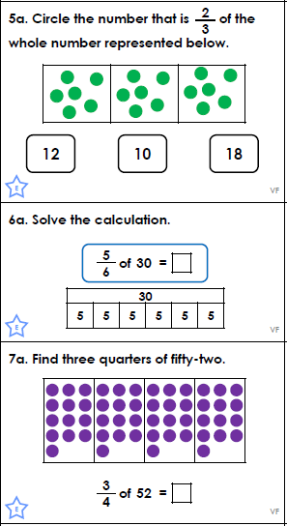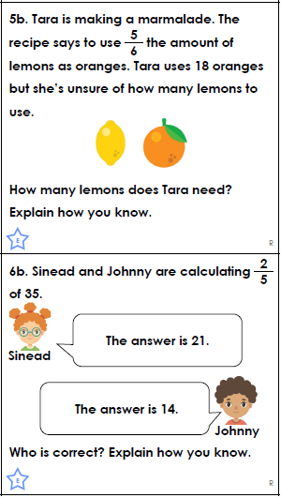
Answers
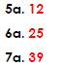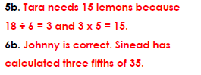
Task 4 – Choose a learning objective from the key Mathematical area list.
Task 5 – Make up your own sporting games, using your Mathematical knowledge within your new sport (be creative and imaginative, you could even have a go at it). (Art and English relate to this activity.)

English Task 2 (20 min)
Task 1 – Power of reading, English lesson video.
Story videos: 1. https://youtu.be/lgwBib-yiJQ
2. https://youtu.be/08_Dq-mCKMk
Task: https://youtu.be/zTRtlDc6RsA
Task 2 – Power of reading, English lesson video. https://youtu.be/8mqp0iqv4CQ
Task 3 – SPAG, English lesson video. Follow up activity sheets - varied fluency, application and reasoning. https://youtu.be/o-CTx38Qv2A
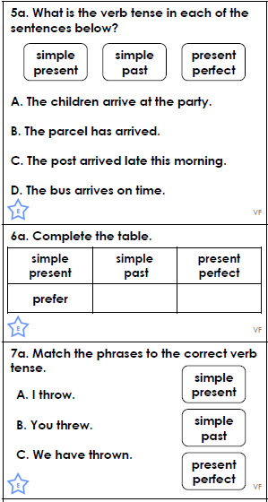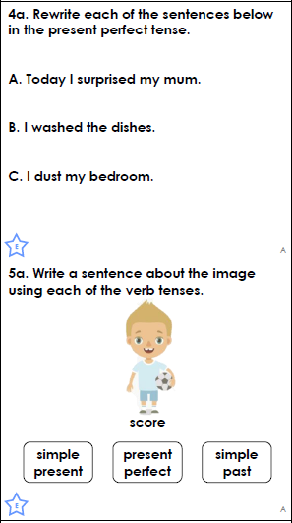
Answers
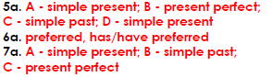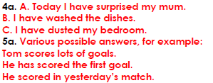
Task 4 – Imagine you are a sports presenter. Create a sports report on your favourite sport. It could be dance, gymnastics, golf, cricket, football, basketball, netball, etc. You can write it or perform it and record it.
Task 5 – Write a sales pitch for your maths sporting games to explain it and why it is good. Why should people play it? Why is it different from other sports? Remember to be persuasive.

Reading
Remember to read EVERYDAY.
The Accelerated Reader (AR) programme is also accessible from home during this time too, so once you’ve finished your books make sure you log on and take a quiz. https://ukhosted43.renlearn.co.uk/2152328/default.aspx
Nessy - https://www.nessy.com/uk/
Task 3 (20 min)
Time Tables Rock Star - https://play.ttrockstars.com/auth/school/student/76329
Rodocodo - https://game.rodocodo.com/
SPAG – http://www.crickweb.co.uk/ks2literacy.html
Art/DT Task 4 (20 min)
Design a kit for your new sport. Think about if you are going to have shorts, skirts, long sleeve tops, short sleeve tops, jumpers, hats, and so on. You could collage it, paint it, draw it, colour it, etc.

Global learning Task 5 (20 min)
Research when and where the first Olympics took place.
Find out what countries have held the Olympics, where are those countries?
Find out what each hosting countries national anthem is. Try and make your own anthem related to a sport in your life.
Did any countries have any traditions that they performed? See if you can watch each countries opening ceremony and compare them.

Task 6 (20 min)
French - (Log in – Username - Buckden Password – Starfish)
https://www.linguascope.com/
Skill Builder -
https://www.skillsbuilder.org/resources/rocketing-resolutions
GenR8
Climbing shoes activity
Science Task 7 (20 min)
Living things and their habitats – Woodland habitat classification.
General activities
Remember to keep active!
- Yoga
- PE - Join Joe Wicks for a PE lesson. He is on YouTube every weekday.
https://www.youtube.com/watch?v=lEWcBIvqjDk
- Touchtyping - https://www.bbc.co.uk/bitesize/topics/zf2f9j6/articles/z3c6tfr
- Coding - https://scratch.mit.edu/
- Get in touch with a friend or family member
- Be mindful, do a random act of kindness for someone in your household.
- https://www.skulduggerypleasant.co.uk/books/
- https://www.anglianwater.co.uk/in-the-community/schools/learning-at-home/
In your journal you write:
- How you are feeling,
- What you have done (this can be any of the work you have done from the blog and anything that you have done whilst at home),
- What you have enjoyed each day.

