29th June
Dear Year 2,
Hello everyone! It was lovely to speak to you all again this week. The theme for the blog this week is ‘Clean Water and Sanitation’ I hope you enjoy some of these activities.
I hope you are enjoying writing your daily journals to capture what you are doing at home during this time. Remember to write in your journal:
- How you are feeling
- What you have done. This can be any of the work you have done from the blog and anything that you have done whilst at home.
- What you have enjoyed each day.
I can’t wait to see your journals which will be shared upon our return to school with your classmates!
If you would like to take some photos of your work to show, me you can send them to the school office! I have loved seeing the videos/photos/work that you have been sending in.
Take care and stay safe
Hopefully I will see you all soon
Mrs Jaynes and Mrs Tarpey
x
This is a suggestion of how much learning to do over a day with a year 2 child. These slots add up to 2 hours of learning, split into small chunks with breaks. Of course what is important is that you do what works best with your family. The work listed below is more than enough for 5 days of 2hr learning so please choose the tasks that you would prefer to do with your child. Also don’t forget to do some exercise and read every day!
am 20 min | Maths activity
am 20 min | English activity
10:30 | Snack time
am 2 x 20 min | TT Rockstars/Nessy
12:30 | Lunchtime
pm 20 min | Something unfinished from the morning or maybe some art
pm 20 min | An activity from general activities list

Clean water and Sanitation

Maths
Task 1
Watch the clip
https://youtu.be/xuSFIAvUpcA
Grouping and sharing as a method for division. Work out the answers to these calculations
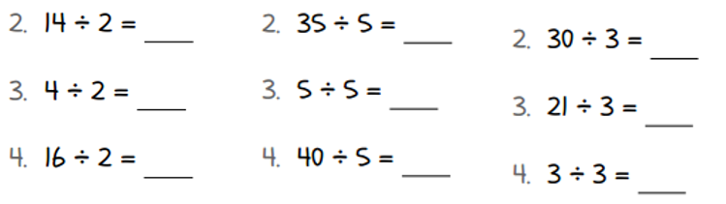
Task 2
Watch the clip
https://youtu.be/a011lexbpoA
Using repeated subtraction on a numberline as a method for division.
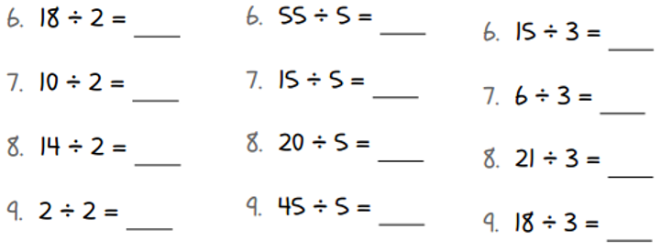
Task 3
Watch the clip
https://youtu.be/zvbjsaBnejQ
Solving word problems.
The picture are attached to the blog if needed.

Task 4
Other sites that you could also use for learning your times tables
https://www.topmarks.co.uk/maths-games/hit-the-button
https://www.timestables.co.uk/3-times-table.html

Task (20 min a day)
The following activities are ongoing tasks and should be practised every week at times that would suit you best. You do not need to do them all every day, pick one or two per day.
Number - count in steps of 2, 3, and 5 from 0, and in tens from any number, forwards and backwards
Know number bonds to 20
Times tables - recall and use multiplication and division facts for the 2, 5 and 10 multiplication tables (Try making mini times tables booklets)
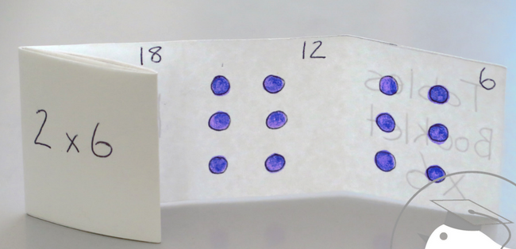
Time - tell and write the time to five minutes, including quarter past/to the hour (on an analogue clock)
Know the number of minutes in an hour and the number of hours in a day.
Money - Recognise different monetary coins, find different combinations of coins that equal the same amounts of money
Measure - measure items in cm/m, kg/g, l/ml

Task (2 x 20 min per week)
TT Rockstars https://ttrockstars.com/

Task (2 x 20 min per week)
Abacus https://www.activelearnprimary.co.uk/login?c=0

English
Remember to read every day

Task 1
Watch the clip
https://youtu.be/qNfFU8Ifahc
Alternatively all of the information contained in the videos is written below.
Look at the pictures of Egg Box Dragon, Emma and Emma’s dad (see file saved as thought bubbles). How might each character be feeling? What might they be thinking about? Use the thought bubbles attached and write down what they might be thinking about. Remember to look carefully for clues in the pictures, especially looking closely at their facial expressions.
Task 2
Watch the clip
https://youtu.be/ZEASPeWqW3I
Alternatively all of the information contained in the videos is written below.
Use the pictures labelled predictions. What is Egg Box Dragon doing in each picture? Who might Egg Box Dragon be helping? Make predictions about these.

Task 3
Watch the clip
https://youtu.be/xnrja-GxKX0
Alternatively all of the information contained in the videos is written below.
Create yourself a character that could live or work near where Egg Box Dragon lives. Think about giving your character a name, job and a little bit about them. Once you have all of these ideas, then write a letter to Egg Box Dragon asking for help. Explain that you have lost something and think that Egg Box Dragon would be able to help.
Remember to explain clearly why you’re asking for Egg Box Dragon’s help. Use full stops, capital letters and question marks, if needed.

Task (if you have a password 2 x 20 min)
Nessy https://www.nessy.com/uk/

Spelling
Look at homophones. What is a homophone?
https://www.bbc.co.uk/bitesize/topics/zqhpk2p
Eg; hear/here, see/sea. bare/bear, blue/blew, night/knight, there/their/they’re
https://www.learninggamesforkids.com/vocabulary-games/homophones-games.html

Science
Task 1 (1 x 20min)
Try to filter some dirty water to see if you can make it cleaner. You could try to filter through paper, fabric, different sized stones, sand or even soil to see what happens.
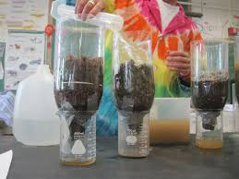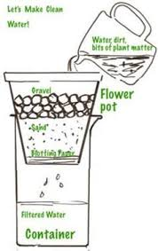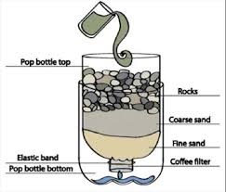

Task 2 (1 x 20 min)
Try to make a lego water cycle
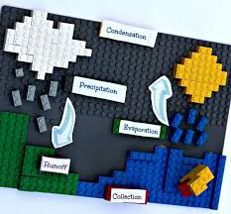

Global learning
Revision What can you remember about clean water and sanitation?
Task 1 (1 x 20 min)
- Who was Joseph Bazalgette, what did he invent?
- What happens at Grafham Water?
- Has Grafham Water reservoir always been there?
- Where is most of the Earth’s water?
- Can you name 5 oceans?
- What is a reflection?
- Can you explain the water cycle?

Task 2 (1 x 20min)
All water is precious and we need to look after it. Do you remember the water collection system that you designed with Mrs Dunford? Can you design and build a water collection system in your garden to collect rain water next time it rains?
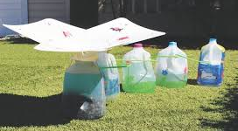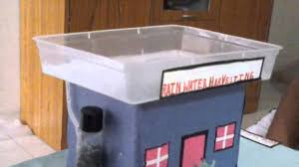

Task 3 (1 x 20min)
Watch this Thomas video to learn more about clean water and sanitation.
https://www.youtube.com/watch?v=IhzOcb3-zhQ
Make a mind map of all of the important uses of water.

Task 3 (2x20min) Geography
Find some pictures of oceans, lakes, ponds and rivers. Then use some scrap paper to make some artwork to help you remember the differences in these bodies of water.
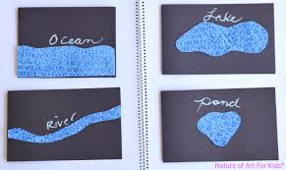
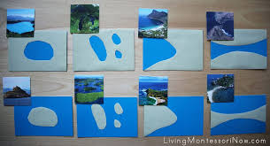

Art
Task 1 (1x 20 min session)
Try some wax and watercolour art. Use an old candle to draw a picture and then paint over it with some watercolour paints. What do you notice? Why do you think this happens?
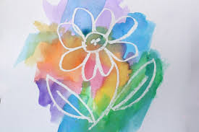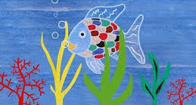

P.E.
Find two buckets, one needs to be empty and fill the other with water.
Put the buckets at either end of your garden or a green space and time how long it takes and count how many trips it takes to transfer all of the water into the other bucket using a plastic tub.

Computing
https://www.rodocodo.com/

