29th June 202
Dear Kenny class,
We can see that lots of you have been having an amazing time with all the photos coming in, keeping them coming. Hopefully you will have the opportunity to watch the videos that have been put up a long with this week’s plan. There are Maths and Phonics videos to help guide you through the week. The videos won’t be long and might need to be paused at certain times while you are asked to do something. The work you produce this week can be emailed to EYFS@buckdenacademy.org.
This is a suggestion of how much learning to do over a day with a reception child. Aim for a maximum of 2 hours focused learning interspersed with play based learning and physical activity. Of course what is important is that you do what works best with your family. The work listed below is more than enough for 5 days of learning so choose the tasks that you would prefer to do.
am 30 min | Sports/ physical activity- try Boogie Beebies for a change if you like or cosmic yoga
am 20 min | Maths activity – Weight.
am 20 min | Fine Motor control activity- like lego, puzzle, drawing, writing, cutting.
10:30 | Snack time- can you help prepare it?
am 2 x 20 min | Reading/ Sharing a story/ Phonics online game- see ideas below  Focus on Phase 3 – embed the learning – ‘th’,’ng’,’ai’
12:30 | Lunchtime
pm 1 hour or longer if you are having fun! | An activity from the ideas below and/or independent learning through play time where your child makes choices.
Pm 20 min | Complete your journal for the day- draw and or write

Maths
Weight -
- Hold two containers (one in each hand) place different items in each container, which one is heavier? Which one is lighter? Change the items and repeat
- Start with one item i.e an apple and find at least 5 objects that are heavier and 5 that are lighter.
- Do some baking/cooking using scales to measure the ingredients.
- Use scales to compare items weight, use terms heavy/heavier and light/lighter
- Use different sized and weighted parcels (maybe put some heavier objects in the smaller parcels so they are heavier than the biggest parcel – so the children don’t think bigger means heavier) Order the parcels into heaviest to lightest or lightest to heaviest.
- Can you balance random objects using a set of scales?

Phonics- Recap phase 3 – make sure it is stuck in! Continue with ‘th,’ ‘ng,’ ‘ai’
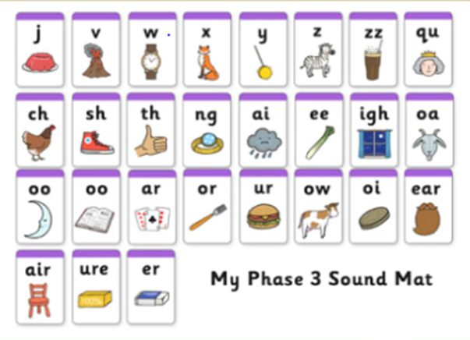
- House hunt - find objects in your house or garden, that start with the sound.
- Treasure or trash – write some words on pieces of paper, or using objects children decide whether the word starts with one of our sounds (treasure) – put these words in a ‘special box’ and if it isn’t treasure then its trash – put these words in the ‘bin.’ Alternatively, use https://www.phonicsplay.co.uk/BuriedTreasure2.html
- Sound detectives – Read through your favourite story books, find the sound, and talk about where it appears in the words.
- Word builder – using letters/sounds written on Lego blocks and joined together.
- Think of any words that have the sounds in and join together to make some silly sentences.
- Use a timer, how many times can you write the sound in 1 minute. Or repeat but writing of words containing our sounds.
- Pirate ship game – write the letters up and attach them to walls (one sound per wall) say a word and they have to run to the correct sound.
- Fashion 3 spaces near each other and label each with a sound, kick a ball or throw an item into the box and say the sound that it corresponds to.
- Create your own phonics game.
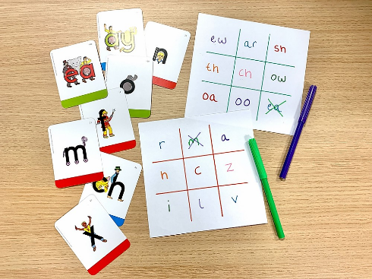
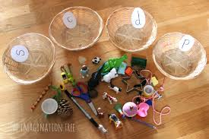
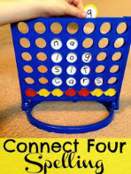

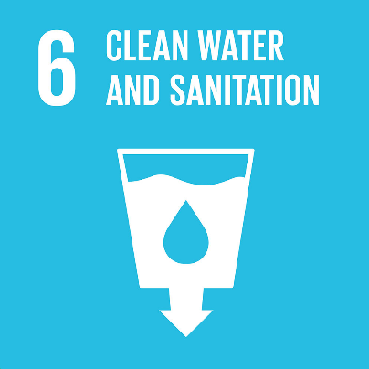
Clean Water and Sanitation

Introduction
https://www.allaboardforglobalgoals.com/en-us - Start by watching the Clean Water and Sanitation video on here.
Idea 1
Using different items in your house try to clean a cup of dirty water. i.e sponge, kitchen paper, towel etc. which one was best? You could do this by pouring through the item into a new cup.

Idea 2
Have a go at this Science experiment. You need to get a cup of dirty water then place in a folded up piece of kitchen paper which overlaps into an empty cup. The Kitchen roll should soak up the water and transfer it cleaned into the empty cup. Similar to the walking water experiment
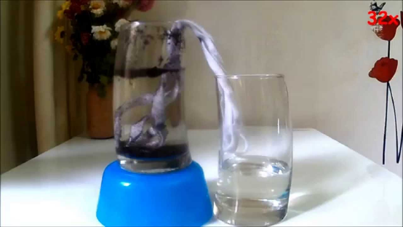

Idea 3
Count how many times you go to the toilet. Keep a tally record.
Idea 4
Create your own miniature water wall, you will need something to catch the water at the bottom so as to not waste it.
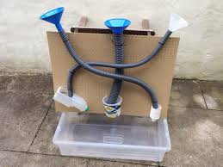
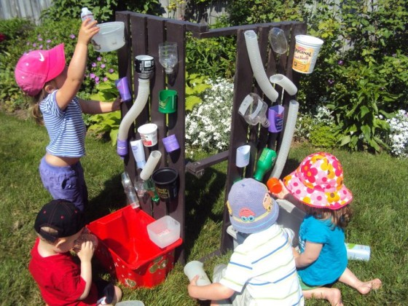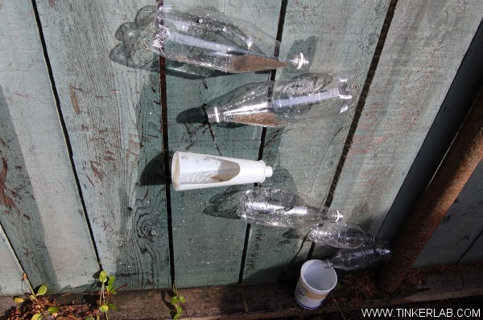

Idea 5
Look on Google maps how many bodies of water (blue bits) are there in Buckden and where you live? How many have you been to? What are they? Rivers, ponds, seas, lakes? What is the difference between all of these?

Idea 6
https://www.youtube.com/watch?v=jjPfLhJbdc0 – watch this video about rain water taking litter to the local bodies of water. Take a walk and look for litter on your way round. Take a picture of what you see but remember not to touch. How much did you find?

Idea 7
Go for a hunt around your house, what items can you find that can carry water. What is the wackiest one?
Idea 8
Collect rain water and use it for a wax resist painting.
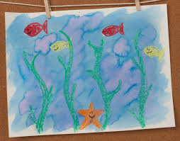 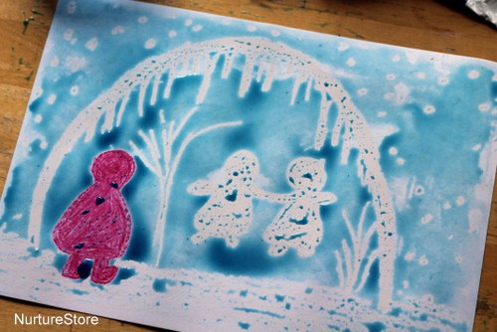 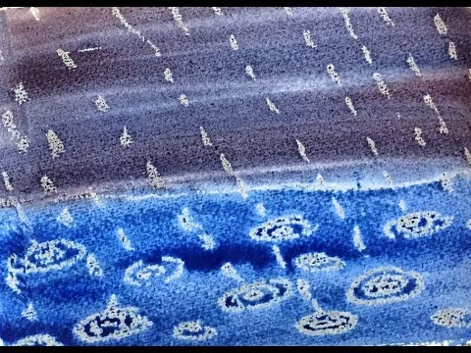

Idea 9
Using different colour chalk, drawn around the outline of the puddle then let it dry for an hour or two then using a different colour draw around the puddle again once the puddle has completely vanished colour in each section to make a rainbow pattern.


