Maths tasks week beginning 29th June 2020

This week children will develop their understanding of multiplication as repeated addition, understanding the difference between equal and not equal groups. They will use their knowledge of skip counting in 2s, 5s and 10s and will use concrete, pictorial and abstract representations to help them to find the total of multiple equal groups and of doubles. These representations will include arrays, a powerful way of developing multiplicative reasoning. This will then feed into their work on division in the following unit.

Task 1 - counting in 10s, 5s and 2s
We have done a lot of counting in 2s, 5s and 10s this year.
2s https://www.youtube.com/watch?v=8wwydguSKOU
https://www.bbc.co.uk/bitesize/topics/zqbg87h/articles/zc7ygdm
5s https://www.youtube.com/watch?v=_awKlEMyleA
https://www.bbc.co.uk/bitesize/topics/zqbg87h/articles/zw8qxfr
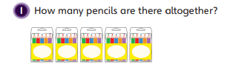
10s https://www.youtube.com/watch?v=uYRTtwZGwj8
https://www.bbc.co.uk/bitesize/topics/zqbg87h/articles/zq3rk2p
Ask children:
What do you need to know before you can count how many pencils there are?

How many jumps of 5 are you going to need to make?
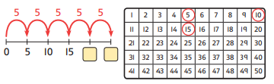
How do the jumps look similar and different on the number line and 100 square?

Are there any patterns you could use to help you count?
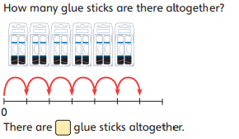
Here are some more questions for the children to use their skip counting skills to work out.
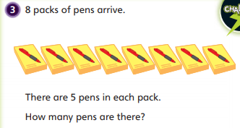

Task 2 Making equal groups
See video Week 5 maths 1
In this lesson, children will develop their ability to recognise and find equal groups of numbers and say how many groups of a number there are.
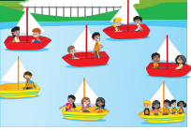
How many red boats are there?
How many people are there in each red boat?
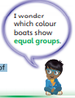
b) How many yellow boats are there?
Are there the same number of people in each yellow boat?

Use this picture to focus on why it is easier and more efficient to count the children in the red boats. See whether children can recognise that, as there are unequal numbers of children in the yellow boats, it is not possible to count using a repeating pattern.
Questions to ask your children:
- How did you count the total amount of people in the red boats?
- Which boats are easier to count?
- How could you show the groups on a number line?
- Is a ten frame useful for this count or not?
- Could the children in the yellow boats be grouped equally?
- How do you know?
- Is there more than one way to share the children in the yellow boats equally?

Let children explore sharing different numbers of objects into equal groups. Start with the children in the yellow boats. Children should discover that there is only one way to make equal groups: 3 groups of 3. 12 is a useful number to investigate as it can be shared into equal groups of 2, 3, 4 and 6.

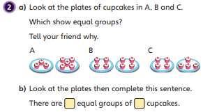
Children could make their own boats (this could just be a drawing) to share children into and use teddies, counters, stones as the children.
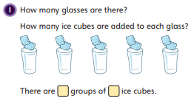

Were children able to recognise that equal groups can be arranged differently as long as they each contain the same number of objects?

Task 3 Making equal groups
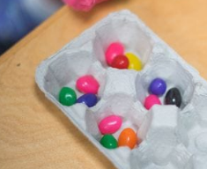
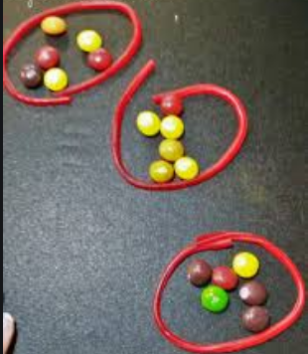
Experiment with making equal groups with different objects. Below are some examples of things you could use.
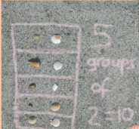

Keep going until you have gotten really good at making equal groups and being able to say (or write):
“There are X equal groups of X”.
For anyone who likes ato use work sheets see below.

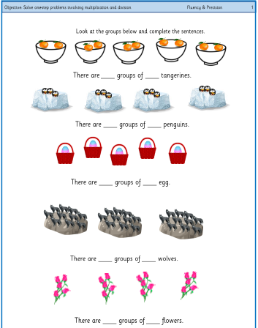

Task 4 adding equal groups
See video Week 5 maths 2

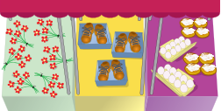
In this lesson, children will build on their understanding of equal groups and begin adding equal groups together to find a total.

Millie bought 3 bunches of flowers. How many flowers did she buy?

Ask children: How many flowers are in a bunch?
• Are all the bunches of flowers equal?
• What equal groups can you see?
• Can you see any unequal groups?
• How could you represent the groups you have just counted?
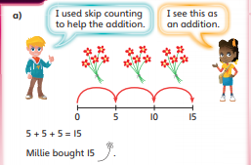
After children have had a go look at the different methods they could have used.

You could use skip counting to solve this problem and use a numberline or 100 square to help.

You may also use repaeted addition, so 5 + 5 + 5.

Look at the first picture again. Dan bought 5 pairs of shoes. How many shoes did he buy?

Ask the children:
• What do you need to know about the pairs of shoes before you can find the total?
• What number will you skip count in?
• How can you use a number line to represent the count?
• How can you show your counting as an addition?

Use concrete resources that can be used to represent the objects pictured. These could be arranged along a large printed number line to help children link the concrete with the abstract if needed. Encourage children to represent each of their skip counts along a number line and link them to an addition calculation.
See below for more problems to solve.
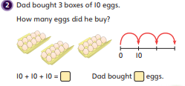
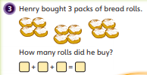
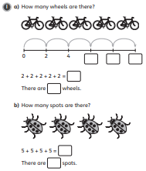
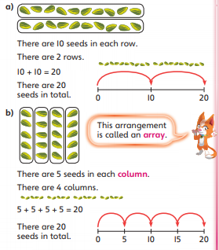
Task 5 Making simple arrays
See video Week 5 maths 2

Today we are looking at arrays. Do you remember doing an array hunt before half term? Talk to someone in your home about arrays and what they are. You could look again for the arrays you found around your house last time.

We are going to focus on the columns and rows or arrays for this task.

When you find arrays count how many items/sections there are in each row and how many rows there are. Then do the same with the columns.

It is imortant that you saw it as a sentence outloud,
“There are 5 seeds in each column. There are 4 columns.”

Then you can use skip counting to find how many there are in total.



