English tasks week beginning 29th June 2020

Task 1 and 2
See videos week 5 English 1 and 2
We are going to spend a few days doing a longer piece of writing this week. For this piece of writing you are going to write in role from Funni’s perspective, considering what she’s done so
far and what she feels at this point in the story.

To do this there are a few things to remember:
- Use your phonics knowledge to help spell words (you all have sound mats we sent home if you weren’t here on the last few days and would like one we can email one through or leave one at reception to collect)
- Use your diagram of Funni with your ideas about what she is thinking and feeling.
- Use capital letters and full stops.
- Use ‘and’ and ‘because’ to join sentences and ideas together.

I have split this into 2 sessions so you can write about Funni before she does anything to her special place and then add more to show what she does to it.

Remember to write about the special place, what Funni does to it but also how Funni is feeling. I have written an example on the video to give you an idea.

Task 3
See videos week 5 English 3
Watch the video and think about these questions:
o How did you feel when we turned the page?
o What made you feel this way?
o Why do you think they chose to present this spread differently to the rest of the story? How did it affect you when we turned the page and then turned the book?

Read the text aloud. Did this page surprise them or is it what they thought would happen? Look together at the text – how do you think the children feel about meeting each other? Investigate the contrast in Zoo ‘grinning shyly’ at first against the way his speech builds as he speaks to Funni about the garden. Do you think he is still feeling shy now? How do you think he feels around her now? How do you know?

You could write in your book how you think Funni is feeling or what she is thinking.
Zoo speaks here: “It’s awesome! I saw it and thought I must be dreaming!”
Practice saying this line and think about how you will deliver it and say it.

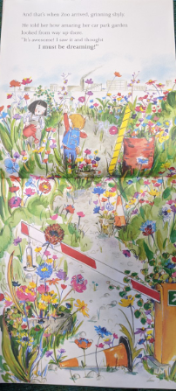
Task 4
On this page Funni and Zoo meet for the first time.
How do they think Zoo entered the scene – would he run in if he started off being shy?
o How do they think Funni will react to Zoo’s comments?

How do you think the scene might continue? What might they say or do next?

o Can they remember a time that they made friends with someone new?
o What did they do in the first moments?
o How did their friendships develop?
o What do they think Funni and Zoo might do now?

Write down activities and games that you might do when you are making friends with a new person.

Task 5
One or our targets in year 1 is to use various suffixes. Below is a short activity to complete that helps you to use the suffixes –er and –est.



