
Week beginning 29th June 2020 clean water and sanitation
Activity 1 https://www.allaboardforglobalgoals.com/en-us
scroll down to find goal 6- clean water and sanitation
https://www.bbc.co.uk/iplayer/episode/m000hlth/maddies-do-you-know-series-4-5-drinking-water-and-carrot
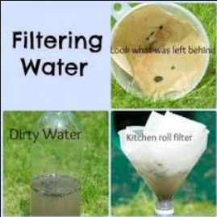
Experiment with cleaning water! You’ll need a coffee filter, sand, a jar and a bottle with dirty water. Make up some muddy water. Next talk about how this water probably would not taste very good. Explain how some children may not have clean water to drink. Clean the water. Have your child place the coffee filter and sand (covering the bottom of the filter) over an empty glass jar. Next, have your child slowly pour the dirty water into the jar through the filter. How does the filtered water look? Do you need to clean it again or is it clear enough to drink?
For older children, test different types of filters such as gravel, paper towel, etc. Make a chart of the cleanest to the dirtiest water with snapshots of the water in the jars.
Activity 2
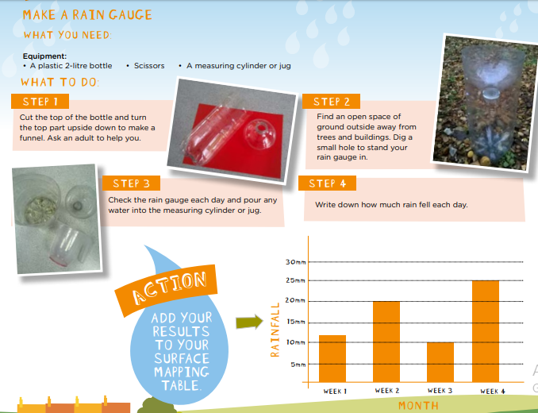
Make your own rain gauge and measure how much rain we have each day/week.

Activity 3
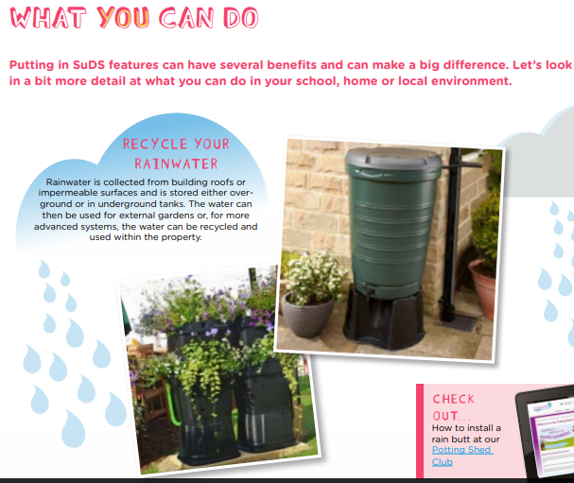

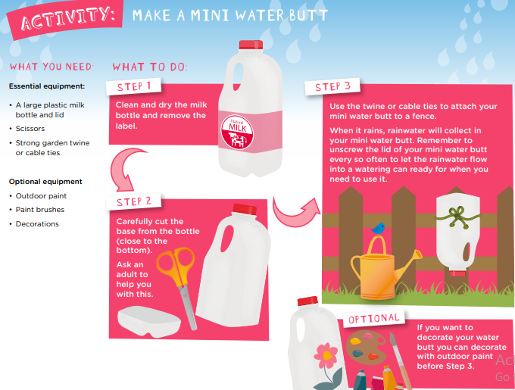
Activity 4
https://www.bbc.co.uk/cbeebies/watch/do-you-know-evaporation-song
watch Maddie’s song about evaporation then you can complete a science experiment.
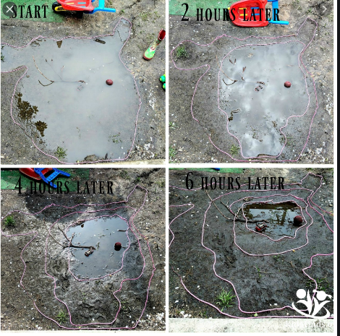
Wait for some rain to make some puddles (or make your own puddles!). Once you have a puddle chalk round the edge or use some string to place around the edge. Come back every hour or 2 (depending on the heat of the day) and mark the edge again.

Activity 5
Create your own miniature water wall, you will need something to catch the water at the bottom so as to not waste it.
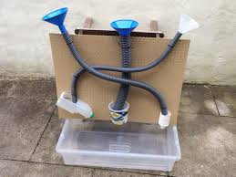
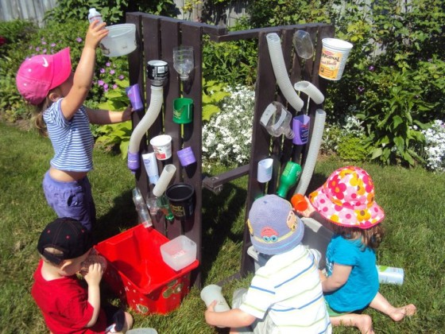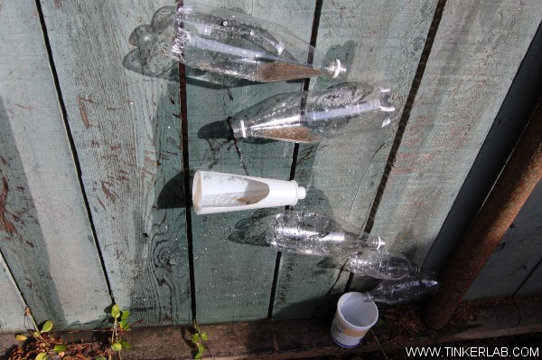
Activity 6
Try some wax and watercolour art. Use an old candle to draw a picture and then paint over it with some watercolour paints. What do you notice? Why do you think this happens?


