29.06.20
Good Morning Year 4,

This week’s theme for our learning is Clean water and sanitation. Make sure you have fun!

Task 1 | AM 20 min | Maths lesson.
Task 2 | AM 20 min | English lesson.
10:30 Snack time
Task 3 | AM and PM 2 x 20 min | TT Rockstars/Rodocodo/SPAG
12:30 Lunchtime
Task 4 | PM 20 min | Art activity
Task 5 | PM 20 min | History/Geography
Task 6 | PM 20 min | French/Skills Builder/RE
2:00 Snack time
Task 7 | PM 20 min | Science
Task 8 | PM 20 min | This could be finishing an activity from earlier or an activity from the general list.
Daily journal and reading

Mathematics Task 1 (20 min)
The activities listed below are key Mathematical areas that the children need to practise every week, they do not need to do them all every day, but pick one or two per day. These will be ongoing and you can complete them in any fun ways you can.
Key Mathematical areas;
Number - count in multiples of 6, 7, 9, 25 and 1000
Times tables recall multiplication and division facts for multiplication tables up to 12 × 12
Measures - Convert between different units of measure - kilometre to metre; hour to minute]
Money - estimate costs, compare costs and calculate amounts in £ and p
Time - read, write and convert time between analogue and digital 12- and 24-hour clocks
convert from hours to minutes; minutes to seconds; years to months; weeks to days.

Make sure you are practising your timestables as much as you can.
Abacus - The children can access this resource via the website https://www.activelearnprimary.co.uk
The password is year 4 and the school code kmm7 in the bottom box.

PLEASE NOTE YOU DO NOT NEED TO PRINT THESE SHEETS, YOU CAN ANSWER THEM ON PAPER.
Task 1 – Task 1 Maths lesson video. https://youtu.be/mY4zCrlIX-M
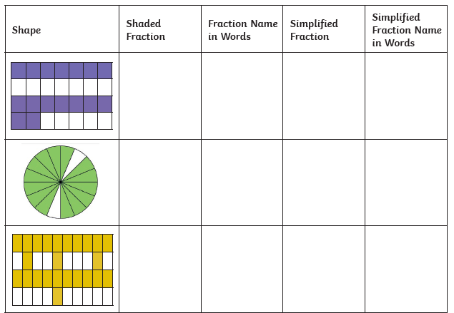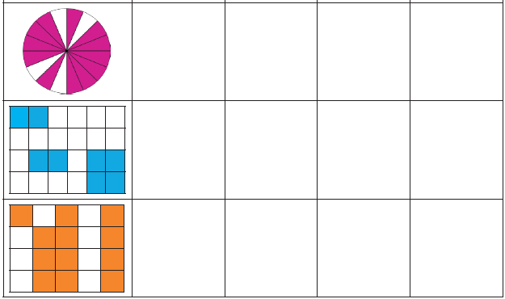

Answers
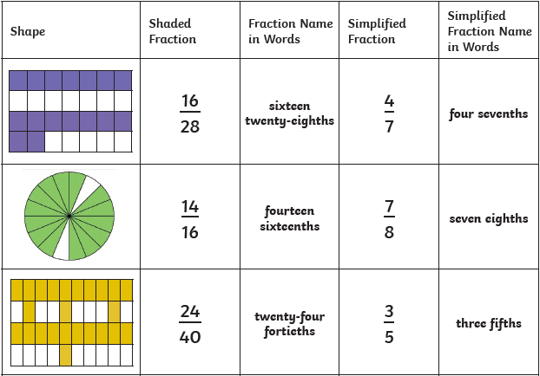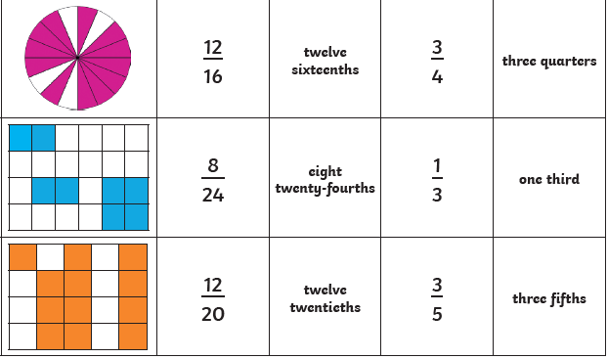

Task 2 – Task 2 Maths lesson video. https://youtu.be/7x1EBLW6dN0
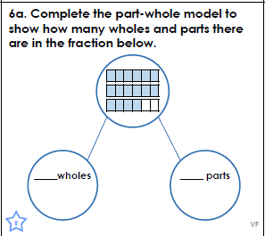
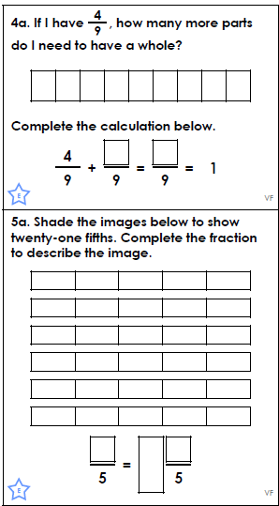
Answers
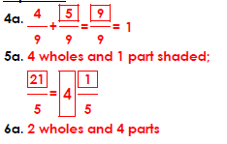

Task 3 – Task 3 Maths lesson video. https://youtu.be/Sjy5lyzC9Sw
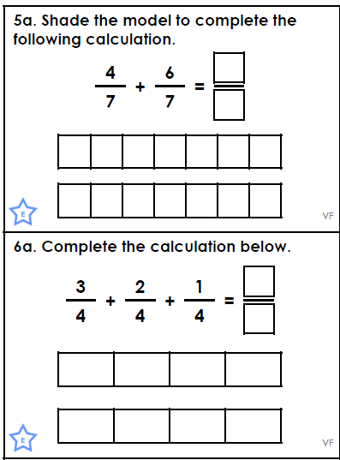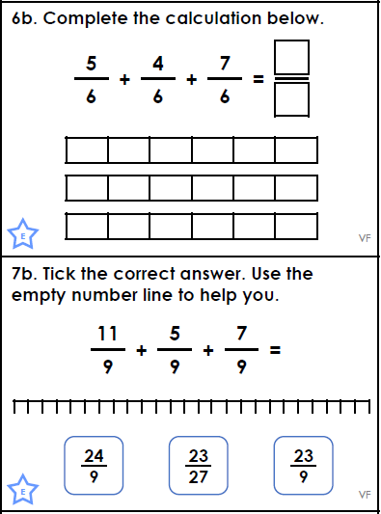
Answers
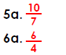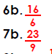
Task 4 – Choose a learning objective from the key Mathematical area list.
Task 5 – Time your grown up in the shower. If an average shower uses 9.5 litres of water a minute, calculate how much water they used in their shower. Now time yourself and calculate how much you used and compare these. You can time each family member and add these together to get your households daily use of water, just in showers. Then calculate an average water use for the week, in showers, of your household.

English Task 2 (20 min)
Task 1 - Power of reading, English lesson video. https://youtu.be/sfkN-4ZbJPQ
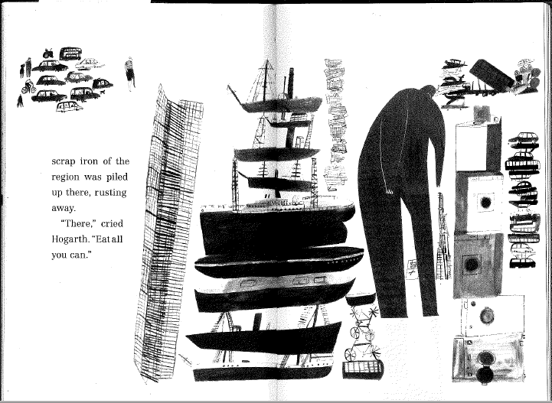
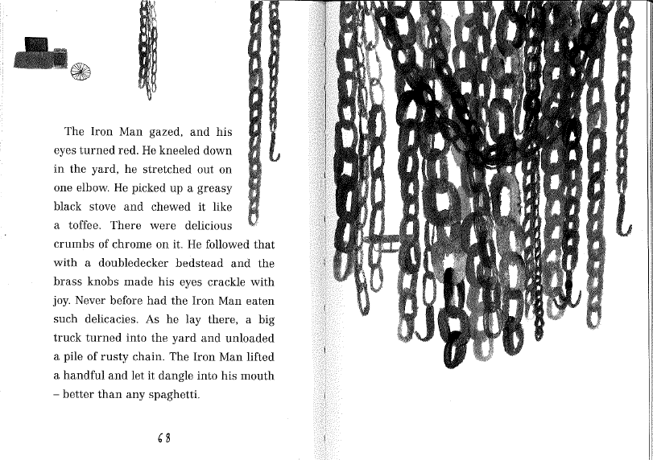
Task 2 - Power of reading, English lesson video. Part 1 https://youtu.be/Q3Da_8ngSps
Part 2 https://youtu.be/IrEzx_iVGBE

Task 3 – SPAG, English lesson video. Follow up activity sheets - varied fluency, application and reasoning. https://youtu.be/g5Dv7hGq9ac
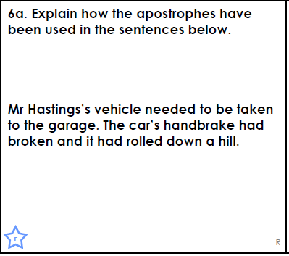
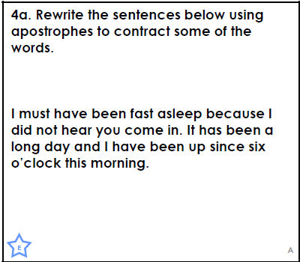
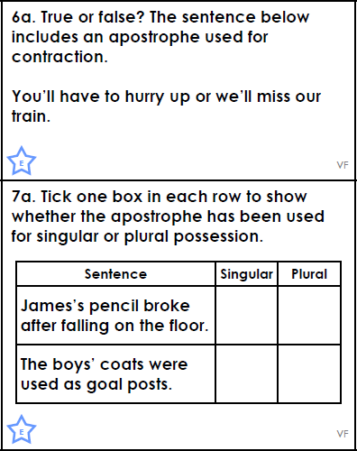

Answers
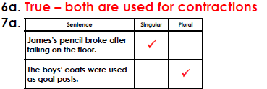
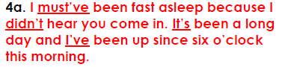
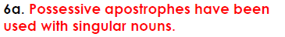

Task 4 – Comprehension
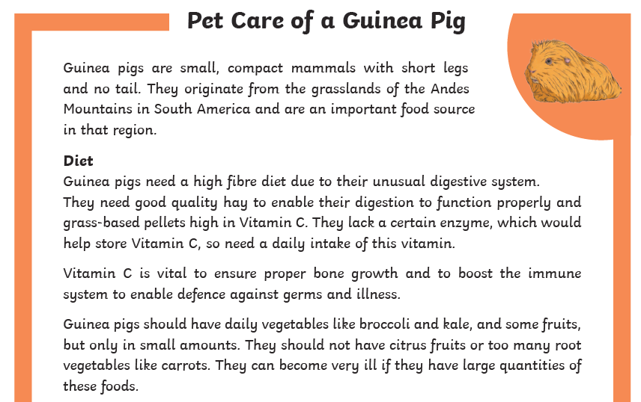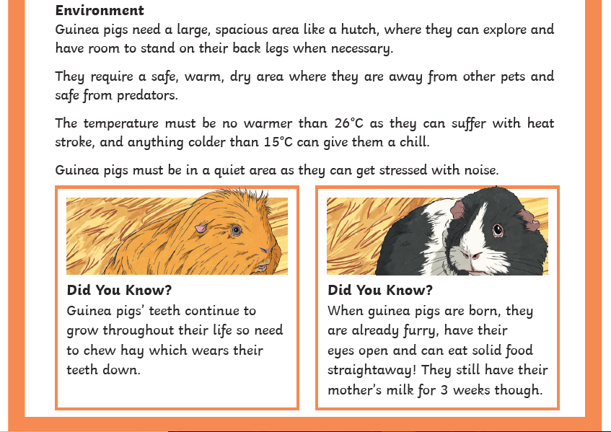
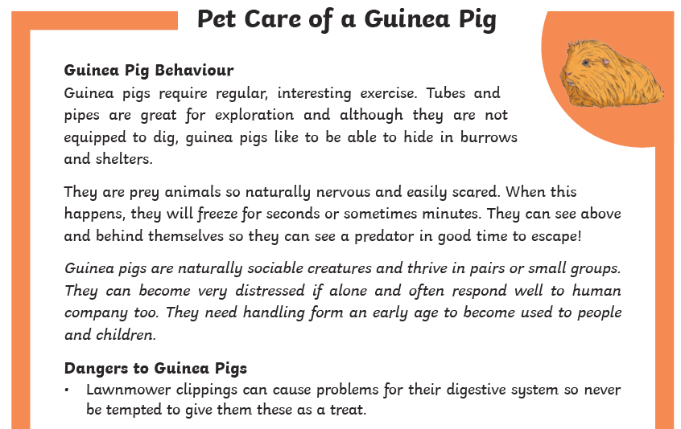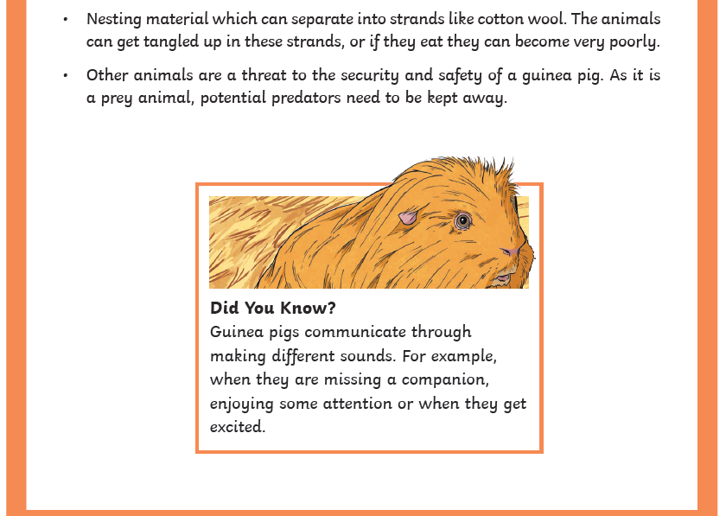
Questions
- What is the purpose of the first paragraph? Give as much detail as you can.
- Guinea pigs need two very specific foodstuffs. What are they, and why are they important to a guinea pig?
- Guinea pigs are not to be given citrus fruits. Name two such fruits.
- Explain why guinea pigs need to be housed in a specific temperature.
- Which of the Did you know….? facts surprises you the most, and why?
- Why are guinea pigs easily scared?
- How do you think a predator might interpret a guinea pig ‘freezing’ when it senses danger?
- Look at the paragraph in italics. Summarise the main point in that paragraph.
- What part of a guinea pig would be affected if it was given mown grass to eat?
- Imagine you are writing a label describing a guinea pig in a pet shop. In one paragraph, give the most important information to tell a potential owner about guinea pigs.
Answers
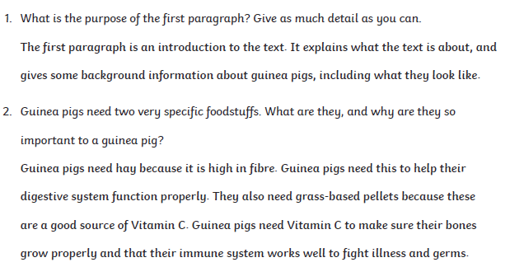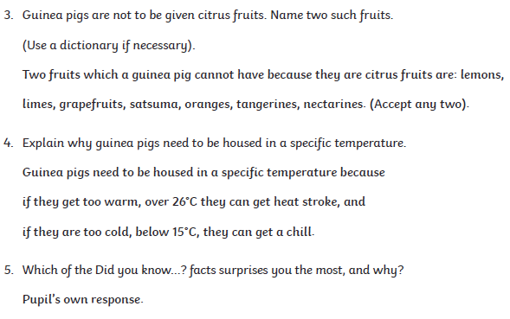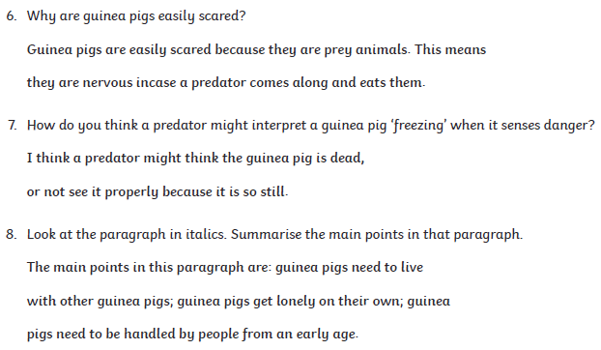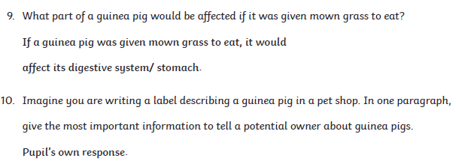

Task 5 –
Write a newspaper report about the space invader from The Iron Man. You have already come up with a headline, picture and caption. You may want to re-watch the video lessons to hear the story again to help you. Remember to include:
- who, what where, when, how/why
- facts (things which are true e.g. it’s the size of Australia)
- opinions (things which people think e.g. it’s evil and will destroy the world)
- quotes from people (you could use world leaders, villagers, Hogarth, the farmers)
- what might happen in the future
Reading
Remember to read EVERYDAY.
The Accelerated Reader (AR) programme is also accessible from home during this time too, so once you’ve finished your books make sure you log on and take a quiz. https://ukhosted43.renlearn.co.uk/2152328/default.aspx
Nessy - https://www.nessy.com/uk/

Task 3 (20 min)
Time Tables Rock Star - https://play.ttrockstars.com/auth/school/student/76329
Rodocodo - https://game.rodocodo.com/
SPAG – http://www.crickweb.co.uk/ks2literacy.html
Art/DT Task 4 (20 min)
Design a poster to convince people to save what and why. Remember to use persuasive vocabulary, make it eye catching and informative.
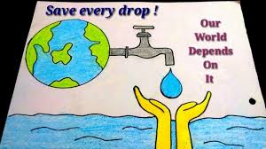
Collect the rain water or if you have a water butt use that. Make a picture with the water. You could do it on the pavement, on the fence, on card/paper or on a chalk board. See what natural colouring you could add or maybe if you have some add food colouring or marbling inks.
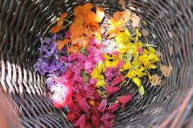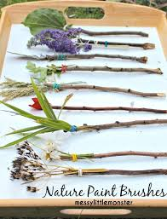

Global learning Task 5 (20 min)
PLEASE NOTE YOU DO NOT NEED TO PRINT THIS SHEET
Where does your water at home come from? Name some of the different ways people are getting water in the document called ‘Where does drinking water come from (other countries)’. Why is it different in other countries?
Think about these questions:
How heavy is the container? Can dust and dirt get into the water? Can the water slop out of the container? How much water would the container hold? How easy is it to carry the container?
Now try making an obstacle course outside (in your garden or an outdoor space nearby) for getting your water from its source (e.g. an outside tap or a bucket/ tub of water) to your ‘home’ (this might just be a marker so you know where to stop). You could try timing yourself to see how much water you can transport while spilling as little as possible/ how many times you can do before you get too tried/ how long it would take to transport the amount of water for your shower.
Task 6 (20 min)
French - (Log in – Username - Buckden Password – Starfish)
https://www.linguascope.com/
Skill Builder -
https://www.skillsbuilder.org/resources/rocketing-resolutions
GenR8
Science Task 7 (20 min)
Living things and their habitats – Go on an invertebrate hunt. You can draw this, you do not need to print it.
General activities
Remember to keep active!
- Yoga
- PE - Join Joe Wicks for a PE lesson. He is on YouTube every weekday.
https://www.youtube.com/watch?v=lEWcBIvqjDk
- Touchtyping - https://www.bbc.co.uk/bitesize/topics/zf2f9j6/articles/z3c6tfr
- Coding - https://scratch.mit.edu/
- Get in touch with a friend or family member
- Be mindful, do a random act of kindness for someone in your household.
- https://www.skulduggerypleasant.co.uk/books/
- https://www.anglianwater.co.uk/in-the-community/schools/learning-at-home/
In your journal you write:
- How you are feeling,
- What you have done (this can be any of the work you have done from the blog and anything that you have done whilst at home),
- What you have enjoyed each day.

