Clean Water and Sanitation
Hi everyone, we hope you and your family are well and staying safe.
Here are some ideas for you to be working on whilst you are at home this week.
Please continue with your daily journal to capture what you are doing at home during this time. In your daily journal you write:
- How you are feeling.
- What you have done. This can be any of the work you have done from the blog and anything that you have done whilst at home.
- What you have enjoyed each day.
Below is a table suggesting how much learning to do over a day with a year 5 child. These slots add up to 4 hours of learning, split into small chunks with breaks. Of course what is important is that you do what works best with your family. The work listed below is more than enough for 5 days of 4hr learning so choose the tasks that you would prefer to do.
Please also ensure that you include some daily physical activity, Joe Wicks uploads a PE lesson on YouTube every day, these are good fun and you can access these when you would like to.
We also expect that you read daily, whether this be a story, magazine, information book or poetry. You can complete AR quizzes using this link: https://ukhosted43.renlearn.co.uk/2152328/default.aspx

am 45 min | Maths activity
am 45 min | English activity
10:30 | Snack time
am 2 x 30min | TT Rockstars/Rodocodo/Nessy
12:30 | Lunchtime
pm 45 min | Something unfinished from the morning or maybe some art
pm 45 min | An activity from general activities list

Maths
Task 1 (45min a day)
Choose an area of maths from the list below, you only need to choose one area a day, you do not need to do all of them every day. Use this time at home to practise some real life math skills. By practising these skills, other areas of maths will become easier for you as well.
Numbers - read, write, order and compare numbers to at least 1 000 000.
You could read some different numbers that you find in books, newspapers. Write the numbers using numerals and words.
Measures - convert between different units of metric measure - kilometre and metre; centimetre and metre; centimetre and millimetre; gram and kilogram; litre and millilitre
Could you measure your garden, Bedroom, kitchen? What if you wanted to plant a new flower bed or build a den in your bedroom, how much space would it take up? How long would it be? If you go out for a daily walk, how far do you walk in metres? Kilometres?
Could you help in the kitchen to bake or cook dinner? Measure your ingredients carefully.
Times tables - Know multiplication and division facts up to 12 x 12
Money - estimate costs, add and calculate change in £ and p.
Can you calculate the cost of the weekly shop? What about change if you didn’t have the exact amount?
Time - tell the time using analogue, digital, 12 and 24 hour clocks.
Read the clock at different times of the day. What time do you wake up, have lunch, dinner, bedtime? Can you give those times using analogue, digital, 12 and 24 hour clocks.
Read and interpret a variety of time tables including, bus, train and tv guides. What time do your favourite programs start? How long do they last? Could you take a train from St Neots to London? How long is the journey? What time are the trains? etc

Task 2 (2 x 30 min per week)
TT rockstars https://ttrockstars.com/
Video tasks:
Lesson 1: https://www.youtube.com/watch?v=pPK5_dwt0Gs
1 pound (lb) = 16 ounces (oz)
1 ounce (oz) = approx. 28 grams (g)
1kg = approx. 2.2 pounds (lb)
1 stone = 14 pounds (lb)
- Which imperial unit would you use to measure: a) the weight of a cup? b) the weight of a dog?

- Choose the best estimate: A egg weighs, 2, 12 or 20 ounces?

- A box of oranges weighs 17lb. How many ounces is this equal to?

- Max’s cat weighs 11lb. Max says his cat has a mass of about 5kg. Is Max correct? Show workings to support your answer.

- A giant octopus has a mass of 7 stone and 2lb. What is its mass in pounds? What is its mass in kilograms?

- Find out how many pounds and ounces you weighed when you were born. Convert this mass into metric units.

Lesson 2: https://www.youtube.com/watch?v=ASNhozZ1RI8
Watch the video and then complete the questions below:
- 1 pint is approximately equal to 570ml. Copy and complete the bar model below by adding 570 each time.
1pt | 2pt | 3pt | 4pt | 5pt | 6pt | 7pt | 8pt
570ml | 1140ml | 1710ml

Use the bar model in question 1 to complete these measurements.
- 5 pints = __________ml
- __________ pints = 4560ml
- 3 pints = __________ml
- 1litre 450ml = __________pints
- __________ litres __________ml = 6 pints
- __________ pints = 3.99 litres
- ½ pint = __________ millilitres

- There are 8 pints in a gallon. Which measurement is nearest to 1 gallon?
4 litres / 4 ½ litres / 5 litres. Explain your answer.

- Luis’s mother wants to fill up her car with 10 gallons of fuel. At petrol station A, fuel costs £5 per gallon. Petrol station B charges £1 per litre.
- Which petrol station is cheaper? (show your working)
- How much money does Luis’s mother save by going to this petrol station?

- You have been asked to buy 2 pints of milk. It is only sold in litres. How many litres would you buy? Explain your answer.

Lesson 3: https://www.youtube.com/watch?v=WagaSjRs5CI
Watch the video and then complete the questions below:
- How many minutes is a 310 minute rail journey? (draw a bar model to help you)
- How many minutes is a 195 second pop song? (draw a bar model to help you)
- Two films have different running times. King of the Penguins lasts for 2 hours and 7 minutes. Escape from Planet Zarg lasts 137 minutes. Which film is longer? (draw a bar model to help you find the answer)
- James says ‘4.25 hours is 4 hours and 25 minutes’. Is James correct? Explain your answer.

English
Task 3 (5x 30 min)
Read every day
Video tasks:
Lesson 1: https://www.youtube.com/watch?v=J-US8TpfJB0
Lesson 2: https://www.youtube.com/watch?v=mU_Y8lLwl3o
Web links to help with research about workhouses:
http://bit.ly/homeworkhelp_workhouses
http://bit.ly/tour_workhouses
https://victorianchildren.org/

Lesson 3: https://www.youtube.com/watch?v=aONpTAj6UPM
After watching the video, please complete these tasks:
Identify an antonym of the following words: predictable, assist, important, encourage, permanent.
Complete each sentence using two words that are antonyms of each other.
- This __________ piece of music was written by a composer who was __________.

- If I __________ you this parcel in the post, will you be there to __________it?

- Cotton is a __________ material but nylon is a __________ fabric.

- The first attempt was a __________ but the second attempt was a __________.

- The doctors hope that his condition will __________ and not __________.

- The accused said that he was __________ but the judge decided he was __________.

Geography
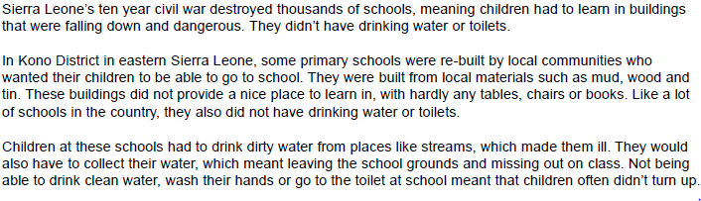
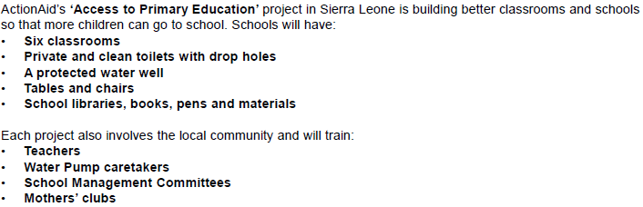

Here is an example of how they have helped build a school:

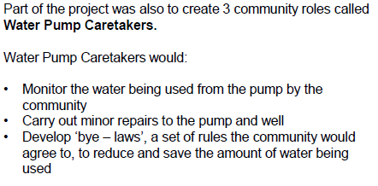
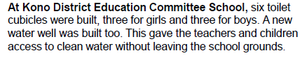
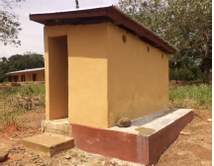
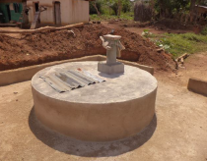

Here are some questions for you to answer:
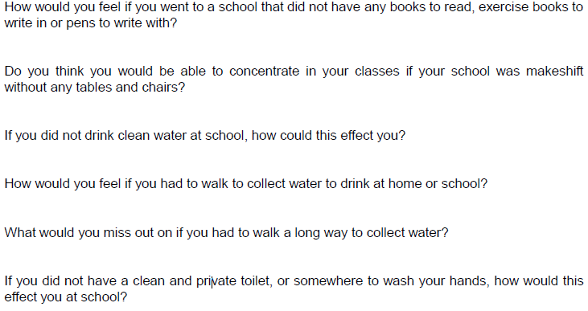
Science
In your recycling, look for a clear water bottle with a lid.

Now add some water to the bottle.

Then go into your garden and add some soil to it, maybe some sand if you have it. You could also add some stones or other items that you find. Make sure that you don’t pick up anything that you shouldn’t or might be a hazard.

Now give your bottle a good shake….would you drink that water?

All water that we drink has to be filtered in order for it to be safe for us to drink. There are still many people around the world that have limited or no access to clean water, which of course is very bad for their health.
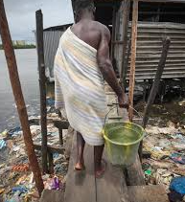

So, guess what your challenge is…..

How can you filter the water in order to make it as clean as you possibly can?

The larger items might be more obvious, but the really murky water with small bits in might be harder. If you are stuck for ideas you could do some research.

How clean did can you get your water? Please don’t taste it to test but you might want to take pictures of before, during and after to compare.

It would be really great if you could write out a set of instructions so that other people could filter dirty water in the same way that you have.

Art
Many photographers enjoy taking photographs of reflections, some then recreate them by drawing and painting them. Here are some examples below.
When you are out for a walk or as you spot a puddle in the garden or if you are doing some washing up, what reflections do you spot, taking a photo of it and recreate it yourself by drawing it and then painting.

Photographs:
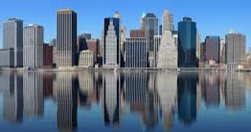
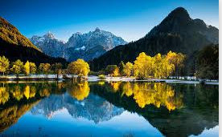

Paintings (not of the photos above):
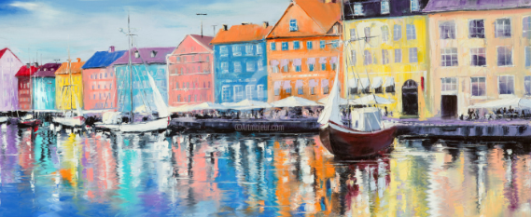
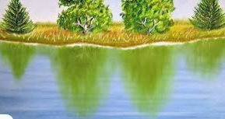

Maths – Lesson 1 (answers)
- a) ounces b) pounds
- 2 ounces
- 272 ounces
- Yes
100lb / 45kg

Maths – Lesson 2 (answers)
1.
1pt | 2pt | 3pt | 4pt | 5pt | 6pt | 7pt | 8pt
570ml | 1140ml | 1710ml | 2280ml | 2850ml | 3420ml | 3990ml | 4560ml

a) 5 pints = 2850ml
b) 8 pints = 4560ml
c) 3 pints = 1710ml
d) 1 litre 140ml = 2 pints
e) 3 litres 420ml = 6 pints
f) 7 pints = 3.99 litres
g) ½ pint = 285 millilitres

2. 4 ½ litres
3. a) 1 gallon costs £5 at petrol station A but only £4.56 at petrol station B. Petrol station B is cheaper.
b) She saves £4.40
4. 1 pint is approximately 570ml so 2 pints is about 1,140ml. So, you could buy 1 litre if you don’t need exactly 2npints of milk. If you need at least 2 pints then you will need to buy 2 litres and you will have some left over.

Maths – Lesson 3 (answers)
- 5 hours and 10 minutes
- 3 minutes and 15 seconds
- 2 hours and 7 minutes = 127 minutes, 137 minutes = 2 hours and 17 minutes. Escape from Planet Zarg is longer.
- No, James is not correct.
0.25 of an hour is a quarter of an hour, which is 60 minutes ÷ 4 = 15 minutes

English – Lesson 3 (answers)
Predictable / unexpected
Assist / hinder
Important / insignificant
Encourage / dissuade
Permanent / temporary
- Famous / unknown
- Send / receive
- Natural / synthetic
- Success / failure
- Improve / worsen
- Innocent / guilty

