22nd June 202
Dear Kenny class,
We can see that lots of you have been having an amazing time with all the photos coming in, keeping them coming. Hopefully you will have the opportunity to watch the videos that have been put up a long with this week’s plan. There are Maths and Phonics videos to help guide you through the week. The videos won’t be long and might need to be paused at certain times while you are asked to do something. The work you produce this week can be emailed to EYFS@buckdenacademy.org.
This is a suggestion of how much learning to do over a day with a reception child. Aim for a maximum of 2 hours focused learning interspersed with play based learning and physical activity. Of course what is important is that you do what works best with your family. The work listed below is more than enough for 5 days of learning so choose the tasks that you would prefer to do.
am 30 min | Sports/ physical activity- try Boogie Beebies for a change if you like or cosmic yoga
am 20 min | Maths activity – Length, Height and Distance.
am 20 min | Fine Motor control activity- like lego, puzzle, drawing, writing, cutting.
10:30 | Snack time- can you help prepare it?
am 2 x 20 min | Reading/ Sharing a story/ Phonics online game- see ideas below  Focus on Phase 3 – embed the learning – ‘qu’,’ch’,’sh’
12:30 | Lunchtime
pm 1 hour or longer if you are having fun! | An activity from the ideas below and/or independent learning through play time where your child makes choices.
Pm 20 min | Complete your journal for the day- draw and or write

Maths
Length, Height & Distance -
- Go on a scavenger hunt around your house and garden, collect different resources like a flower, a pencil, a teddy (you can choose anything). Can you put them in size order from smallest to tallest or tallest to smallest and say which is taller and which is smaller?
- With the food you have been growing from the responsible consumption, can you keep a measure of their height?
- Cut out footprints and place them toe to heel. How many footprints does it take to get from your front door to the different rooms in your house?
- Make a tower (skyscraper) using block construction (e.g. lego/ duplo) then measure using different objects i.e pencil sharpeners, fingers, toes, paperclip, cd’s etc.
- Create or use a small vehicle, start at the same place and push each vehicle. Which went the furthest distance?
- Can they organise members of your household into tallest and shortest?
- Can you create a 2 metre guard and space things in your house 2 metres apart?

Phonics- Recap phase 3 – make sure it is stuck in! Continue with ‘qu,’ ‘ch,’ ‘sh’
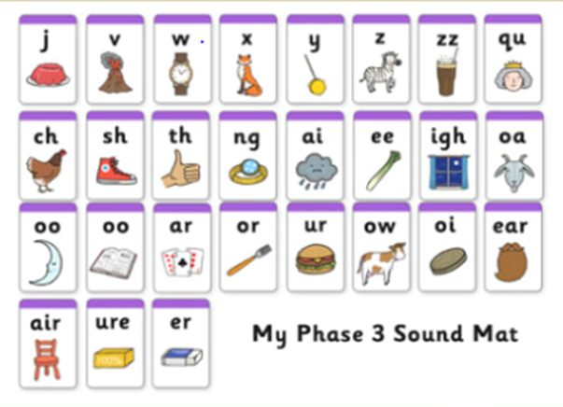
- House hunt - find objects in your house or garden, that start with the sound.
- Treasure or trash – write some words on pieces of paper, or using objects children decide whether the word starts with one of our sounds (treasure) – put these words in a ‘special box’ and if it isn’t treasure then its trash – put these words in the ‘bin.’ Alternatively, use https://www.phonicsplay.co.uk/BuriedTreasure2.html
- Sound detectives – Read through your favourite story books, find the sound, and talk about where it appears in the words.
- Word builder – using letters/sounds written on Lego blocks and joined together.
- Think of any words that have the sounds in and join together to make some silly sentences.
- Use a timer, how many times can you write the sound in 1 minute. Or repeat but writing of words containing our sounds.
- Pirate ship game – write the letters up and attach them to walls (one sound per wall) say a word and they have to run to the correct sound.
- Fashion 3 spaces near each other and label each with a sound, kick a ball or throw an item into the box and say the sound that it corresponds to.
- Create a your phonics game.
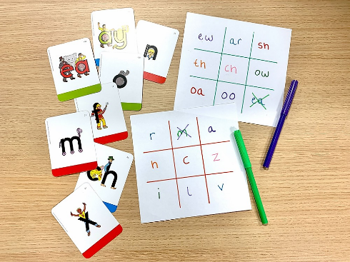
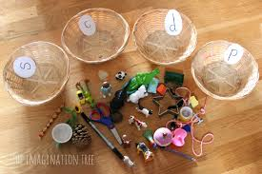
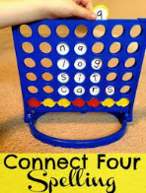

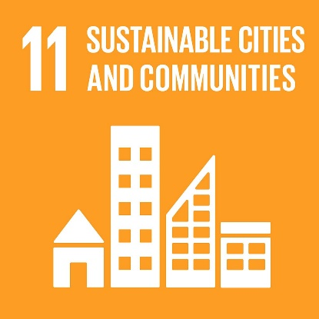
Sustainable Cities

Idea 1
Using box craft or construction to create your own city.

Idea 2
Go for a walk and count how many houses have solar panels. Use this time to discuss what solar panels do and are for.

Idea 3
Be an Eco-warrior. Go round your house and make sure all taps are turned off and light switches are off during the day, recycling is put in the correct bin.

Idea 4
Solar power experiment – take two plastic bottles paint one white and one black. Then place on unblown balloon onto of each bottle then leave them out in the sun. What happens? OR you could attempt to recreate this experiment = https://www.youtube.com/watch?v=qWc6Z-NEjR0

Idea 5
Talk about these 3 types of renewable energies. Then design your own building showing how you would do these. Maybe a turbine on the top or surrounding the building, solar panels as window a waterfall coming off the roof down the side onto a turbine.

Idea 6
Write your own or change verse to this song = https://www.youtube.com/watch?v=8DJ45Yc3urg

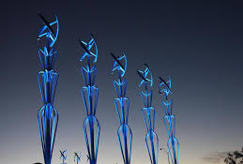
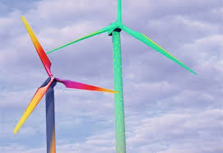
Idea 7
Walk around your village and keep an eye out for wind turbines. How do they work?
Design your own wind turbine.
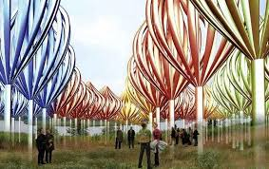

Idea 8
Look our your window and do a tally chart of how many people you see on bicycles – good for the environment and cars – not good for the environment (unless they are electric)
Idea 9
Listen and watch this story https://www.youtube.com/watch?v=RwoZ5ZVpfIU – What did you notice about where the robot lives? How could you make it better?
Idea 10
Explore this website = https://kidzania.co.uk/whats-inside/all-activities/tv-studio
It is a fun place in London that is like a mini-city. There is information about lots of different roles to support how a city is run. Which one do you like best Can you dress up a pretend to be that person for the day?
Idea 11
There is an artist called L.S Lowry who is famous for painting cities. Can you take one of his pictures and add to it to make it eco-friendlier?



