22.06.20
Good Morning Year 4,

This week’s theme for our learning is Sustainable cities. Make sure you have fun!

Task 1 | AM 20 min | Maths lessons
Task 2 | AM 20 min | English lessons
10:30 Snack time
Task 3 | AM and PM 2 x 20 min | TT Rockstars/Rodocodo/SPAG
12:30 Lunchtime
Task 4 | PM 20 min | Art activity
Task 5 | PM 20 min | History/Geography
Task 6 | PM 20 min | French/Skills Builder/RE
2:00 Snack time
Task 7 | PM 20 min | Science
Task 8 | PM 20 min | This could be finishing an activity from earlier or an activity from the general list.
Daily journal and reading

Mathematics Task 1 (20 min)
The activities listed below are key Mathematical areas that the children need to practise every week, they do not need to do them all every day, but pick one or two per day. These will be ongoing and you can complete them in any fun ways you can.
Key Mathematical areas;
Number - count in multiples of 6, 7, 9, 25 and 1000
Times tables recall multiplication and division facts for multiplication tables up to 12 × 12
Measures - Convert between different units of measure - kilometre to metre; hour to minute]
Money - estimate costs, compare costs and calculate amounts in £ and p
Time - read, write and convert time between analogue and digital 12- and 24-hour clocks
convert from hours to minutes; minutes to seconds; years to months; weeks to days.

Make sure you are practising your timestables as much as you can.
Abacus - The children can access this resource via the website https://www.activelearnprimary.co.uk
The password is year 4 and the school code kmm7 in the bottom box.

PLEASE NOTE YOU DO NOT NEED TO PRINT THESE SHEETS, YOU CAN ANSWER THEM ON PAPER.
Task 1 – Task 1 Maths lesson video. Part 1 https://youtu.be/Lkhe5vLFrT4
Part 2 https://youtu.be/UMzlnOCzNoM
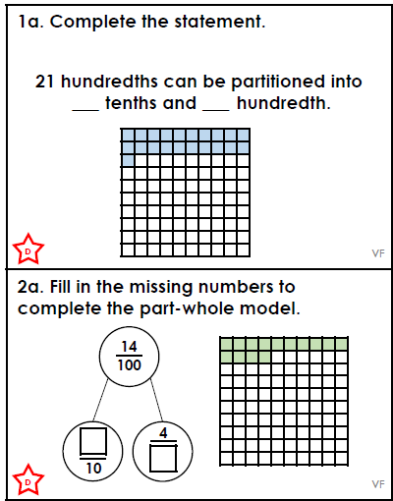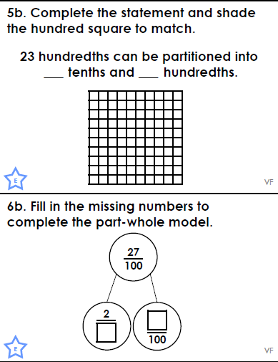
Answers
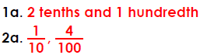
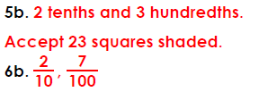

Task 2 – Task 2 Maths lesson. https://youtu.be/KanIBYrJIrs
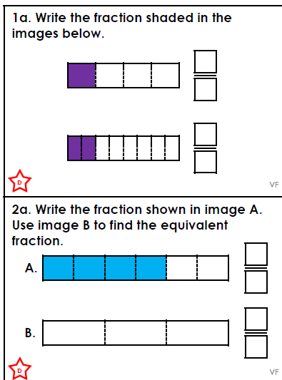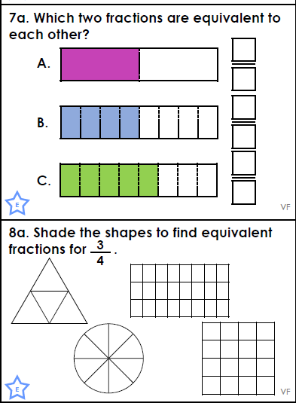
Answers
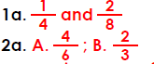
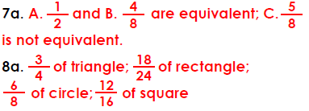

Task 3 – Task 3 Maths lesson. https://youtu.be/ItJIoCP7EDY
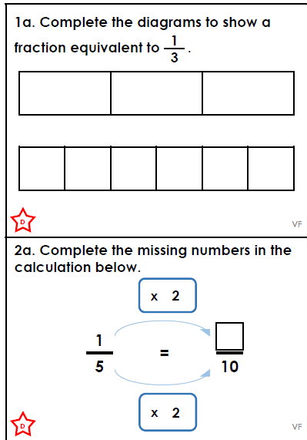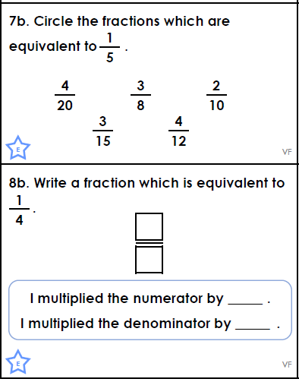
Answers
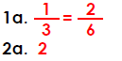
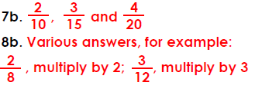
Task 4 – Choose a learning objective from the key Mathematical area list.

Task 5 – Hundredths practice
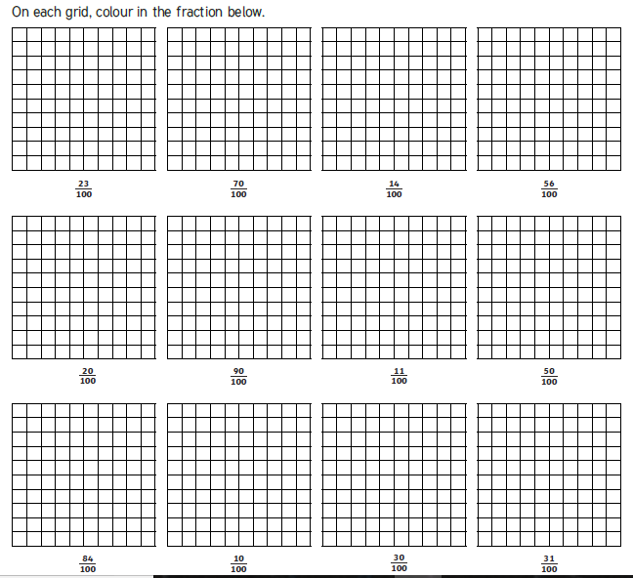

English Task 2 (20 min)
Task 1 – Power of reading, English lesson video. https://youtu.be/U8MRQRsr2pY
Task 2 – Power of reading, English lesson video. Part 1 https://youtu.be/J9Wj_S9ci1w
Part 2 https://youtu.be/jb8xSwy0CYM

Task 3 – SPAG, English lesson video. Follow up activity sheets - varied fluency, application and reasoning. https://youtu.be/8ORjZYX6GoQ
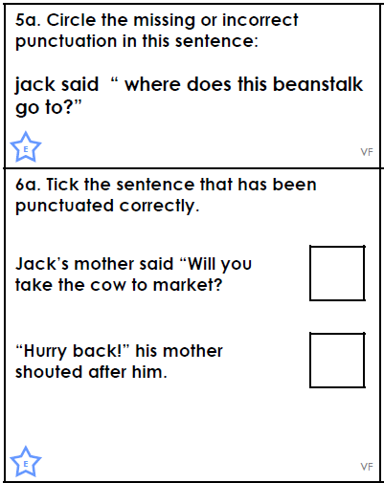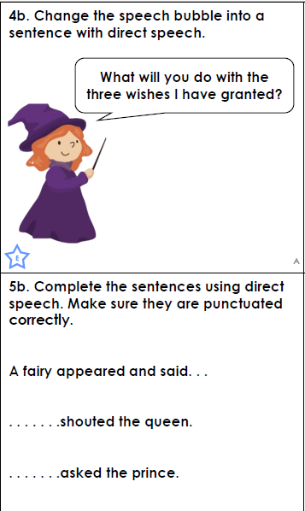
Answers
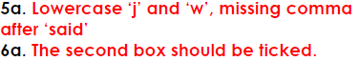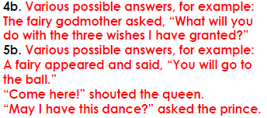

Task 4 – Design your own sustainable city and plan a presentation to a new developer. Remember your persuasive vocabulary, to consider what makes your city sustainable and what features it will have to prove to the developer your city is the one to build.

Task 5 – Now present your presentation, maybe someone at home could film it and ask you questions. You could do a presenting Skills Builder task to get you prepared.
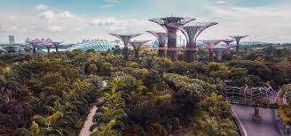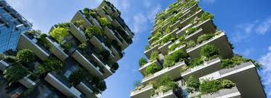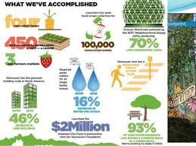

Reading
Remember to read EVERYDAY.
The Accelerated Reader (AR) programme is also accessible from home during this time too, so once you’ve finished your books make sure you log on and take a quiz. https://ukhosted43.renlearn.co.uk/2152328/default.aspx
Nessy - https://www.nessy.com/uk/
Task 3 (20 min)
Time Tables Rock Star - https://play.ttrockstars.com/auth/school/student/76329
Rodocodo - https://game.rodocodo.com/
SPAG – http://www.crickweb.co.uk/ks2literacy.html

Art/DT Task 4 (20 min)
Create a lego brick print city.
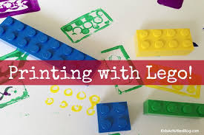
Build a 3D sustainable city with recycling materials.
Global learning Task 5 (20 min)
Research and identify the geographical features (roads, waters, green space, climate, population). You can use the word mats as prompts for research of Milton Keynes and Welwyn garden city and compare and contrast the two regions.
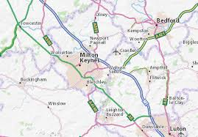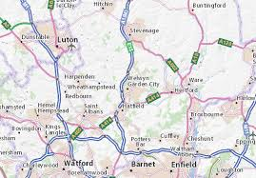
Task 6 (20 min)
French - (Log in – Username - Buckden Password – Starfish)
https://www.linguascope.com/
Skill Builder -
https://www.skillsbuilder.org/resources/rocketing-resolutions
GenR8
Science Task 7 (20 min)
Living things and their habitats – Complete the Vertebrates activity sheets. You can draw this, you do not need to print it.
Go outside and explore as many different habitats as you can.

General activities
Remember to keep active!
- Yoga – Cosmic Kids, Go noodle
- PE - Join Joe Wicks for a PE lesson. He is on YouTube every weekday.
https://www.youtube.com/watch?v=lEWcBIvqjDk
- Touchtyping - https://www.bbc.co.uk/bitesize/topics/zf2f9j6/articles/z3c6tfr
- Coding - https://scratch.mit.edu/
- Get in touch with a friend or family member
- Be mindful, do a random act of kindness for someone in your household.
- https://www.skulduggerypleasant.co.uk/books/
- https://www.anglianwater.co.uk/in-the-community/schools/learning-at-home/
In your journal you write:
- How you are feeling,
- What you have done (this can be any of the work you have done from the blog and anything that you have done whilst at home),
- What you have enjoyed each day.

