22nd June
Dear Year 2,
Hello everyone! It was lovely to speak to you all again this week. The theme for the blog this week is ‘Sustainable Cities’ I hope you enjoy some of these activities.
I hope you are enjoying writing your daily journals to capture what you are doing at home during this time. Remember to write in your journal:
- How you are feeling
- What you have done. This can be any of the work you have done from the blog and anything that you have done whilst at home.
- What you have enjoyed each day.
I can’t wait to see your journals which will be shared upon our return to school with your classmates!
If you would like to take some photos of your work to show, me you can send them to the school office! I have loved seeing the videos/photos/work that you have been sending in.
Take care and stay safe
Hopefully I will see you all soon
Mrs Jaynes and Mrs Tarpey
x
This is a suggestion of how much learning to do over a day with a year 2 child. These slots add up to 2 hours of learning, split into small chunks with breaks. Of course what is important is that you do what works best with your family. The work listed below is more than enough for 5 days of 2hr learning so please choose the tasks that you would prefer to do with your child. Also don’t forget to do some exercise and read every day!
am 20 min | Maths activity
am 20 min | English activity
10:30 | Snack time
am 2 x 20 min | TT Rockstars/Nessy
12:30 | Lunchtime
pm 20 min | Something unfinished from the morning or maybe some art
pm 20 min | An activity from general activities list

Sustainable Cities

Maths

Task 1
Watch the clip
https://youtu.be/1-d73w_VYdI
Find a selection of, about 20, small objects around your house (rubbers, stones, beads, buttons etc). Use these objects to recap grouping and how to set out an array.
Can you make arrays using your concrete objects for the following:
2 groups of 10, 5 groups of 4, 10 groups of 1, 7 groups of 2, 6 groups of 3, 3 groups of 5

Task 2
Watch the clip
https://youtu.be/zYhZiGyJhpc
Drawing arrays. Recap and practise how to draw an array to match the given calculations below. Remember to set your array out clearly to make it easier to understand.
2x6, 8 groups of 3, 10x2, 3x9, 5x7, 9 groups of 2, 6 groups of 5
Task 3
Watch the clip
https://youtu.be/SaULbkqYGDU
Matching arrays, repeated addition and multiplication calculations.
Complete the set for these multiplication calculations:
3x4, 6x2, 10x7, 8x5, 2x9, 5x4, 7x3, 2x10
Task 4
Can you apply these methods to help you answer the following questions:
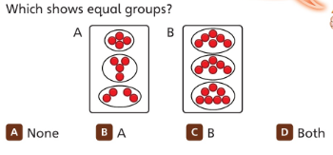
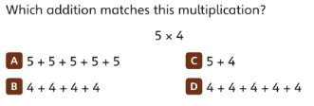
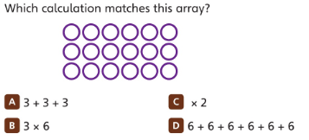
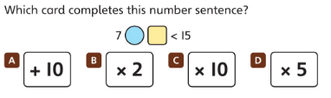
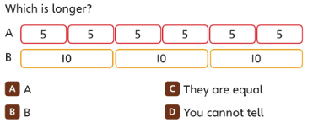
Task (20 min a day)
The following activities are ongoing tasks and should be practised every week at times that would suit you best. You do not need to do them all every day, pick one or two per day.
Number - count in steps of 2, 3, and 5 from 0, and in tens from any number, forwards and backwards
Know number bonds to 20
Times tables - recall and use multiplication and division facts for the 2, 5 and 10 multiplication tables (Try making mini times tables booklets)
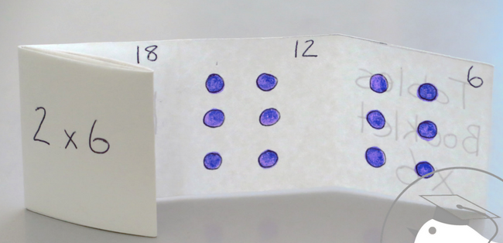
Time - tell and write the time to five minutes, including quarter past/to the hour (on an analogue clock)
Know the number of minutes in an hour and the number of hours in a day.
Money - Recognise different monetary coins, find different combinations of coins that equal the same amounts of money
Measure - measure items in cm/m, kg/g, l/ml

Task (2 x 20 min per week)
TT Rockstars https://ttrockstars.com/

Task (2 x 20 min per week)
Abacus https://www.activelearnprimary.co.uk/login?c=0

English
Remember to read every day

Task 1
Watch the clip
https://youtu.be/E0tu8_89CrI
Alternatively all of the information contained in the videos is written below.
Compare the pictures of the Egg Box Dragon (see attached file). What do we already know about the Egg Box Dragon? Has it changed? If so, how? Try to use some of these words when comparing; so, if, but, because, when

Task 2
Watch the clip
https://youtu.be/xXUJhVF4Dcg
Alternatively all of the information contained in the videos is written below.
Use the outline of Egg Box Dragon (see attached file). Around the outline of the picture, think about how we can describe it. What can we see? Then inside the dragon think about some of the dragon’s characteristics and note them down.

Task 3
Watch the clip
https://youtu.be/4BGdZ6xCTOc
Alternatively all of the information contained in the videos is written below.
Read the poem (see attached file). Can you look at the poem and highlight any patterns that you can see? Now using the notes from the previous task, to turn your ideas into a poem that follows the same pattern as the BeWaRe one.

Task 4
Watch the clip
https://youtu.be/fY00rcpyewk
Alternatively all of the information contained in the videos is written below.
A bit of fun for the end of the week. Perform your poem from the previous task. Think about how each line or verse may be said, could you add actions in. It’d be lovely for other people at home to join you!

Task (if you have a password 2 x 20 min)
Nessy https://www.nessy.com/uk/

Spelling
Words ending in –tion
Eg; station, fiction, motion, section, action, nation, position, location

Science
Task
What is a green roof? Watch this video to find out all about green roofs
https://www.youtube.com/watch?v=RRta4aGJKfc
Try to make a green roof
https://www.youtube.com/watch?v=jUh6R1hs2Tw
This video shows how to make a building with a green roofout of a shoe box.
- Use an upturned shoe box as a building with the upturned lid to make a green roof.
- The shoe box is decorated to look like a building.
- Line the lid with tinfoil and fill with compost.
- Add some grass seed or maybe cress or mustard seeds
- Water and place on a bright warm window sill and wait for it to grow.
What are all of the benefits of having a green roof? Make a poster to try to persuade everybody to introduce a green roof somewhere in their property.

Geography
Task 1
Watch this Thomas video to learn about the good and bad things about cities.
https://www.facebook.com/globalgoalsUN/videos/thomas-and-friends-goal-11/482158012716253/
Can you make a list of all of the benefits of a city and another list about the problems that are in a city?

Task 2
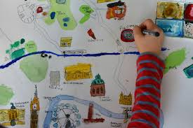
Design a bird’s eye view map or a picture of a sustainable city.

Try to include:
- Alternative ways to travel other than the car. e.g. cycle lanes
- Green spaces e.g. parks
- Ponds and lakes for wildlife
- Wildflower spaces
- Window boxes
- Quality housing for everybody with nobody living on the streets
- Lots of trees
- Green roofs
- Rail way lines
- Cable cars?
- Trams
- Electric car charging points
- Solar panels to supply energy
- Wind turbines
- Recycle points
- Rubbish bins
- Markets to sell local produce
- Community allotments
- City farms
- Museums

Art
Task 1 (1x 20 min sessions)
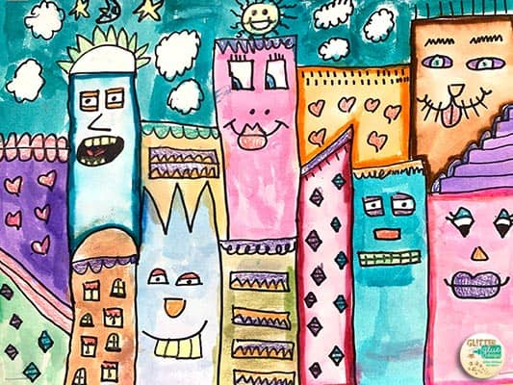
Draw a picture of a happy city. Think of 5 reasons why your city and its people are happy e.g. low pollution, and show those reasons in your picture e.g. clear skies, lots of plants, green rooves and clean buildings.

Task 2 (1 x 20 min sessions)
Draw a picture of city wildlife.
Lots of animals live in the city. Urban rewilding projects are tempting nature back into our cities, from creating city butterfly meadows to building unlikely homes for deadly birds of prey.
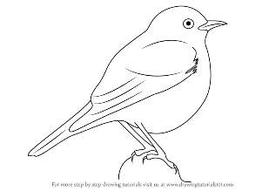
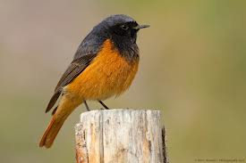
The middle of London’s hectic West End doesn’t seem like the likeliest location for one of the UK’s rarest birds. There are only an estimated 20-40 breeding pairs of black redstarts in the country. But in recent years, without being artificially introduced into the area, this rare bird has started to make a home in this crowded part of Central London.

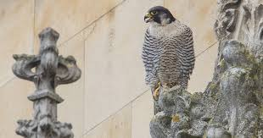
There are Peregrine falcons living in Cambridge at the moment.
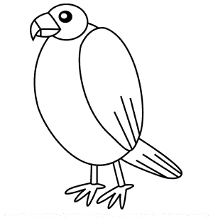

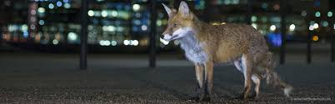
Foxes can often be seen in cities. Can you draw a fox and draw the city around him?
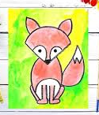

Computing
https://www.rodocodo.com/

