Maths tasks week beginning 22nd June 2020
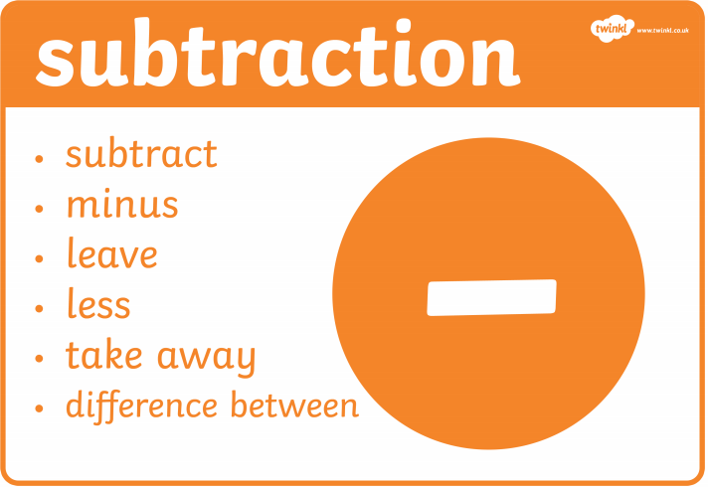
Task 1 – what is subtraction, take away using objects
What do we mean by subtraction? Talk about what it means. Can you create a poster with at the different ways we say subtraction or you might see a subtraction problem worded?
When you have done this use objects of your choice to solve these subtraction calculations.
(It can be good practice to let the children write these out in their books themselves and read the calculations.)
7-3= 8-4= 10-3= 12-7=
15-2= 9-3= 18-5= 14-7=

Task 2 10s frames
See video link maths 1
Using objects to solve subtraction calculations is a good method. How many of you arranged your items in arrays? It can make it a lot easier to do and you are less likely to make mistakes.
The next step is to use 10s frames to help you.
- The first step is to put the greatest number in the 10s frame. (you might need more then 1 10s frame).
- Then look at the number that you are subtracting and take that amount away/cross off.
- Count how many you have left. (Remember it’s a 10 frame so if one is still full you don’t need to start counting from 1, you can start from 10 and count on).
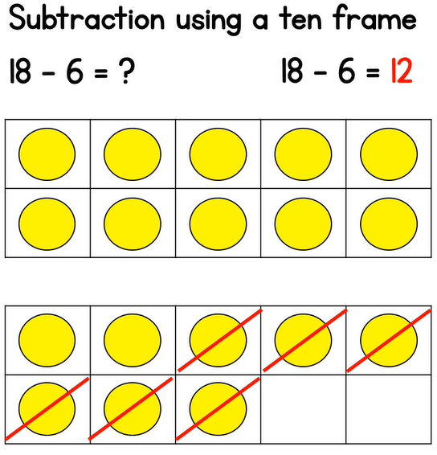
Some example calculations you can complete:
(it is a good idea to give the children examples with the question and answer on different sides of the equals symbol- see examples below)
15-7= 9-4=
?= 16-3 20-6=
7-5= ?=18-7
19-11= 12-4=

Task 3 number line
See video link maths 2
Now you have mastered subtraction using 10s frames we can start using a number line.
- First find the greatest number on the number line and circle it.
- Next count back the amount of jumps that you are subtracting.
- Circle the number that you have ended on, this is your answer.

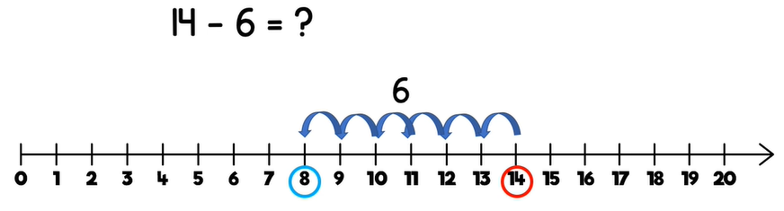

20-7= 8-3= ?=6-2 11-6=
17-7= ?=9-4 14-8= 12-7=

Task 4 addition and subtraction problems
See video link maths 3
Now the children have practised using part whole models, 10s frames and number lines to solve addition and subtraction calculations lets challenge them to solve some word problems. The most important part of this is to understand what the question is actually asking you to do.
- If you print or write the questions out then get the children to underline or highlight the important numbers.
- Then think about if it is an addition or subtraction question.
- Now work out which number you need to add/subtract.
- Finally choose the method you will use to solve the calculation and complete it.

Miss Foster has 4 cups. She finds 2 more. How many cups does she have all together?  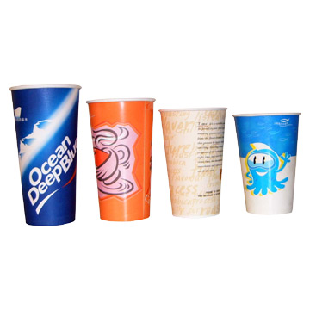  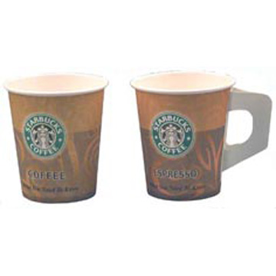 | Kyle has 10 sweets. He eats 5 sweets. How many are left?  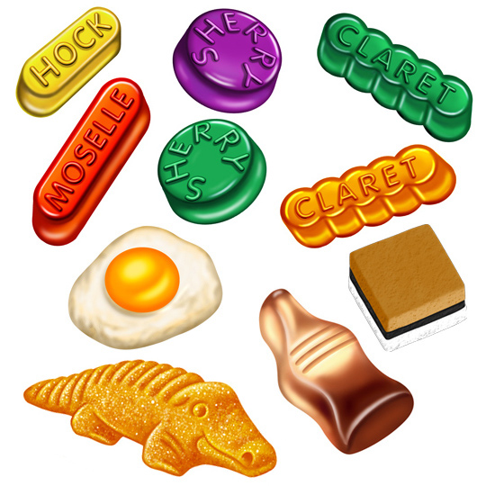 | Joy has 3 books. Evelyn gives her 3 more. How many books does Joy have now?   | A hen lays 4 eggs. She lays 6 more. How many eggs are there?  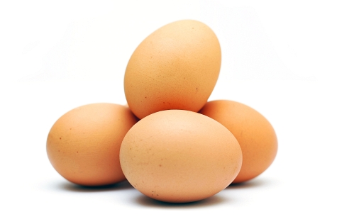  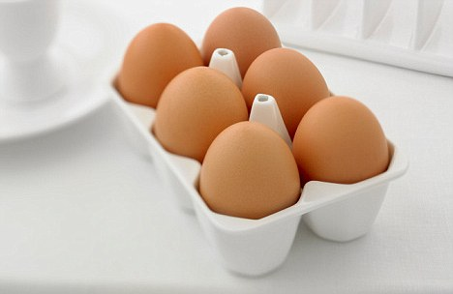
There are 9 butterflies. 1 more comes along. How many butterflies are there now?  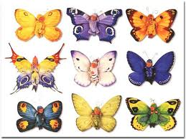  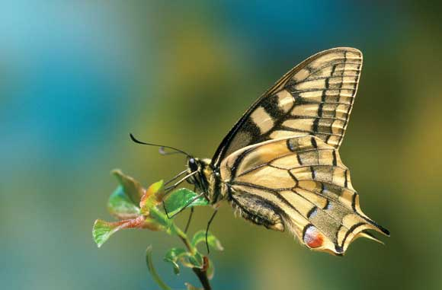 | Nissi has 3 umbrellas. Evelyn has 4. How many umbrellas do they have all together?  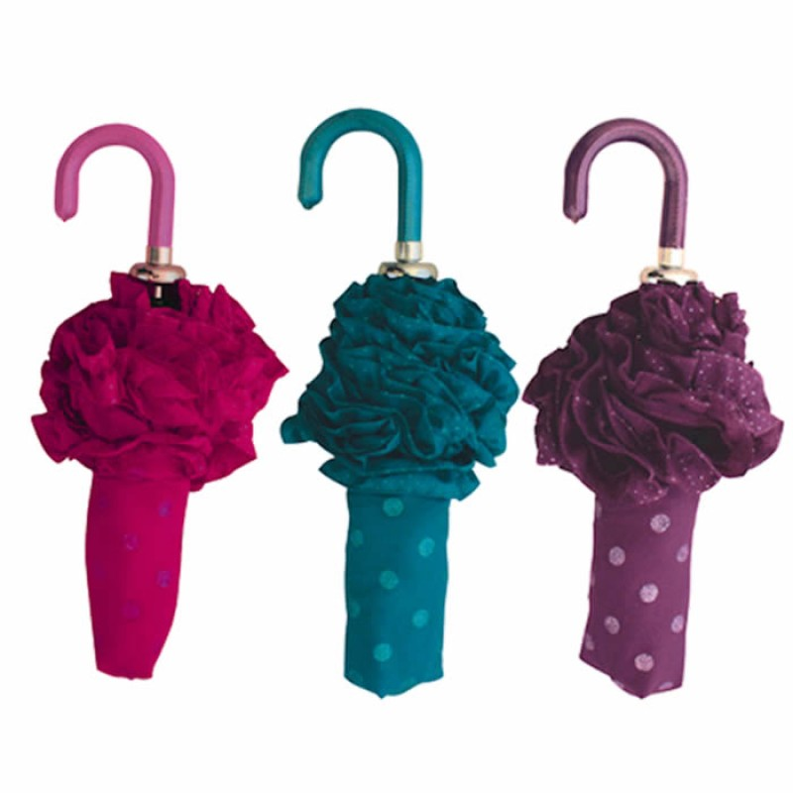  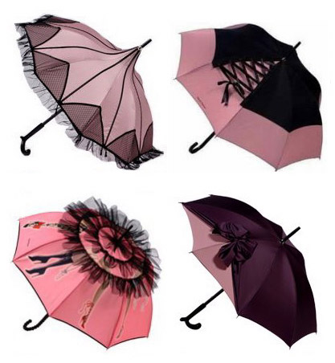 | Nzea has 9 toy cars. He breaks 3. How many toys cars does he have left?  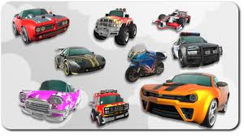 | Benjamin has 20 marbles. He loses 10 marbles. How many marbles does he have left?  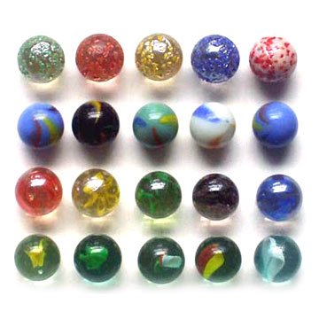
Destiny has 4 umbrellas. She breaks 1 umbrella. How many does she have left? | Irmak has 2 teddy bears. She gets 2 more for Christmas. How many teddy bears does she have?  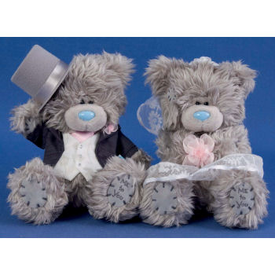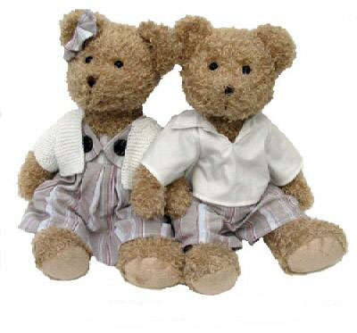 | Kevin has 3 hats. Dontay has 3 hats. How many hats do they have all together?  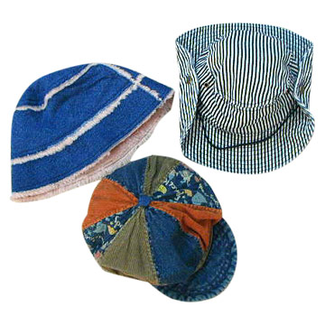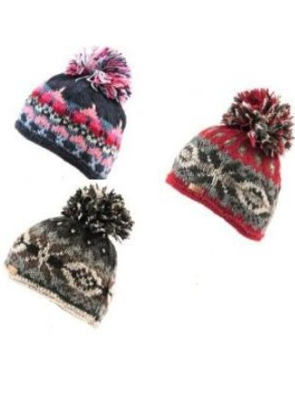 | Tony has 3 pens. 2 go missing. How many pens does Tony have?  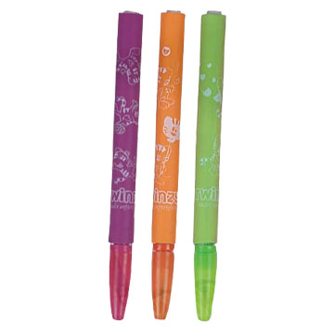
Arda has 3 apples. Coby has 2 more. How many apples are there all together?  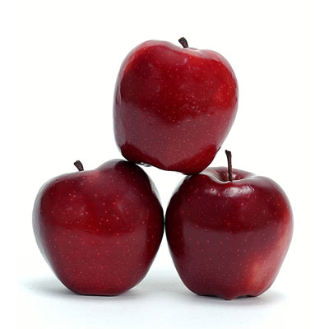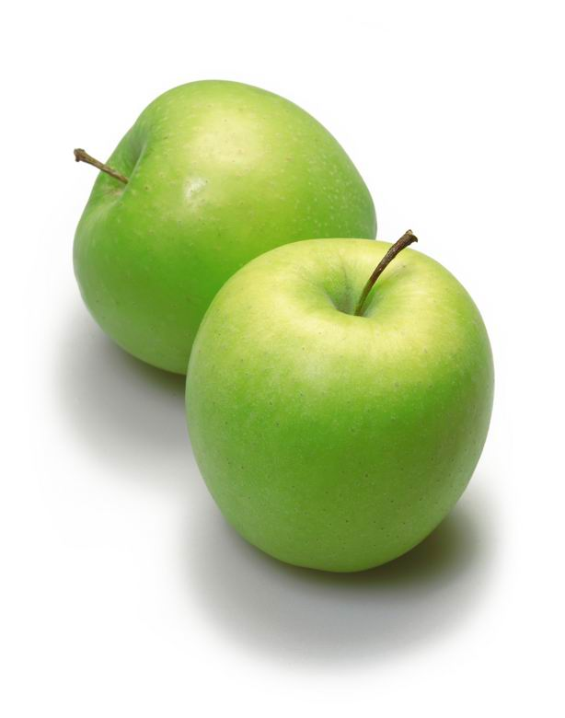 | Devrim has 6 shoes. He loses 2. How many does he have left?  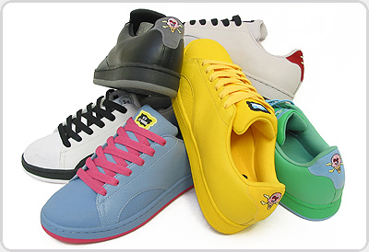 | There are 10 children on the bus. 3 children get off the bus. How many children are still on the bus? | There are 8 children sitting at a table. 2 more children join the table. How many children are sitting at the table?

Task 5 - number bonds to 10
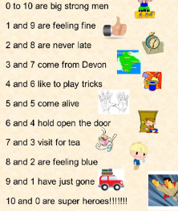
Rhymes and songs are a good way to remember number bonds. Here are some examples but why not try stealing the children’s favourites for each number bond and creating their own number bonds rhyme. They could make their own up completely if they want. They could also make a poster and illustrate it to really make it their own.



