English tasks week beginning 22nd June 2020
Task 1 see video Week 4 English 1
Read the story so far. What do the children now think Funni thought was missing? Does this match their predictions from the previous session?
Now re-read the text again, asking the children to listen and look for information that tells us more about Funni’s character. How do these two pages tell us more about what she is like? Discuss how the author is showing, not telling us this information through her language choices, text making and annotating the text to highlight examples of this in action, for example: ‘Each Saturday…’ shows us she is determined.
Add these observations to the character in your book in a different colour to the last additions to highlight how our knowledge about this character is progressing the more we read.

Task 2 (home learning)
Look back at the illustration the last page we have read, where Funni is kneeling in the soil. How do they think she feels at this point in the story? What do they think her facial expression might look like at this point of the story? Give the children small hand mirrors to help them visualise and actualise their chosen expression
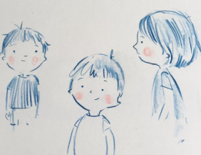
Depth can be given in the placing and shaping of, in particular, the eyebrows and mouth allows for a wide range of expression to be conveyed. There are lots of examples on Fiona Lumbers’ Twitter feed and Instagram page of preparatory character sketches: https://twitter.com/fionalumbers?lang=en https://www.instagram.com/fiona_lumbers/?hl=en , for example:
Try out different ways of placing and shaping the eyes, eyebrows and mouth to show different expressions.

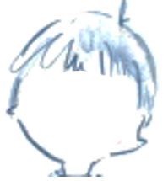
Try adding eyebrows and mouth to the faces below to make them show different expressions.

Task 3 see video Week 4 English 2
Look at some examples of character descriptions from books at home. Gruffalo, the twits (In fact all Roald Dahl books).
Character descriptions will often look at the appearance of the character (what they look like) and what the character’s personality is like (grumpy, happy, kind or mean).
Look back at your outline of Funni where we have already written lots of words and phrases to describe both her appearance and personality and her thoughts and feelings. You can now use this to write a character description of Funni.
Remember think about using great descriptive words and phrases but also use full stops, capital letters and some conjunctions such as; and, because, so, but.

Task 4 see video Week 4 English 3
Get the children to recreate Funni’s pose in these illustration, holding her body position and facial expression they can see in the illustration as closely as possible. How are they feeling as they hold this pose? If they were Funni, what might they be thinking at this point in the story? Allow time for the children to compose and hold this thought. You could get someone to take photos and print them off of you in each pose, print the pictures and cut them out to put in your book, draw Funni in each position or just writing without a picture.
For each picture write a sentence that tells us how Funni is feeling and what she is thinking. Remember you have to pretend you are Funni so your sentence might start with “I am feeling…..because…” or “I love doing this….”
Try to explain why she is feeling how she is using words such as ‘because’.

Remember we really want you trying to be as independent as possible with your writing so use your sound mats to help with spelling words before you ask a grown up. Don’t forget full stops and capital letters.
Task 5
Now look at the picture of the car park (at the end of this document). It is black and white. You can compare with the picture from the book that has colour for the flowers and in the sky.
Experiment with adding your own colour to the picture (if you can print it). What feeling and atmosphere do different colours create when you look at the image?
If you can’t print you can still explore the different feelings different colours portray. Think of different feelings/ atmospheres for example, happy, sad, calm, exciting and use colour to represent each.



