
Week beginning 22nd June 2020 Sustainable cities
We looked at the topic of sustainable cities in spring where we designed a sensory garden for school.
Sustainable cities is partly about making areas where people want to live and stay and having places that will improve peoples lives.
Ideas for activities you could do.
Activity 1
Look at he area where you live. Where are the really pleasant places that make peoples lives better. Why not go for a walk and visit these places. How do they make peoples lives better? Where are your favourite places near where you live?

Activity 2
Watch this Thomas video to learn about the good and bad things about cities.
https://www.allaboardforglobalgoals.com/en-us scroll down until you find goal 11 – sustainable cities and communities.
Can you make a list of all of the benefits of a city and another list about the problems that are in a city?

Activity 3
Create a leaflet for a new town that advertises all the areas that you think will make peoples lives better and more pleasant. You could look at places like Northstowe and see what they are advertisng as nice spaces in thr commnuity. https://www.northstowe.com/content/environment
Use pictures/maps/diagrams and write a description of each area you have included.
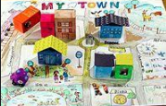
Activity 4
Make a map of your town with pictures and labels.
Try to include:
- Alternative ways to travel other than the car. e.g. cycle lanes
- Green spaces e.g. parks
- Ponds and lakes for wildlife
- Wildflower spaces
- Window boxes
- Quality housing for everybody with nobody living on the streets
- Lots of trees
- Green roofs
- Rail way lines
- Cable cars?
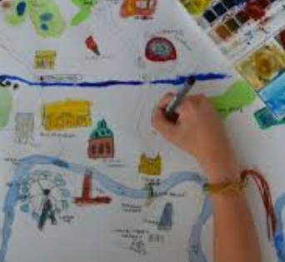
- Trams
- Electric car charging points
- Solar panels to supply energy
- Wind turbines
- Recycle points
- Rubbish bins
- Markets to sell local produce
- Community allotments
- City farms
- Museums

Activity 5
Create your new town. You could use lego, playmobil, junk modelling. Be creative and think about those areas that you looked at near you that make it a nice place to live.
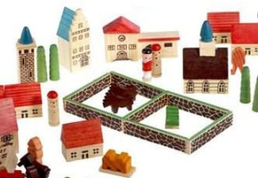
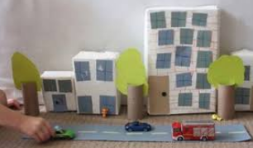

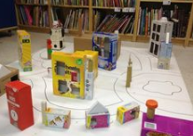
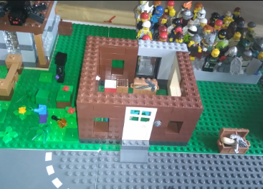

Activity 6
What is a green roof? Watch this video to find out all about green roofs
https://www.youtube.com/watch?v=RRta4aGJKfc
Try to make a green roof
https://www.youtube.com/watch?v=jUh6R1hs2Tw
This video shows how to make a building with a green roofout of a shoe box.
- Use an upturned shoe box as a building with the upturned lid to make a green roof.
- The shoe box is decorated to look like a building.
- Line the lid with tinfoil and fill with compost.
- Add some grass seed or maybe cress or mustard seeds
- Water and place on a bright warm window sill and wait for it to grow.
What are all of the benefits of having a green roof? Make a poster to try to persuade everybody to introduce a green roof somewhere in their property.

Activity 7
In the book we are reading for English Funni has planted some seeds to craete a garden. You couold also plant some seeds and grow your own flowers in your garden or in a pot. Keep a record of how they grow by drawing pictures regularly of what it looks like.

Activity 8
Funni also had a kite with her in her special place. Do you have a kite? If not you could make your own.
https://www.youtube.com/watch?v=w0VXajWKNic

