Sustainable Cities
Hi everyone, we hope you and your family are well and staying safe.
Here are some ideas for you to be working on whilst you are at home this week.
Please continue with your daily journal to capture what you are doing at home during this time. In your daily journal you write:
- How you are feeling.
- What you have done. This can be any of the work you have done from the blog and anything that you have done whilst at home.
- What you have enjoyed each day.
Below is a table suggesting how much learning to do over a day with a year 5 child. These slots add up to 4 hours of learning, split into small chunks with breaks. Of course what is important is that you do what works best with your family. The work listed below is more than enough for 5 days of 4hr learning so choose the tasks that you would prefer to do.
Please also ensure that you include some daily physical activity, Joe Wicks uploads a PE lesson on YouTube every day, these are good fun and you can access these when you would like to.
We also expect that you read daily, whether this be a story, magazine, information book or poetry. You can complete AR quizzes using this link: https://ukhosted43.renlearn.co.uk/2152328/default.aspx

am 45 min | Maths activity
am 45 min | English activity
10:30 | Snack time
am 2 x 30min | TT Rockstars/Rodocodo/Nessy
12:30 | Lunchtime
pm 45 min | Something unfinished from the morning or maybe some art
pm 45 min | An activity from general activities list

Maths
Task 1 (45min a day)
Choose an area of maths from the list below, you only need to choose one area a day, you do not need to do all of them every day. Use this time at home to practise some real life math skills. By practising these skills, other areas of maths will become easier for you as well.
Numbers - read, write, order and compare numbers to at least 1 000 000.
You could read some different numbers that you find in books, newspapers. Write the numbers using numerals and words.
Measures - convert between different units of metric measure - kilometre and metre; centimetre and metre; centimetre and millimetre; gram and kilogram; litre and millilitre
Could you measure your garden, Bedroom, kitchen? What if you wanted to plant a new flower bed or build a den in your bedroom, how much space would it take up? How long would it be? If you go out for a daily walk, how far do you walk in metres? Kilometres?
Could you help in the kitchen to bake or cook dinner? Measure your ingredients carefully.
Times tables - Know multiplication and division facts up to 12 x 12
Money - estimate costs, add and calculate change in £ and p.
Can you calculate the cost of the weekly shop? What about change if you didn’t have the exact amount?
Time - tell the time using analogue, digital, 12 and 24 hour clocks.
Read the clock at different times of the day. What time do you wake up, have lunch, dinner, bedtime? Can you give those times using analogue, digital, 12 and 24 hour clocks.
Read and interpret a variety of time tables including, bus, train and tv guides. What time do your favourite programs start? How long do they last? Could you take a train from St Neots to London? How long is the journey? What time are the trains? etc

Task 2 (2 x 30 min per week)
TT rockstars https://ttrockstars.com/
Video tasks
Lesson 1: https://www.youtube.com/watch?v=aTwc9nzfznk&t=16s
Questions to complete after watching video lesson 1:
- A running track is 400m long. Carrie runs 8 laps. How far is this in kilometres?
- A pipe is 3 metres long. Three 60cm lengths are cut off. How long is the pipe which is left in metres?
- A one pound coin is 3mm thick. How tall is a stack of twelve one pound coins in centimetres?
- A bird feeder holds 200g of seeds. How many times can it be filled from 1kg of seed?
- A small box of cornflakes weighs 750g. A large box weighs 500g more. What does the large box weigh in kilograms?
- A bag of chips weighs 2.35kg. 700g is eaten. How much is left?

Lesson 2: https://www.youtube.com/watch?v=wC4O5ri4_LA
Questions to complete after watching video lesson 2:
- The course of a cross-country race is 2 laps of 1.4km and 3 laps of 750m. How long is the race?
- Wind turbines are spaced 150m apart. There are 25 in a row. How long is the row in kilometres?
- Scott cooks 0.8kg of pasta. This provides 5 servings. How much pasta is in each serving in grams?
- A bar of soap weighs 85g. What is the weight of 40 bars in kilograms?
- A box containing thirty packets of biscuits weighs 4.1kg. Each packet of biscuits weighs 130g. What does the box itself weigh?
- Laurel’s suitcase and luggage weigh 20.4kg. She takes out boots weighing 900g and puts in sandals weighing 450g. What is the weight of the suitcase and luggage now?

Lesson 3: https://www.youtube.com/watch?v=otoUEYj8O8E
Questions to complete after watching video lesson 3:
You need to know:
1 inch is approximately equal to 2.5cm
1 foot is approximately equal to 30cm
1 yard is approximately equal to 90cm
1 mile is approximately equal to 1.6km
- Choose which measurement completes the sentences below (3 feet? / 2.5cm? / 12 inches?)
1 inch is approximately . . . . . . . . . .
1 foot is equal to . . . . . . . . . .
1 yard is equal to . . . . . . . . . .

- A snake is 4 feet long. How many inches long is the snake? (use your answers above to help you)
- Which is taller: a 48 inch chimpanzee or a 3 ½ foot baboon?
- Which is longer: a 6 yard pond or a 21 foot patio?
- Measure how tall you are in centimetres. Now convert this into feet and inches.

English
Task 3 (5x 30 min)
Read every day
Video tasks
Lesson 1: https://www.youtube.com/watch?v=Gl9lYF-anhk
Lesson 2: https://www.youtube.com/watch?v=V1yWT2kehsA
Lesson 3: https://www.youtube.com/watch?v=PLV_On2N-Qc
(see separate sheet of activities on Synonyms)

Geography
Did you know that?
There’s a massive gap in the world between those who have access to the energy needed for a decent quality of life and those who don’t...
Although suitable technologies are available:
- 1.3 billion people live without any form of electricity and 2.7 billion people still cook over open fires.
- Nearly one third of the world’s population don’t have access to electricity from a national grid.
- The majority of people without access to electricity live in remote areas in ‘economically poor’ countries.

Moja island is a small island situated off the East Africa coast in the Indian ocean
- There are 1,450 people who live on the island, divided into four main communities, these are Ericas, Sandis, Hankis and Moodis.
- It has no mains electricity.
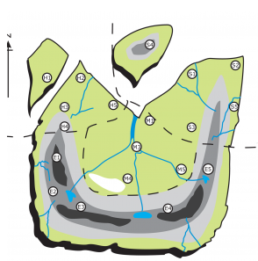
- The islanders mainly use kerosene lamps and candles for lighting and fuel wood for cooking food.

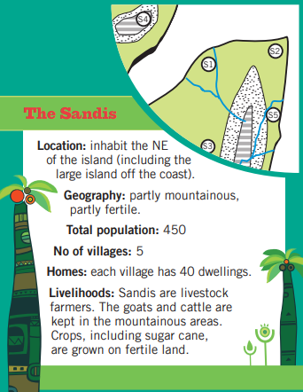
Facts about the four parts of the Island:
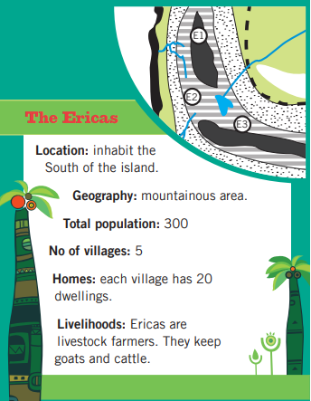

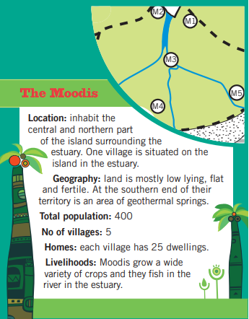
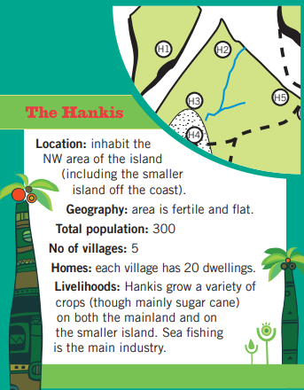

The government of Moja Island has decided to invest money to generate electricity on Moja Island

Your task:
You have been asked to identify and make suggestions for the most appropriate renewable energy options for the four communities on Moja Island.

Below is a table to use to fill in (if you wish to use it) as to which renewable energy you’ve chosen. You may need to research the different renewable energies first.

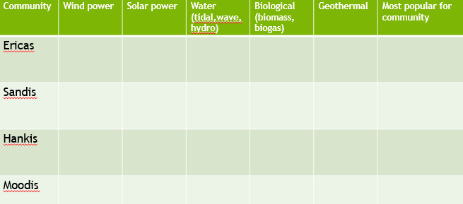

Science
Solar Power
Use this link to watch the video about solar power in Bristol:
https://www.sustainablelearning.com/sites/default/files/videos/original/best_of_bristol_solar_power.mp4
As you are watching it, jot down notes that help to answer some of these questions.
- What is solar energy and where it comes from?
- Why is solar power described as ‘renewable’?
- How many kilowatts of solar energy does St Michael’s Hospital use a year? How many kilowatts would they use in five years?
- What is the official scientific name for solar panels (hint: Chris Dunford from At-Bristol explains it!)
- How does the energy tree work?
- Why would solar kettles be particularly useful in hot countries?
- Can you come up with class pledges that you will all keep to, in order to be more sustainable in terms of your energy usage?
Art/DT
This video shows you how to draw a street using perspective. You can pause the video at different places to help you draw the picture that the lady is making. Ensure you use a ruler and use faint lines so you can rub them out if you need to.
https://www.bbc.co.uk/bitesize/clips/zvq6sbk

Maths – Lesson 1 (answers)
- 3.2km
- 1.2m
- 3.6cm
- 5
- 1.25kg
- 1.65kg
Maths – Lesson 2 (answers)
- 5.05km
- 3.6km
- 160g
- 3.4kg
- 200g
- 19.95g
Maths – Lesson 3 (answers)
- 1 inch is approximately 2.5cm, 1 foot is equal to 12 inches, 1 yard is equal to 3 feet
- 48 inches
- 48 inch chimpanzee
- 21 foot patio

