15th June
Dear Year 2,
Hello everyone! Hope you all had a lovely week last week, although the rainy weather didn’t help. It was lovely to speak to you all again this week. The theme for the blog this week is ‘Responsible Consumption’ I hope you enjoy some of these activities.
I hope you are enjoying writing your daily journals to capture what you are doing at home during this time. Remember to write in your journal:
- How you are feeling
- What you have done. This can be any of the work you have done from the blog and anything that you have done whilst at home.
- What you have enjoyed each day.
I can’t wait to see your journals which will be shared upon our return to school with your classmates!
If you would like to take some photos of your work to show, me you can send them to the school office! I have loved seeing the videos/photos/work that you have been sending in.
Take care and stay safe
Hopefully I will see you all soon
Mrs Jaynes and Mrs Tarpey
x
This is a suggestion of how much learning to do over a day with a year 2 child. These slots add up to 2 hours of learning, split into small chunks with breaks. Of course what is important is that you do what works best with your family. The work listed below is more than enough for 5 days of 2hr learning so please choose the tasks that you would prefer to do with your child. Also don’t forget to do some exercise and read every day!
am 20 min | Maths activity
am 20 min | English activity
10:30 | Snack time
am 2 x 20 min | TT Rockstars/Nessy
12:30 | Lunchtime
pm 20 min | Something unfinished from the morning or maybe some art
pm 20 min | An activity from general activities list

Responsible Consumption

Maths

Task 1
Recap lesson on representation. Find different ways to represent the same number.
https://youtu.be/HwWhPP59Ntw
Answers to the challenge
The 3 largest numbers that can be made are; 75, 73, 72
The 3 smallest numbers that can be made are; 23, 25, 27
If you are confident in trying these now take away the digit 3 from the list so that you are left with
5 7 2. Now try again to make the 3 largest and 3 smallest numbers from these digits.

Task 2
Watch the video clip and complete the calculations on screen.
https://youtu.be/U2mLZpPfM2o
Recap using a numberline to solve subtraction calculations.
27 – 10 =
34 – 20 =
39 – 30 =
35 – 12 =
47 – 22 =
58 – 34 =

Task 3
Watch the video clip
https://youtu.be/p9ij7H_1Fb4
If you can’t see the calculations on the video then use the ones from task 2.

Now that you have some written methods to use, see if you can apply them to help you answer these questions.
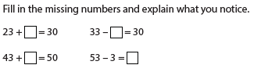
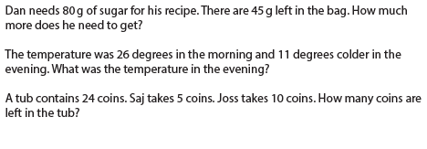
Task (20 min a day)
The following activities are ongoing tasks and should be practised every week at times that would suit you best. You do not need to do them all every day, pick one or two per day.
Number - count in steps of 2, 3, and 5 from 0, and in tens from any number, forwards and backwards
Know number bonds to 20
Times tables - recall and use multiplication and division facts for the 2, 5 and 10 multiplication tables (Try making mini times tables booklets)
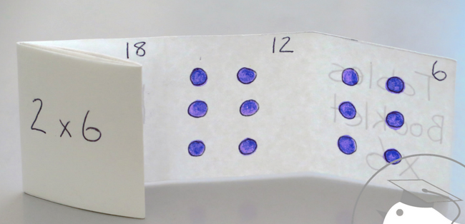
Time - tell and write the time to five minutes, including quarter past/to the hour (on an analogue clock)
Know the number of minutes in an hour and the number of hours in a day.
Money - Recognise different monetary coins, find different combinations of coins that equal the same amounts of money
Measure - measure items in cm/m, kg/g, l/ml

Task (2 x 20 min per week)
TT Rockstars https://ttrockstars.com/

Task (2 x 20 min per week)
Abacus https://www.activelearnprimary.co.uk/login?c=0

English
Remember to read every day

Task 1
Watch the clip
https://youtu.be/jnpjNQbsrpQ
Alternatively all of the information contained in the videos is written below.
Look at the 3 pictures attached below of the Egg Box Dragon. Compare the pictures. What is the same about all of them? Can you spot any differences? What do you like/dislike about the pictures?
Record your thoughts, using ‘because’ to explain your reasons fully. Try to use some comparison words that have either the suffix –er or –est.

Task 2
Watch the clip
https://youtu.be/qJhKq8qNaX4
Alternatively all of the information contained in the videos is written below.
Read the extracts of the text from the attached file. Are there any words or phrases that you don’t understand?
Can you work out the meaning of the following phrases
“….admired him enormously.”
“…a normally silent person.”
Critter
Look back at the picture from task 1 of the Egg Box Dragon asleep under the stars. Think about the following questions;
Will something or someone appear? Will there be a transformation? What will change? What might stay the same?
Think about what might happen in the Egg Box Dragon’s dream. Use your imagination, perhaps it might go on an adventure somewhere.

Task 3
Watch the clip
https://youtu.be/CVjElJX4a34
Alternatively all of the information contained in the videos is written below.
What is going to happen in Egg Box Dragon’s dream? Hopefully you managed to think about it whilst carrying out the previous task. If you didn’t or would like to develop your ideas further you could try to listen to this piece of music and it might inspire you to think more about what is going to happen in the dream.
https://youtu.be/Som5HSyfTm8
Now you are going to try to create a storyboard for your ideas about the dream. I have attached a blank storyboard if you want to use it or you can just draw either 4 or 6 boxes on a piece of paper. Draw and make notes about what you think will happen.
Remember that the last box is going to contain a cliffhanger so don’t finish the dream with Egg Box Dragon waking up.

Task 4
Watch the clip
https://youtu.be/Z8vjSrGx-1s
Now turn your storyboard into an extra part of the story. You might want to have a go at becoming an author and illustrator and create a page that could be inserted into the actual book. Alternatively you could write about your dream and illustrate it.
Remember to think about:
Full stops, capital letters and possibly exclamation marks
Try to add in some expanded noun phrases from last week.

I would love to see these pages of writing. Please email them if you can.

Additional Task
Make your own junk model dragon. Think about the specific features that you would like your dragon to have and what materials you might use to achieve this. Perhaps you could take some inspiration from the Egg Box Dragon in the book or maybe you have your own ideas.

Task (if you have a password 2 x 20 min)
Nessy https://www.nessy.com/uk/

Spelling
‘O’ making an ‘u’ sound in the middle of words
Eg Monday, brother, mother, other, nothing, honey, money, wonder, worry, oven

Science
Task 1
Carry out a food audit throughout the week to see if any food is wasted in your household. Think about how you might collect your data; pictures, lists etc.
If any food was wasted, think about different ways that you could waste less food?

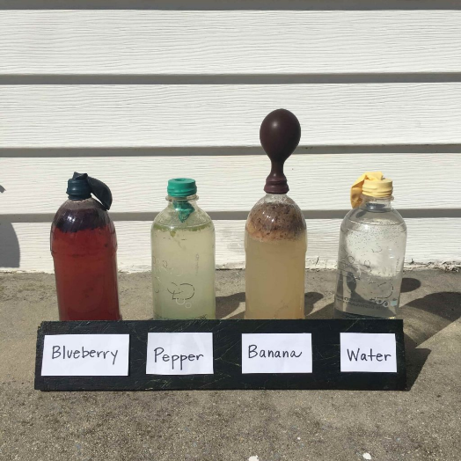
Task 2
Food waste that goes to a landfill site will produce methane gas which contributes to global warming. It is better if food is allowed to decompose naturally in the open air with oxygen e.g. an apple core rotting on the floor.
To explore how different foods produce different amounts of methane when they decompose set up this experiment.
Fill plastic bottles with water to eliminate air from the bottles.
Add a different fruit or vegetable waste to each bottle.
Put a ballonn on the top of the bottle to catch any gas that is produced.
Which is the worst fruit or vegetable to send to the landfill site?

Global Learning
Task 1
What does responsible mean?
What does consumption mean?
Responsible consumption means only buy or take what you need and only throw away anything that you can’t reuse. Watch this video to see what Thomas can tell you about responsible consumption.
https://www.youtube.com/watch?v=paZdt73joYI
After you have watched the video perhaps you can have a discussion using these sentence starters
- What kinds of things do people throw away?
- How can we reuse things at home?
- What can we make from recycled materials?
- What happens to all the waste?
- Should we throw away old toys? What should we do with them?

Task 2
Think carefully about what this means, Reduce Reuse and Recycle

- Reduce
Can you think of ways that you can reduce waste
e.g. don’t buy food that has a lot of plastic packaging
don’t waste food and put it on the compost heap instead
- Reuse
Can you find another use for something that you have finished with (see Art activities below)
- Recycle
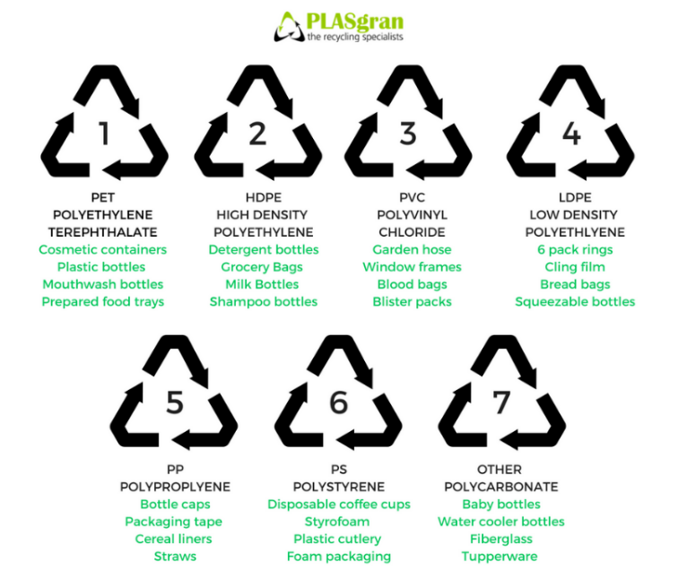
What can be recycled and what can’t?

Explore your recycling with an adult and see if you can find these symbols:

Task 3
Make a poster to tell everybody how important it is to Reduce, Reuse and Recycle. When you have made the poster display it in your window to remind everybody about your important message.
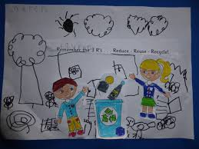

Task 4
Making an ecobrick

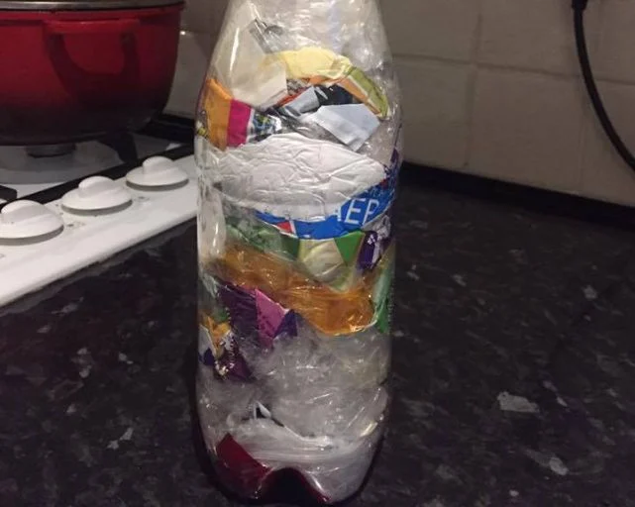
What is an ecobrick?

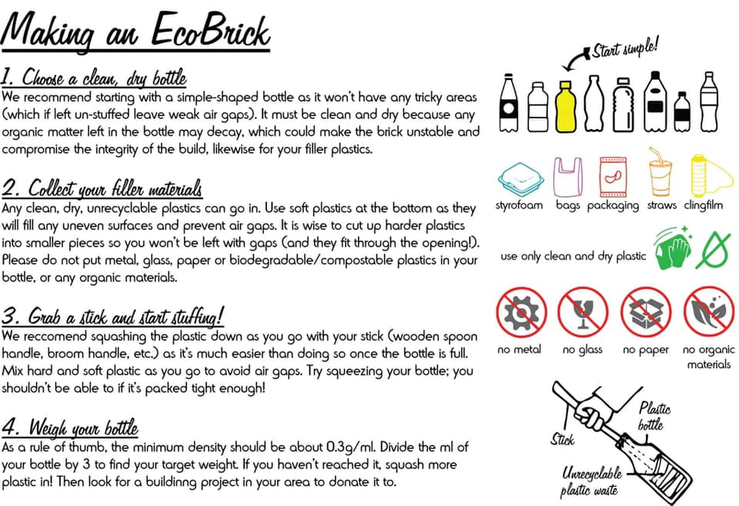

An ecobrick is a plastic bottle stuffed solid with non-biological waste to create a reusable building block.
If you would like to donate your ecobrick to a school project, once you have made it please clean your bottle with soapy water and place it in a carrier bag. The bottles can then be dropped off in the collection box outside the school office.
If we get enough ecobricks we will try to make a raised bed either at school or at the school allotment to repurpose all of this unwanted plastic.
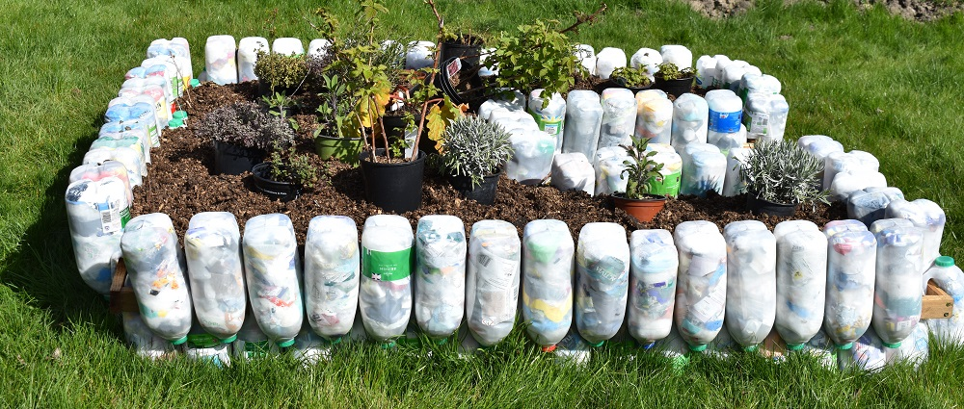
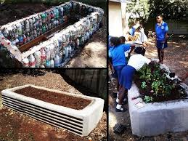

Art
Task 1 (1x 20 min sessions)
Use your imagination and use what is in your recycle box to make a new toy.
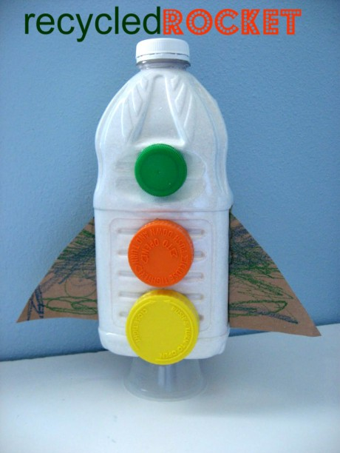

Task 2 (1 x 20 min sessions)
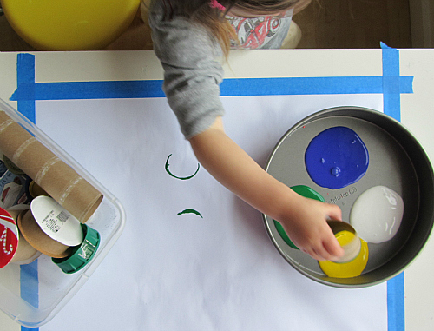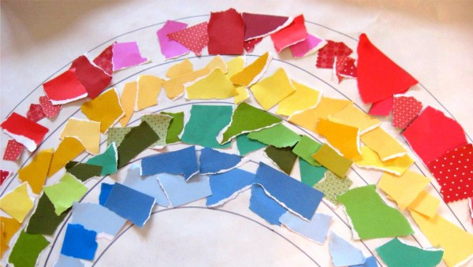

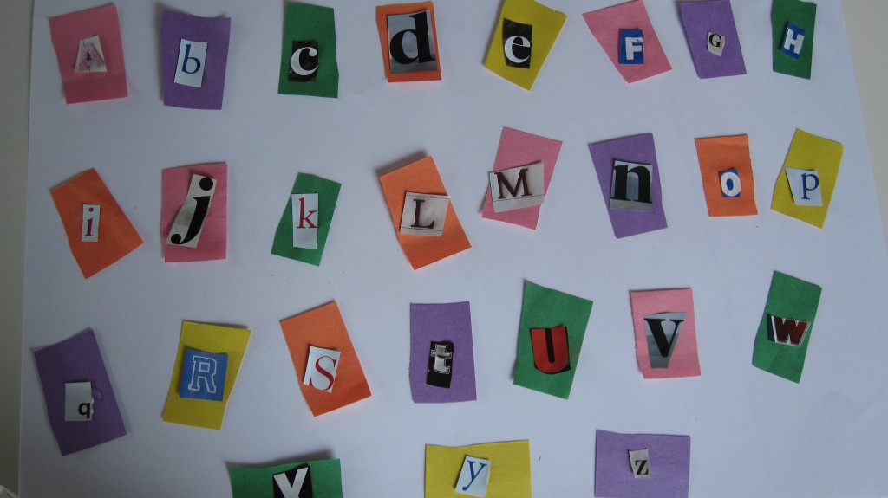

Computing
https://www.rodocodo.com/

