Making an ecobrick

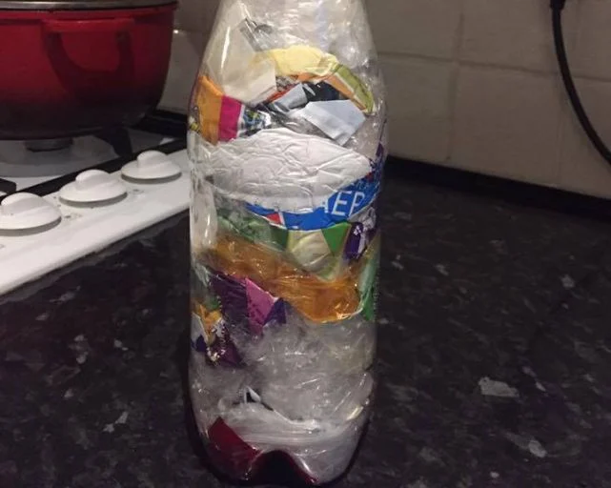
What is an ecobrick?
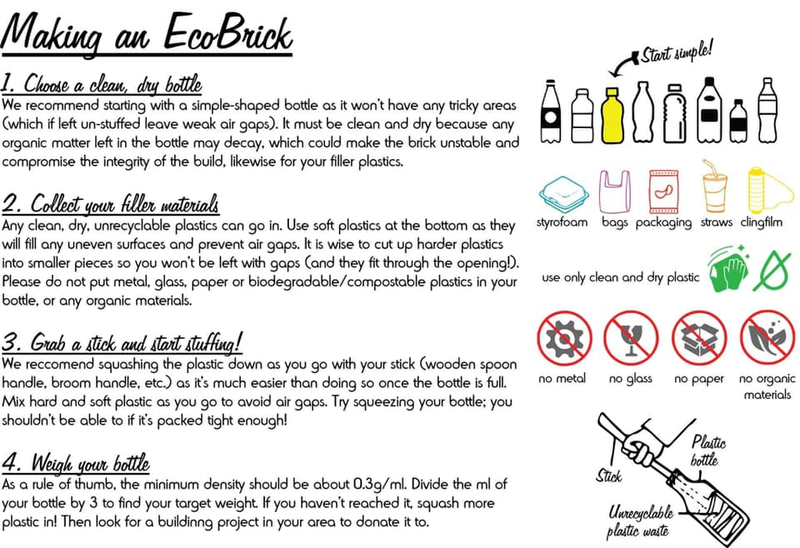
An ecobrick is a plastic bottle stuffed solid with non-biological waste to create a reusable building block.

If you would like to donate your ecobrick to a school project, once you have made it please clean your bottle with soapy water and place it in a carrier bag. The bottles can then be dropped off in the collection box outside the school office.
If we get enough ecobricks we will try to make a raised bed either at school or at the school allotment to repurpose all of this unwanted plastic.


